
H.C.B-A1789
BENZ TRUCK (DD13/ DD15) DIESEL ENGINE FRONT CRANKSHAFT OIL SEAL REMOVER / INSTALLER

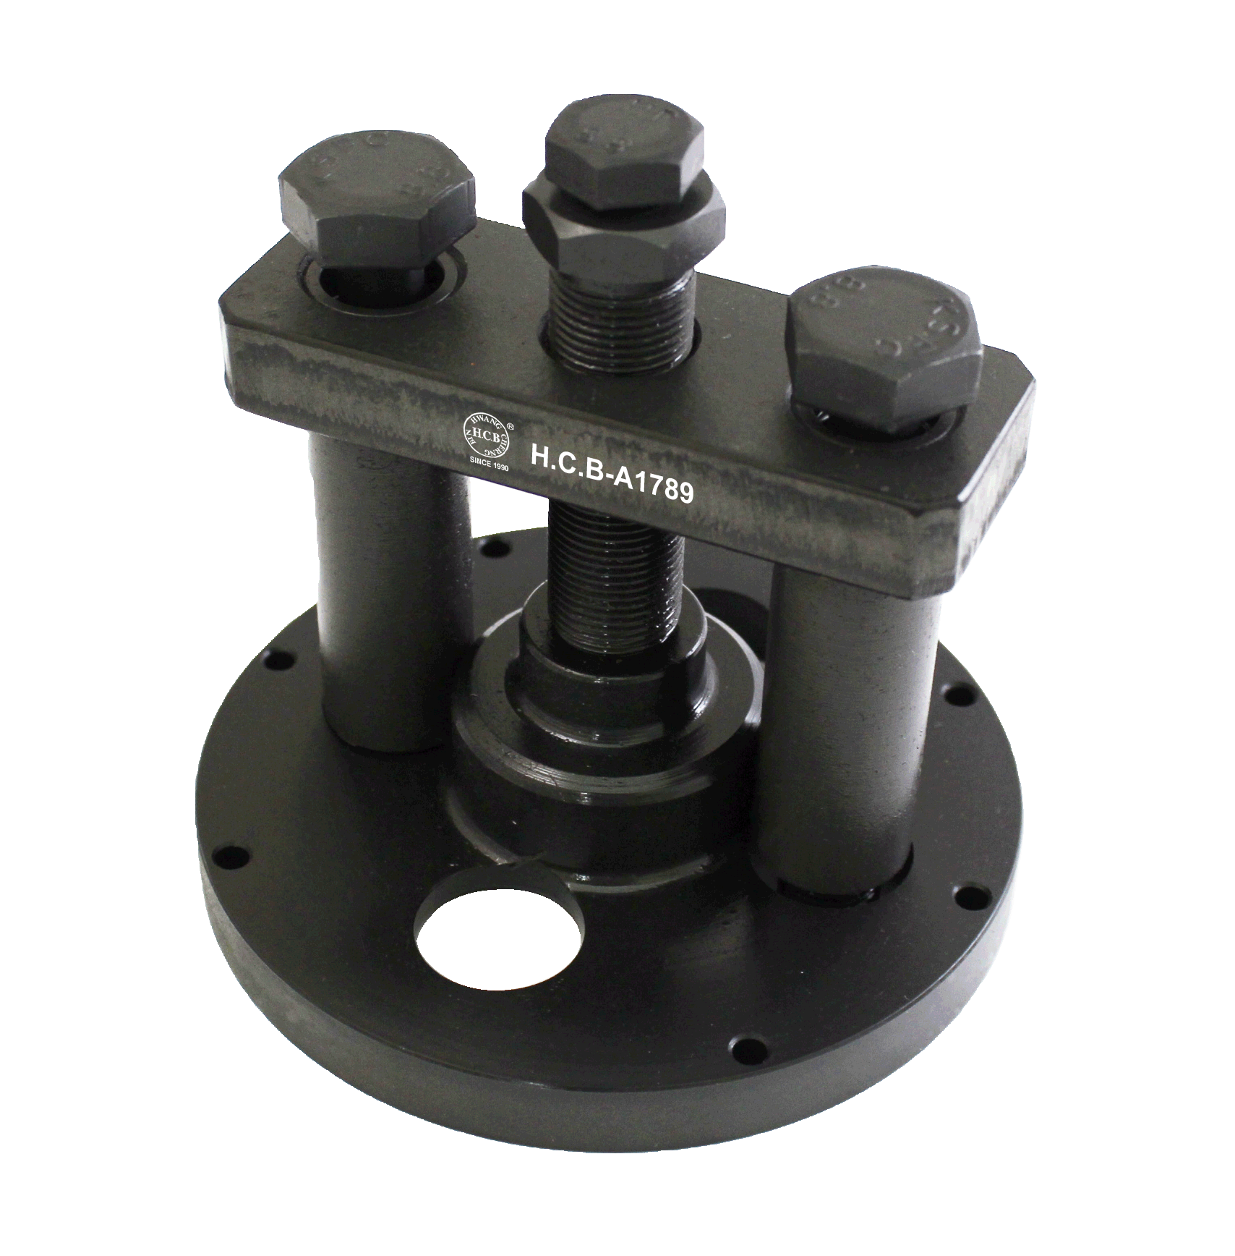

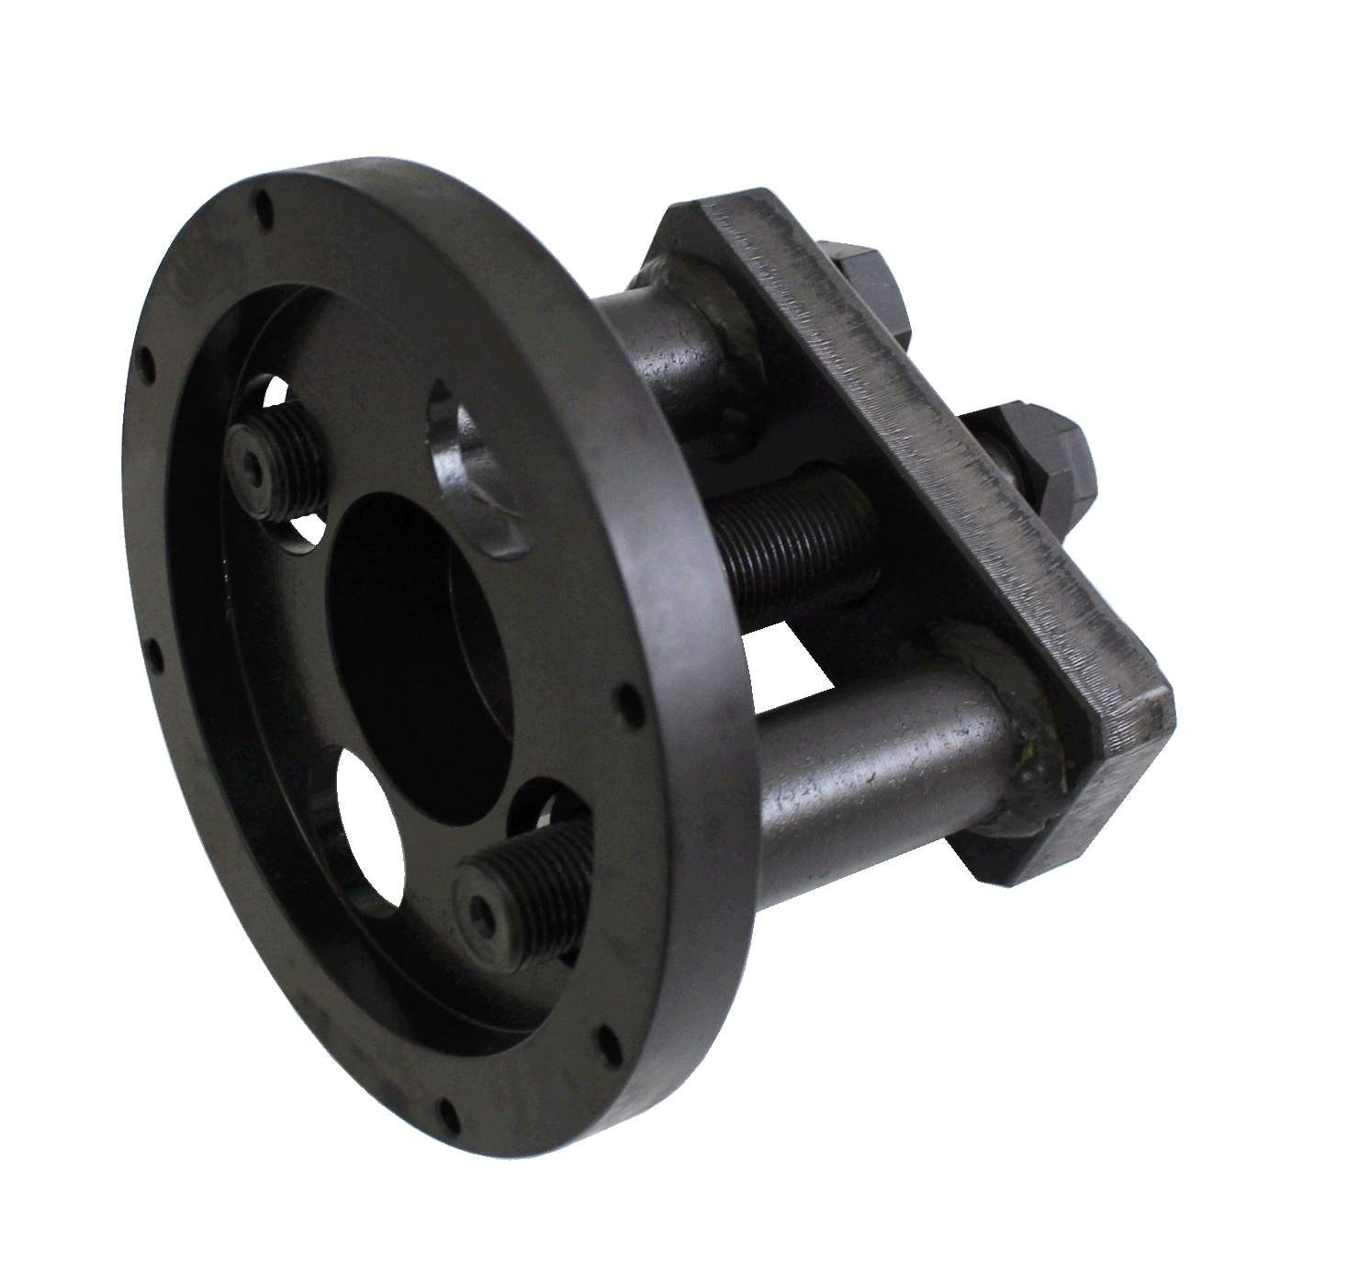

■ Tool for removing the oil seal and installing without damage.
■ OEM No.: W 541 589 02 33 00
■ Applicable engine: DD13 and DD15

- Instructions:
- Removal:
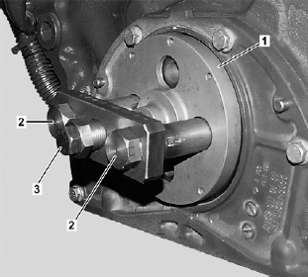
- Fit the base (No. 1) onto the oil seal, and tighten both bolts (No. 2) to fix the tool. Finally, turn the spindle (No. 3) until the base (No. 1) contacts the oil seal.

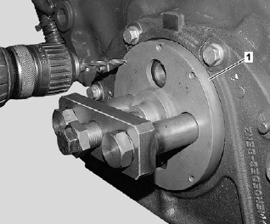
- Use the holes on the base (No. 1) to tap a pair of symmetrical threaded holes.

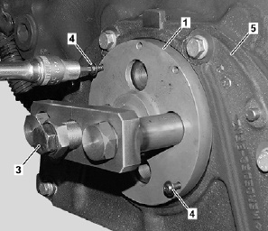
- Tighten two screws (No. 4) onto the threaded holes, and turn the spindle (No. 3) to pull out and remove the oil seal.

- Installation:
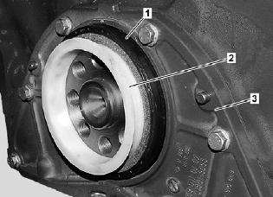
5
- Fit oil seal onto the crankshaft.

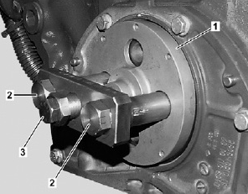
- Fit the base (No. 1) on the oil seal, and tighten both bolts (No. 2). And finally turn spindle (No. 3) to press the oil seal in to finish installation.
5

