
H.C.B-A1788
BENZ TRUCK (OM401/ OM403/ OM421 ~ OM423/ OM441 ~ OM444/ OM447/ OM457/ OM458/ OM541/ OM542/ OM941/ OM942) DIESEL ENGINE FRONT CRANKSHAFT OIL SEAL REMOVER

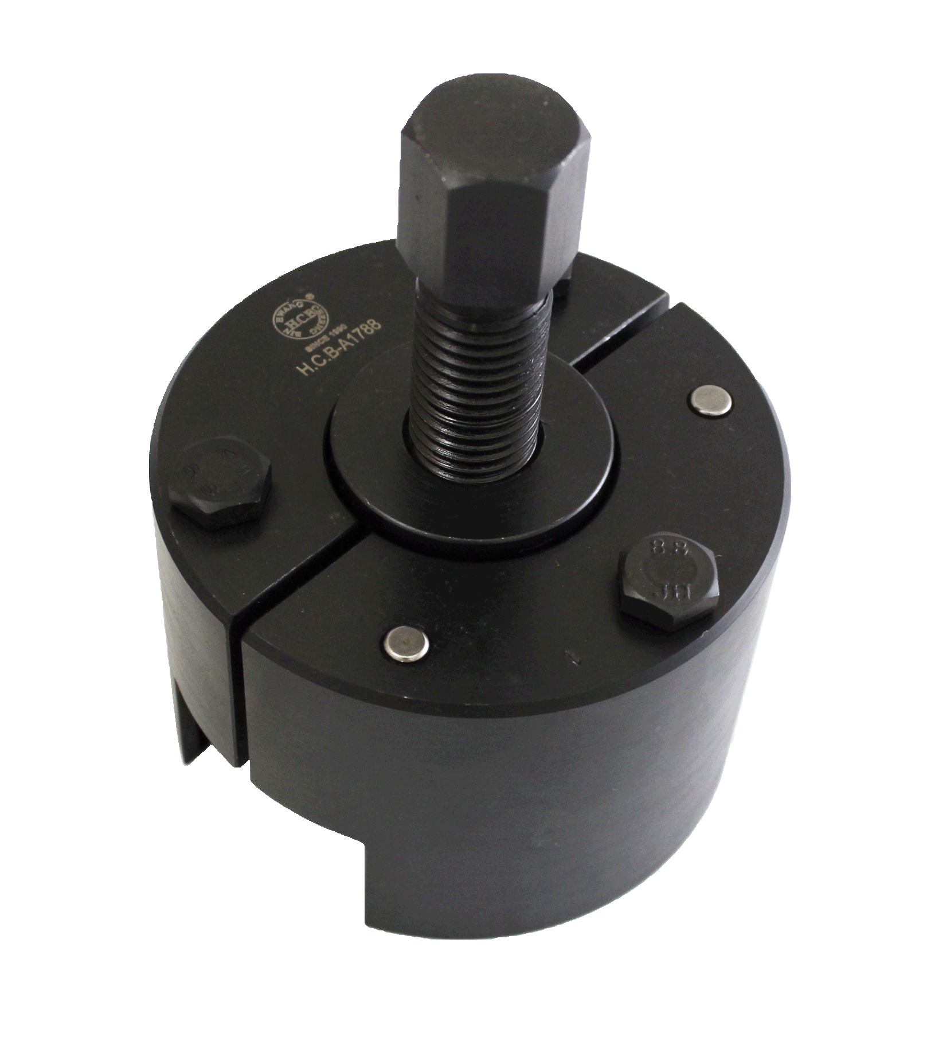

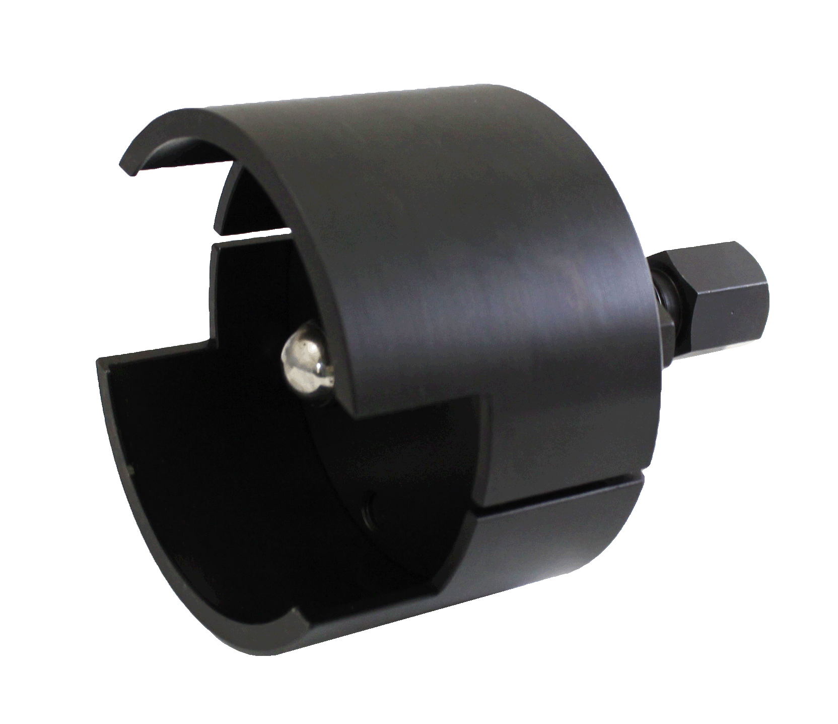

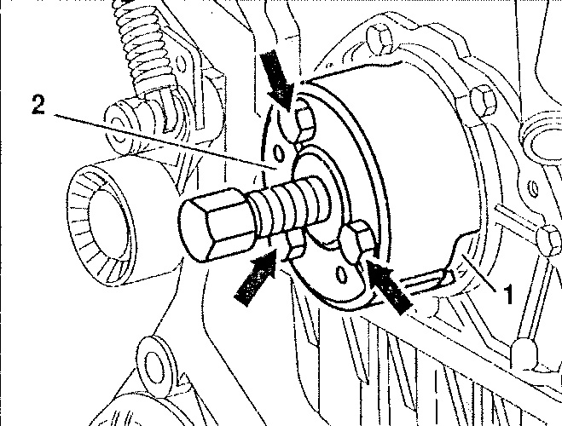

■ While replacing the oil seal, the oil seal must to be removed first.
The related parts might be damaged without using H.C.B-A1788.
■ Application: OM401, OM403, OM421, OM422, OM423, OM441, OM442, OM443, OM444, OM447, OM457, OM458, OM541, OM542, OM941, OM942
■ OEM no.:442 589 00 33 00

