
H.C.B-A1773
BPW TRAILER BUCKET STAND
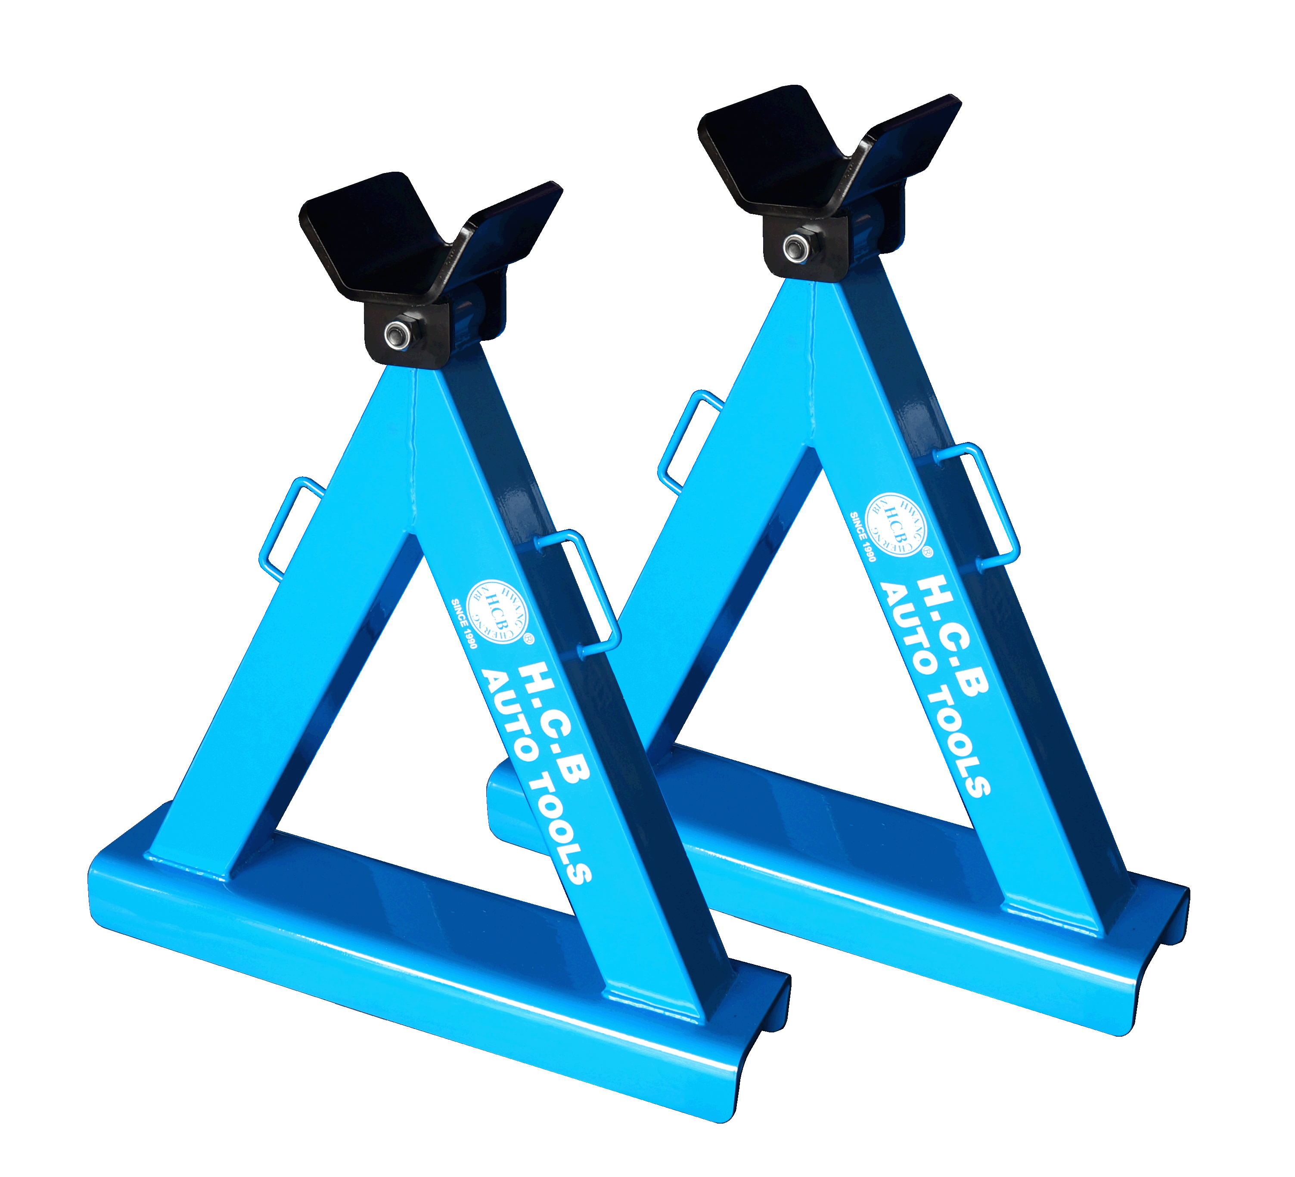

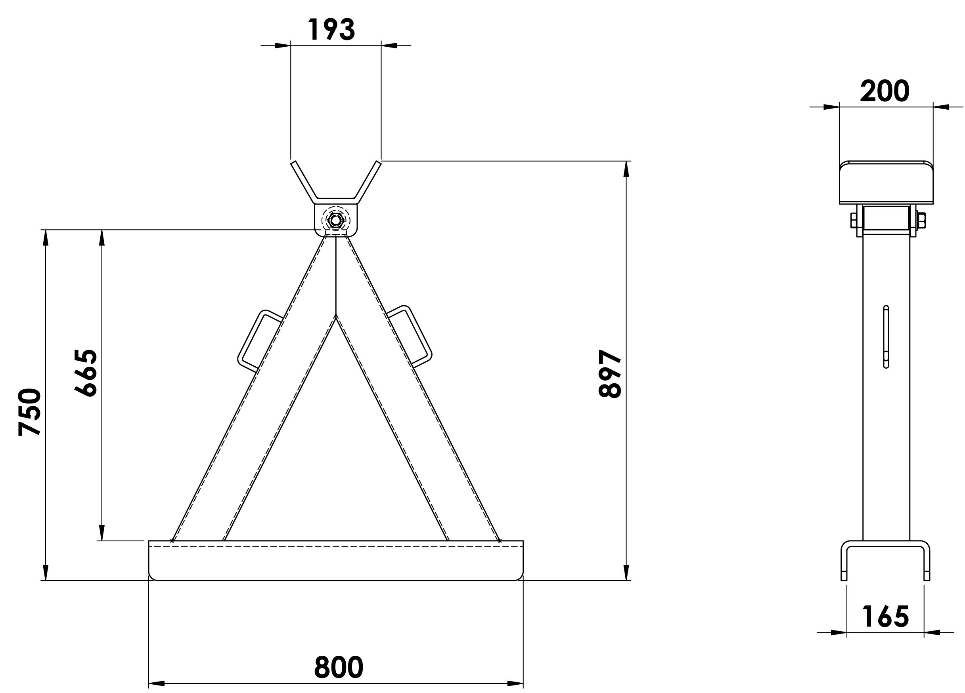

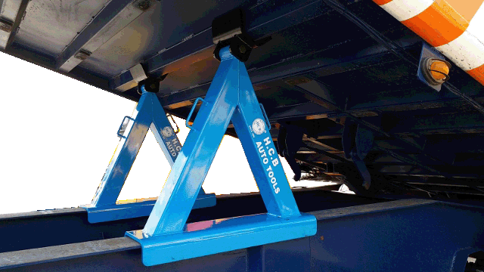

說明:
■The trailer bucket must be raised up while repairing the chassis or wiring. Use H.C.B-A1773 to hold the bucket can avoid the risk of falling bucket due to the abrupt hydraulic system failure, and give mechanics safer working environment.
■Base length: 800 mm, Steel thickness: 12 mm, Capacity: 5-7 TONS

