
H.C.B-A1766

Cummins 3.5L ,3.9L, 5.9L & 6.7L Rear Crankshaft Seal Remover & Installer Tool

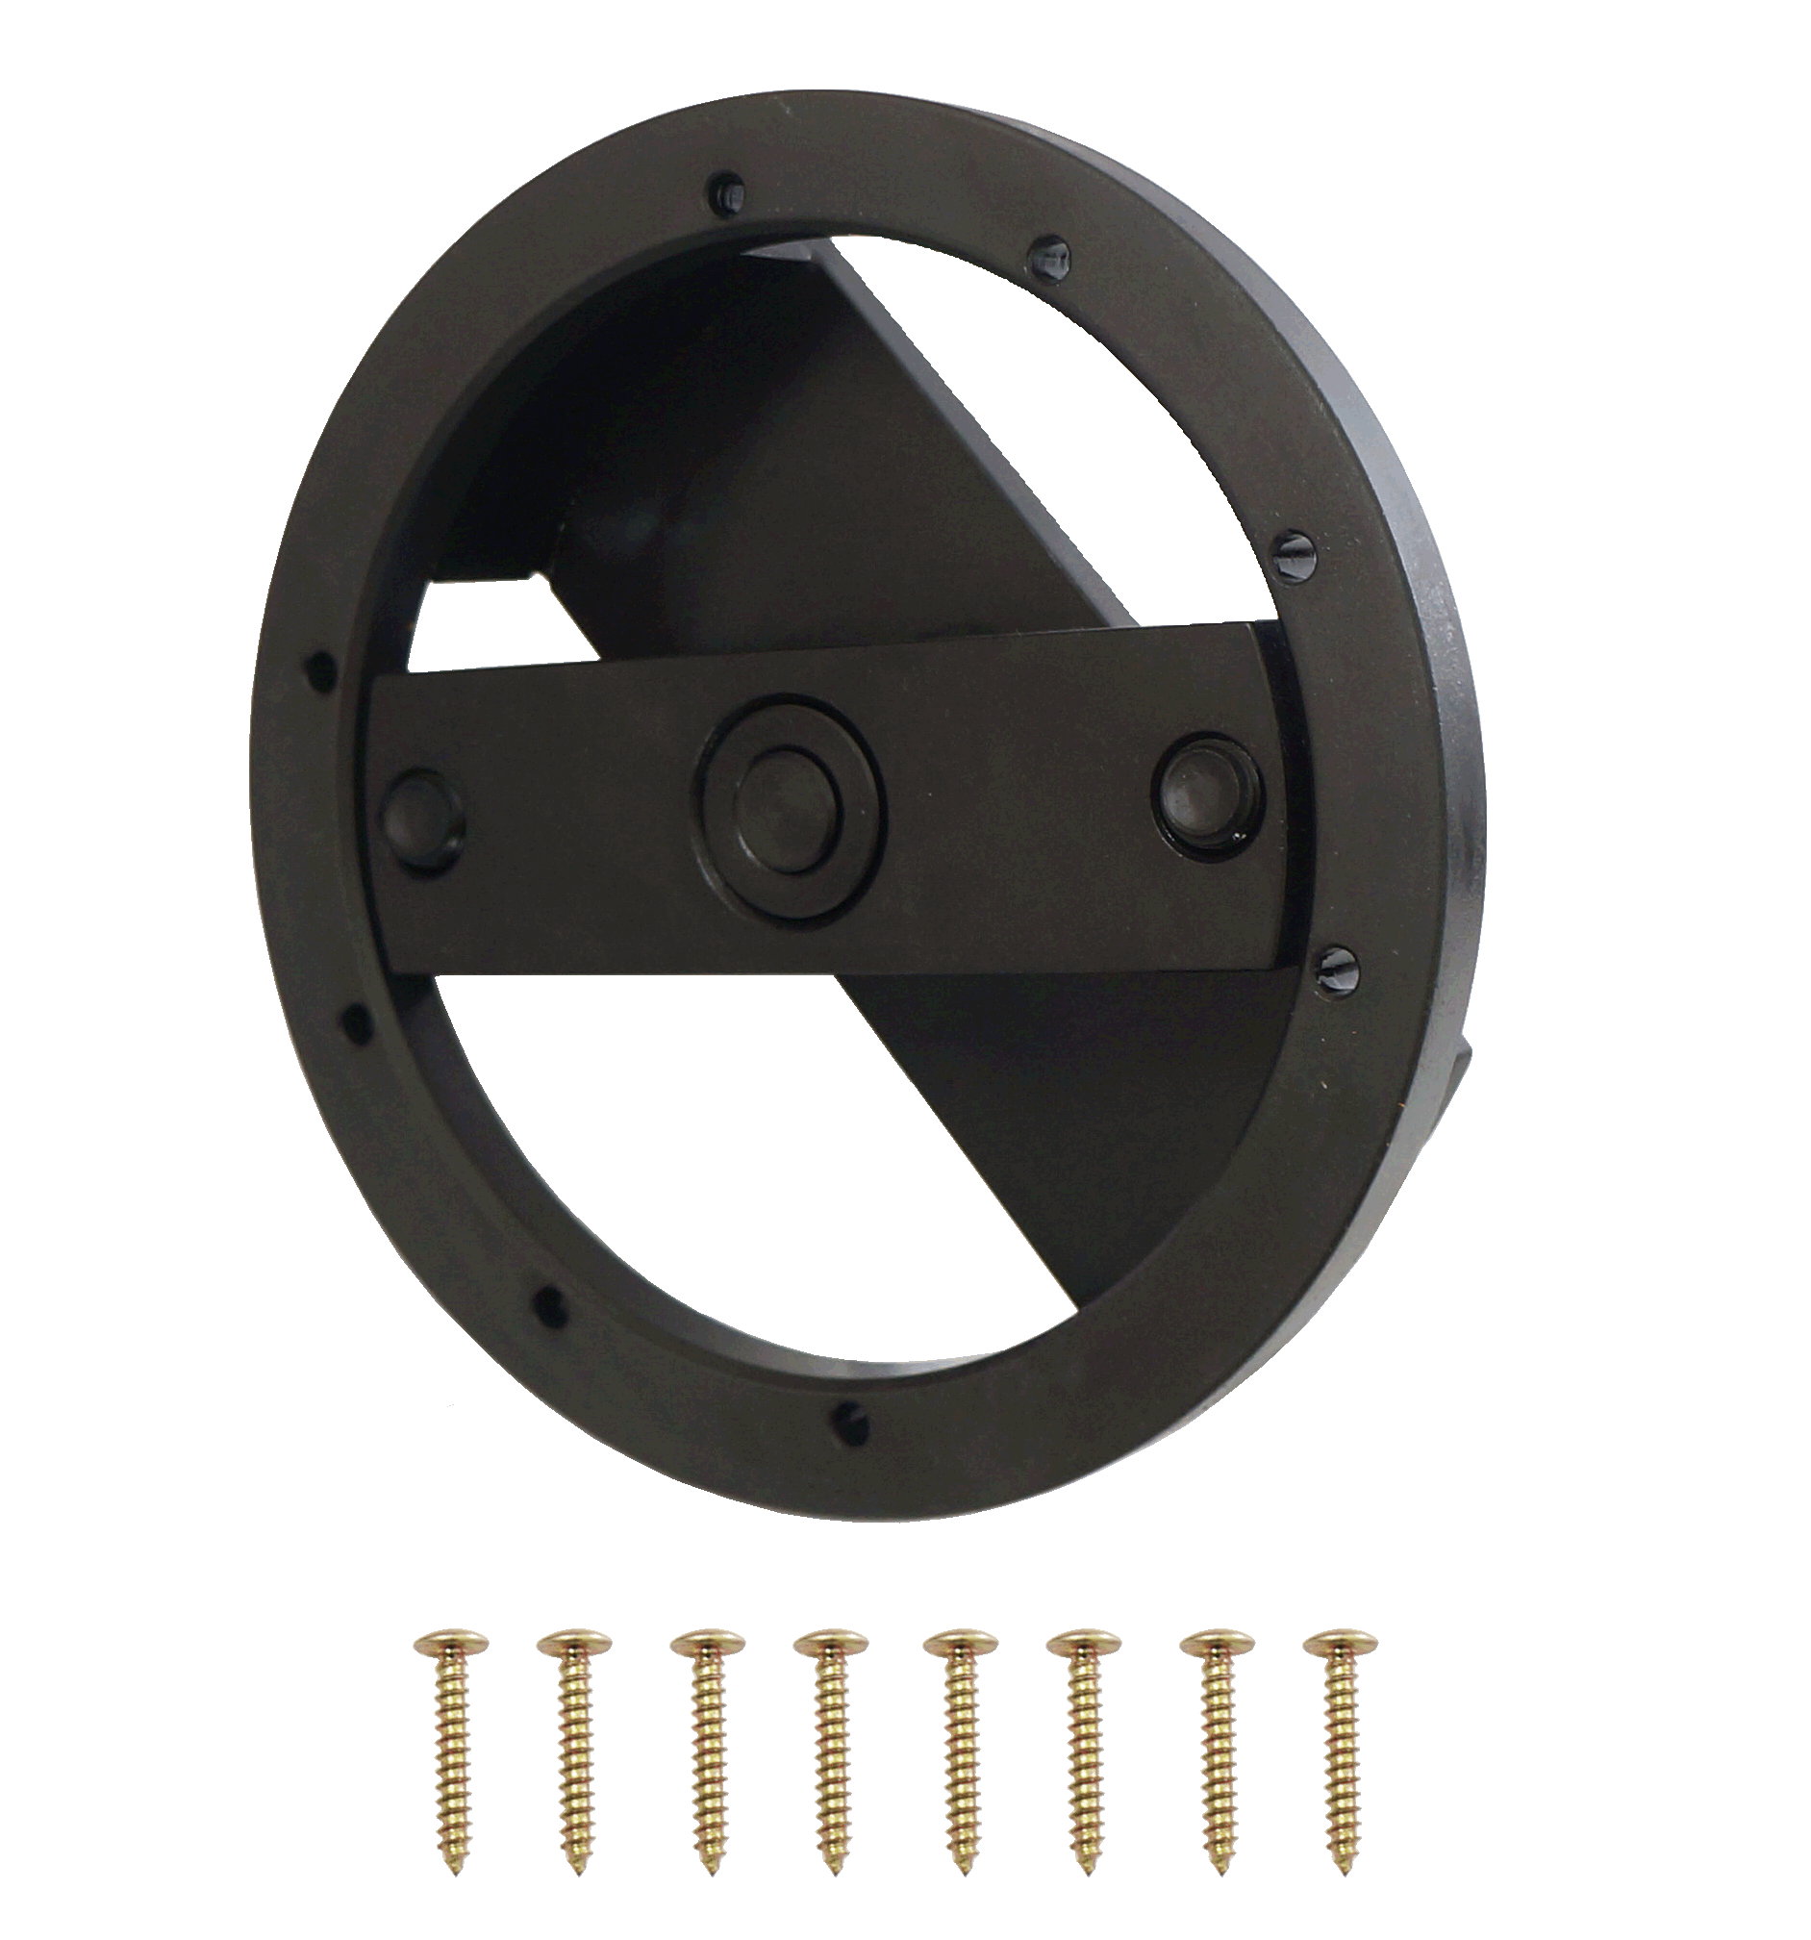
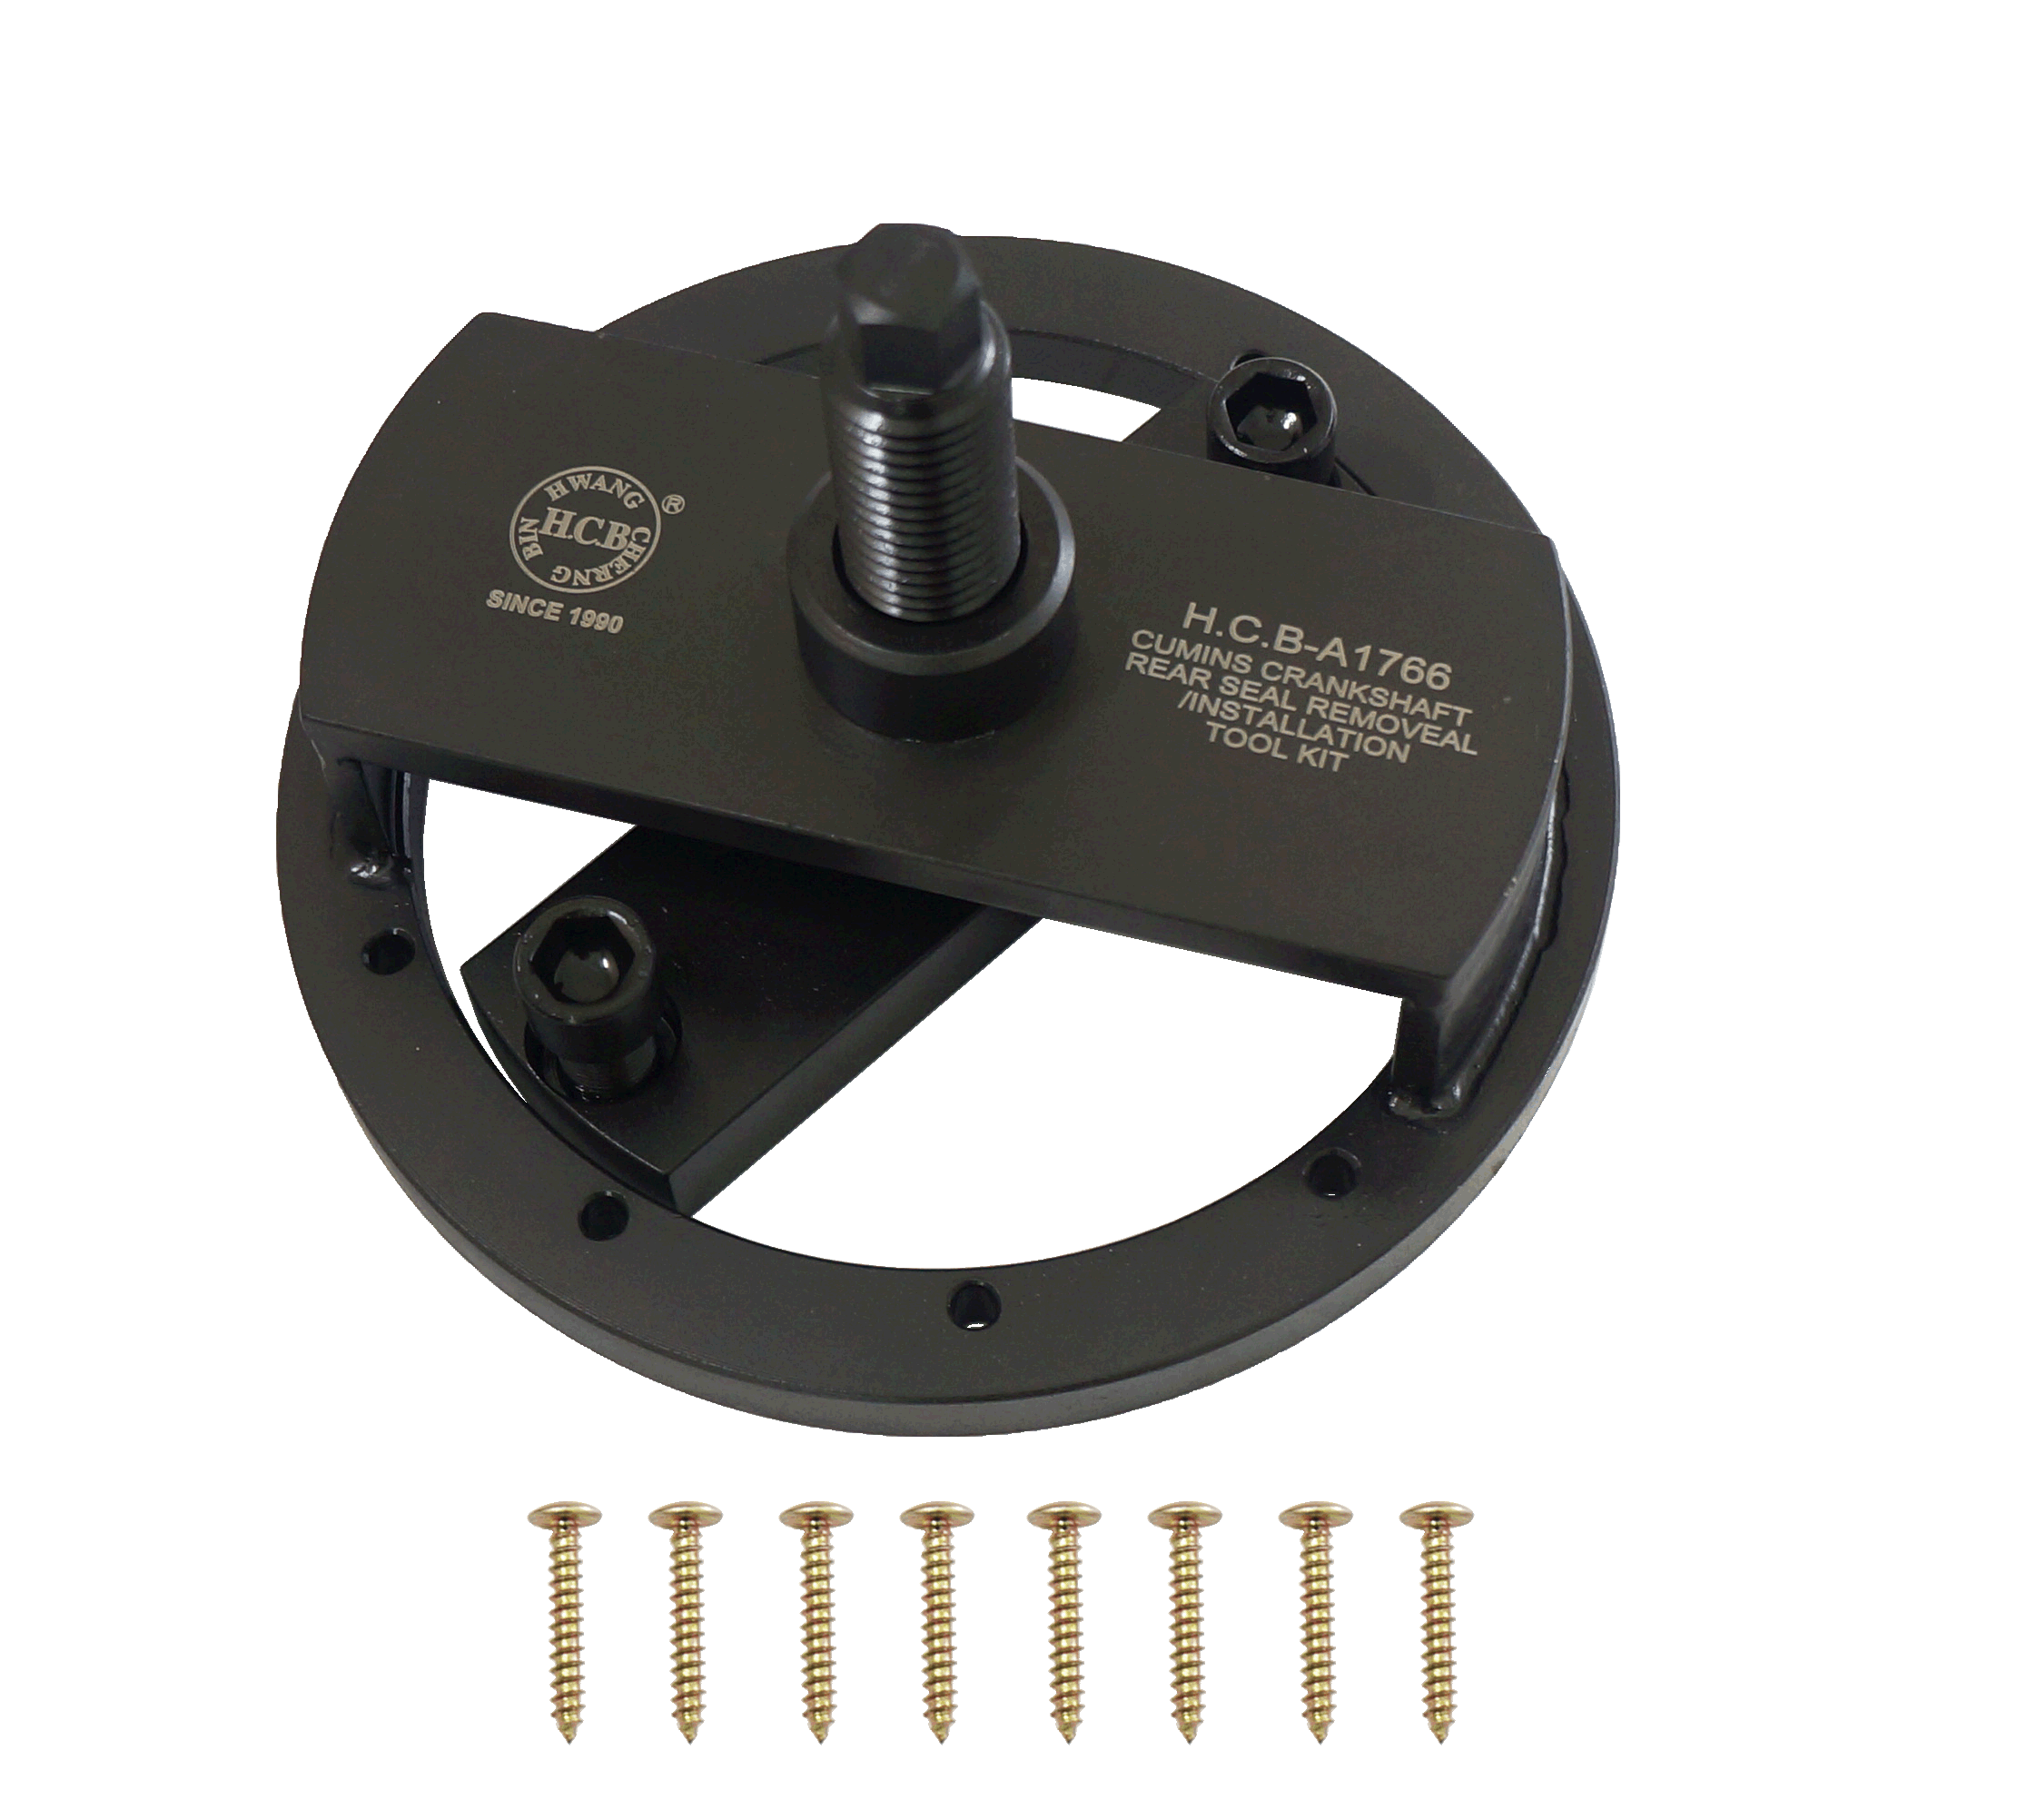

- 3164660 Cummins Rear Crankshaft Seal Remover & Installer Tool
- Applications include 1989-2016 Cummins 4BT 3.9L, B Series 5.9L, ISB 5.9L 6.7L and QSB 5.9L 6.7L, also Paccar engines PX-6.
- Seal # 5259499
- Use to remove and install seals without a wear sleeve such as 3934486 & 3926126.
- Use to install seals with or without a wear sleeve such as 3925529, 3934486 & 3926126 but it can not remove. There is no tool to remove the wear sleeve.

H.C.B-A1766

Cummins 3.5L ,3.9L, 5.9L & 6.7L Rear Crankshaft Seal Remover & Installer Tool

- 3164660 Cummins Rear Crankshaft Seal Remover & Installer Tool
- Applications include 1989-2016 Cummins 4BT 3.9L, B Series 5.9L, ISB 5.9L 6.7L and QSB 5.9L 6.7L, also Paccar engines PX-6.
- Seal # 5259499
- Use to remove and install seals without a wear sleeve such as 3934486 & 3926126.
- Use to install seals with or without a wear sleeve such as 3925529, 3934486 & 3926126 but it can not remove. There is no tool to remove the wear sleeve.

