
H.C.B-A1743
VOLVO
(S60 (11-)/ S80 (07-)/ S80L/ V60/ V70 (08-)/ XC60/ XC70 (08-)/ XC90 (03-)) POSITION SENSOR
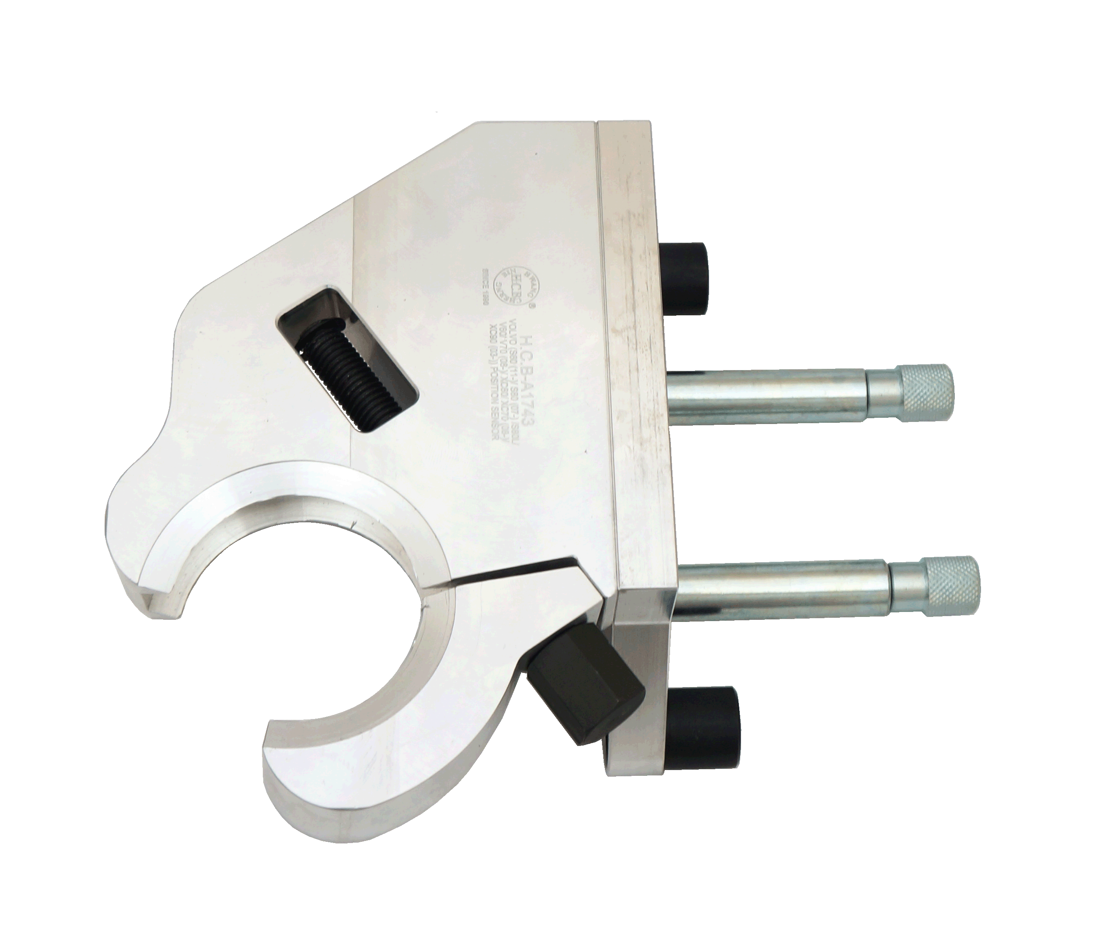

- Position sensor for positioning the engine A/C bracket while installing the bracket.
- Application: VOLVO S60 (11-)/ S80 (07-)/ S80L/ V60/ V70 (08-)/ XC60/ XC70 (08-)/ XC90 (03-)
- VOLVO OEM no. ref.: 9997262
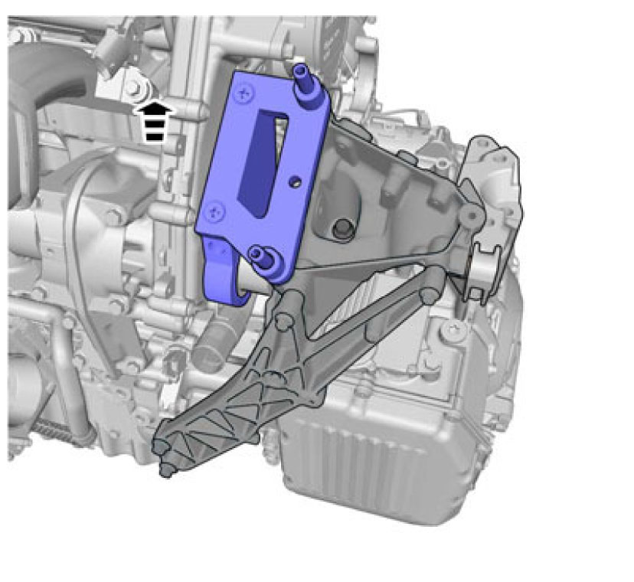
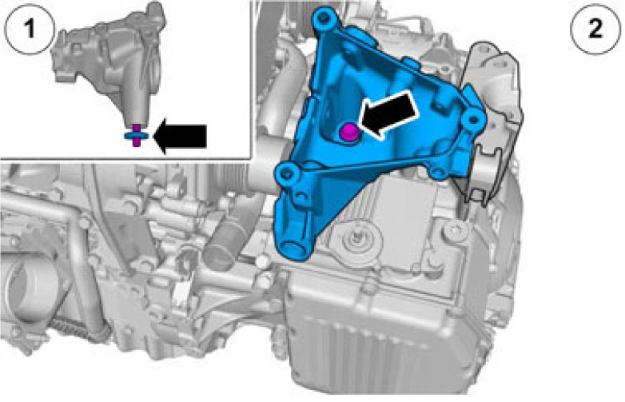
- Instructions:
- Tighten the bolt as the arrow shows manually.
- Install H.C.B-A1743 as picture shows.

- Tighten all the bolts of A/C bracket in order to designated torque value according to the original service manuals.

H.C.B-A1743
VOLVO
(S60 (11-)/ S80 (07-)/ S80L/ V60/ V70 (08-)/ XC60/ XC70 (08-)/ XC90 (03-)) POSITION SENSOR

- Position sensor for positioning the engine A/C bracket while installing the bracket.
- Application: VOLVO S60 (11-)/ S80 (07-)/ S80L/ V60/ V70 (08-)/ XC60/ XC70 (08-)/ XC90 (03-)
- VOLVO OEM no. ref.: 9997262
- Instructions:
- Tighten the bolt as the arrow shows manually.
- Install H.C.B-A1743 as picture shows.

- Tighten all the bolts of A/C bracket in order to designated torque value according to the original service manuals.

