**H.C.B-A1733**



**BMW SELF ADJUSTING CLUTCH (SAC) TOOL KIT**

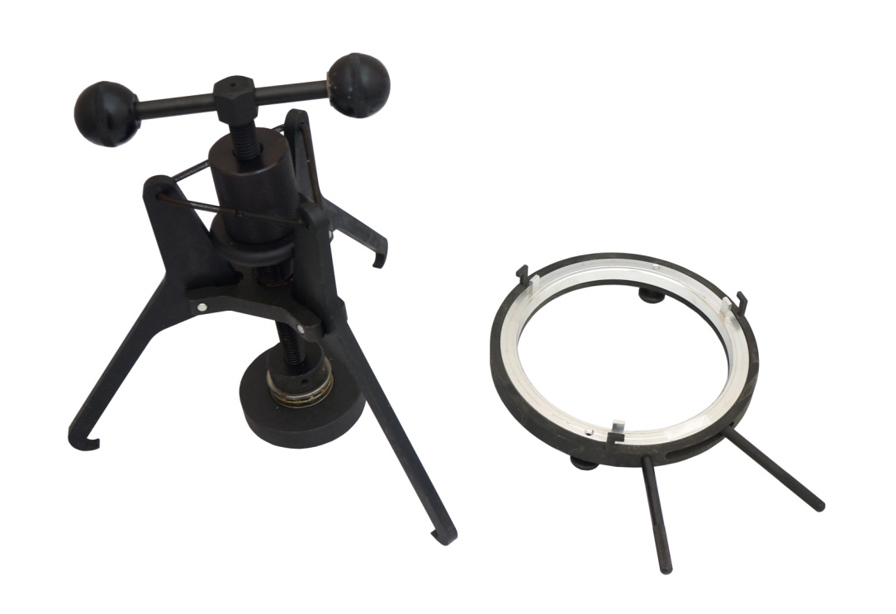

* Locating ring and clutch tensioner set used on the BMW Self-Adjusting Clutches (SAC) to reset and center the centering ring.
* **Application:** E34, E36, E38, E39, E46, E52, E53, E85, Z3 from 9/97 on.
* **BMW OEM no. ref.:** 212170, 212180