
H.C.B-A1719
VOLVO (C70/S70/V70/850) REAR SUSPENSION END LINKS REMOVER/INSTALLER
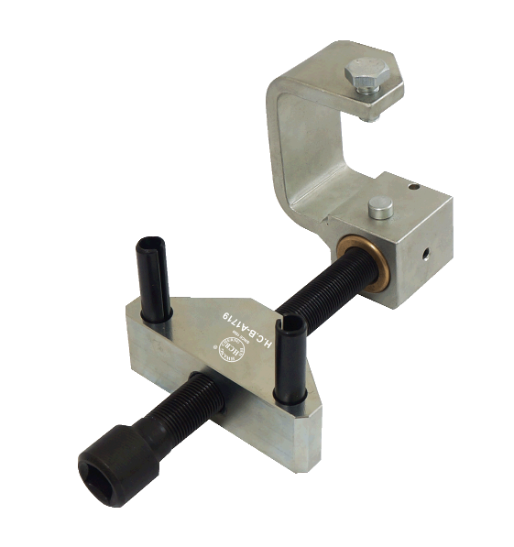
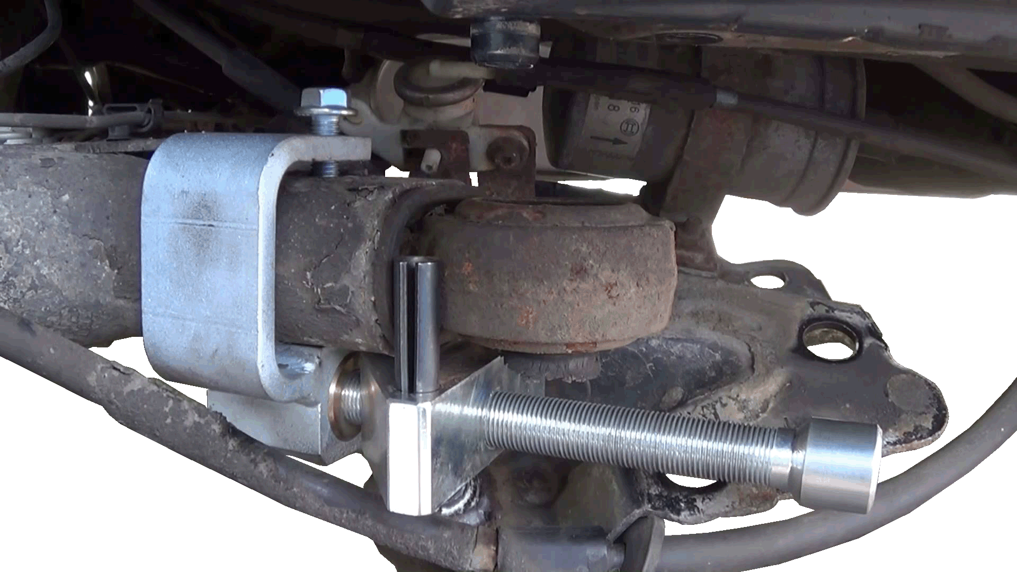

- This tool is used to remove / install the rear suspension end link.
- Application: VOLVO C70 Conv (-05), C70 Coupe (-02), S70, V70 (-00), 850
- VOLVO OEM no. ref.: 9995497

H.C.B-A1719
VOLVO (C70/S70/V70/850) REAR SUSPENSION END LINKS REMOVER/INSTALLER

- This tool is used to remove / install the rear suspension end link.
- Application: VOLVO C70 Conv (-05), C70 Coupe (-02), S70, V70 (-00), 850
- VOLVO OEM no. ref.: 9995497

