**H.C.B-A1715**



**VW SIDE SHAFT COUNTER HOLDER**

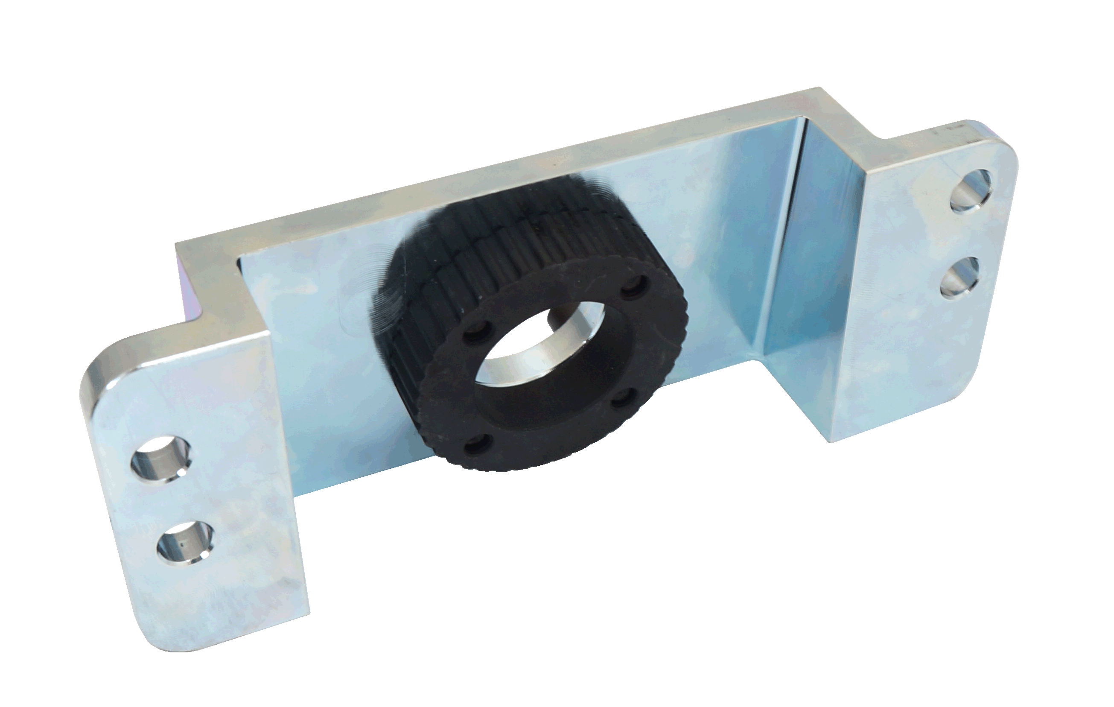

* **Used when loosening side shaft on 6-speed manual gearbox 0B2, four-wheel drive.**
* **Application:**  
  Audi A4 2008>, Audi A5 2008>, Audi A5 Cabriolet 2009>, Audi Q5 2009> with 6-speed manual gearbox 0B2, four wheel drive.
* **VW OEM no. ref.:** T40217

**H.C.B-A1715**



**VW SIDE SHAFT COUNTER HOLDER**



* **Used when loosening side shaft on 6-speed manual gearbox 0B2, four-wheel drive.**
* **Application:**  
  Audi A4 2008>, Audi A5 2008>, Audi A5 Cabriolet 2009>, Audi Q5 2009> with 6-speed manual gearbox 0B2, four wheel drive.
* **VW OEM no. ref.:** T40217