
H.C.B-A1709
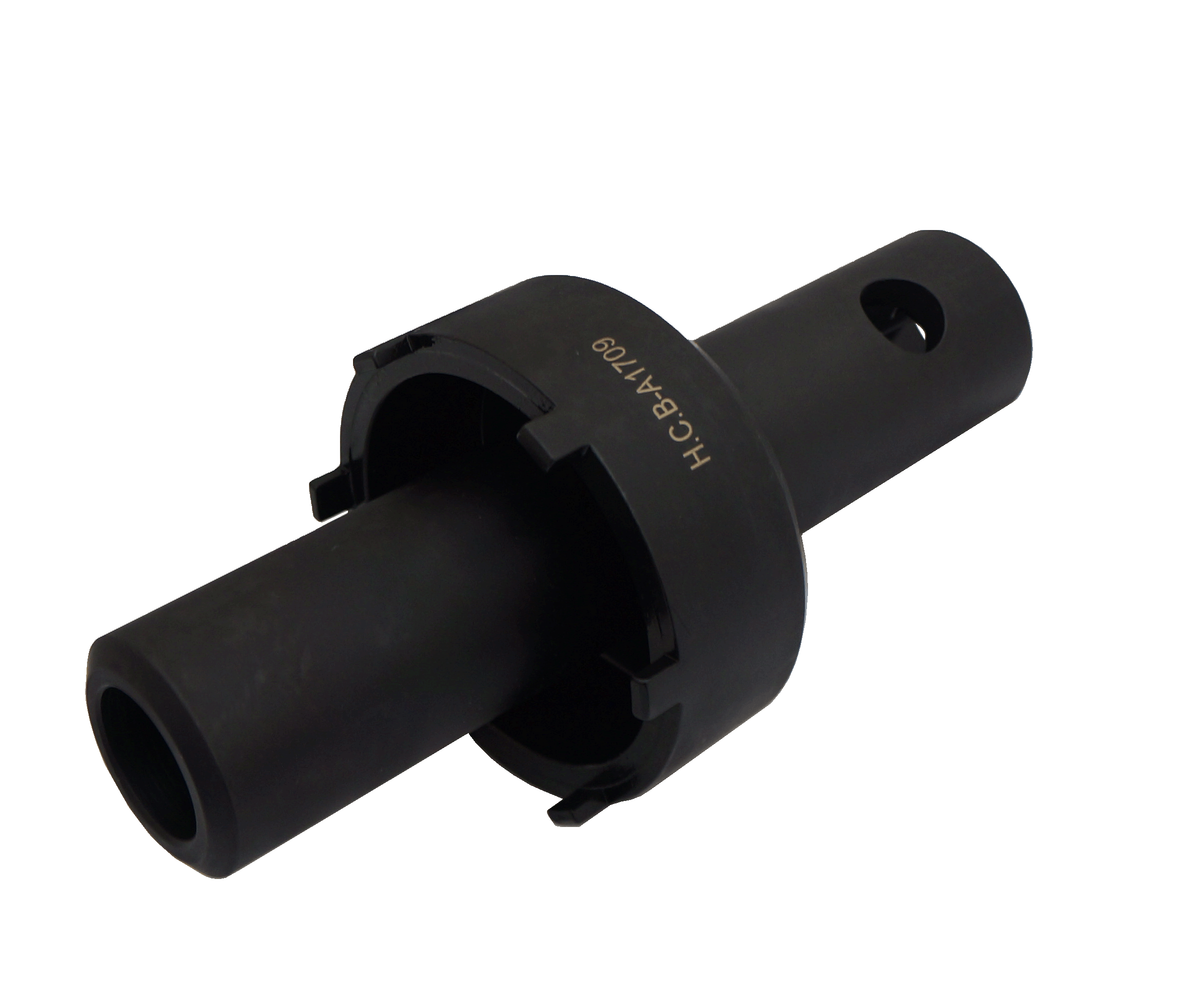
BENZ (2640/ 2644/ 2648) TRUCK TRAILER HEAD LIFTING AXLE NUT SOCKET (Dr. 3/4", 100 mm, 6 TEETH)

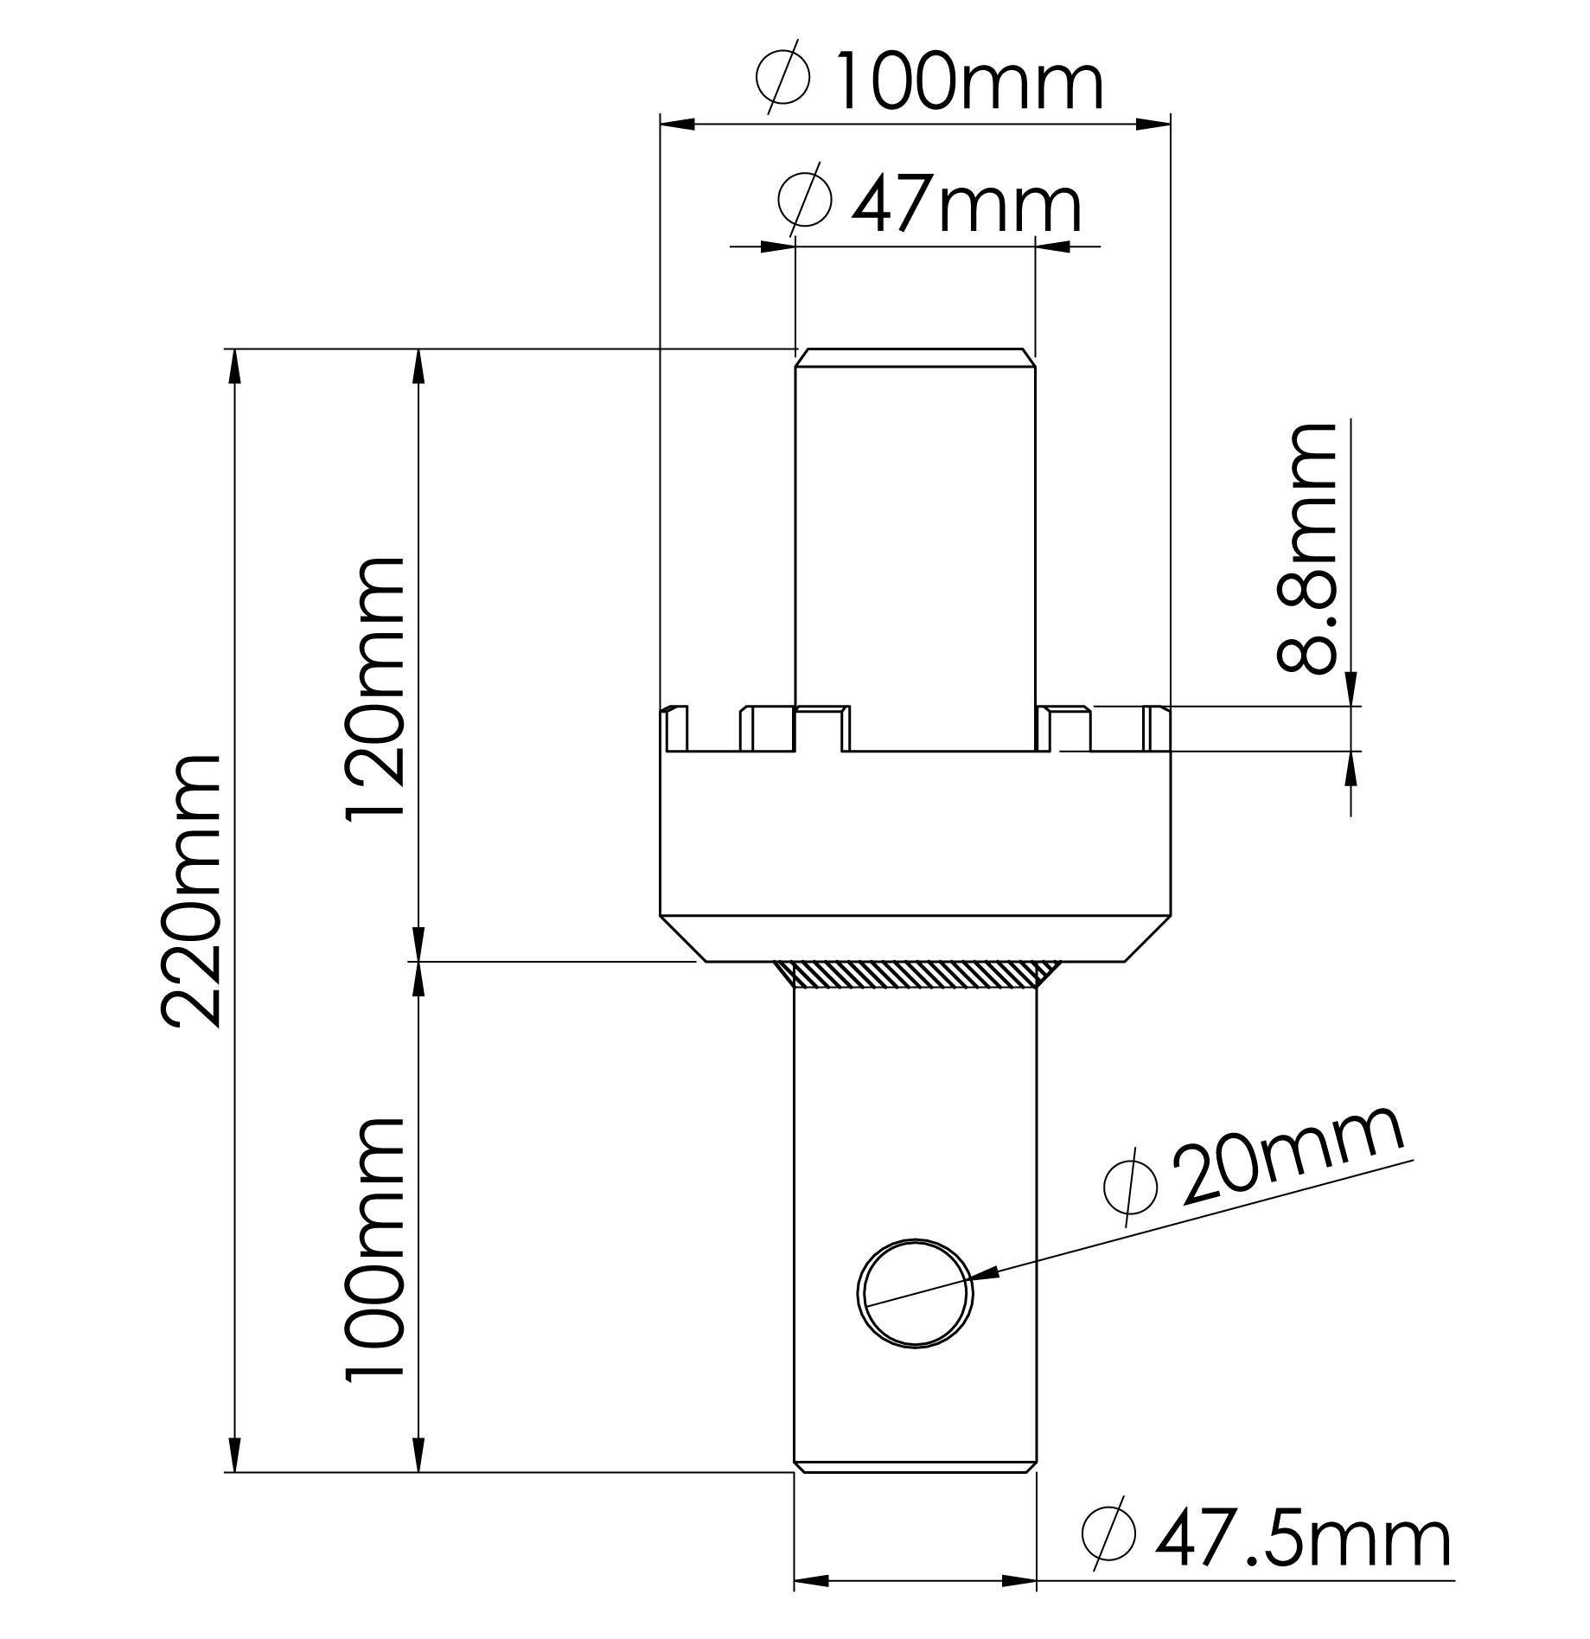
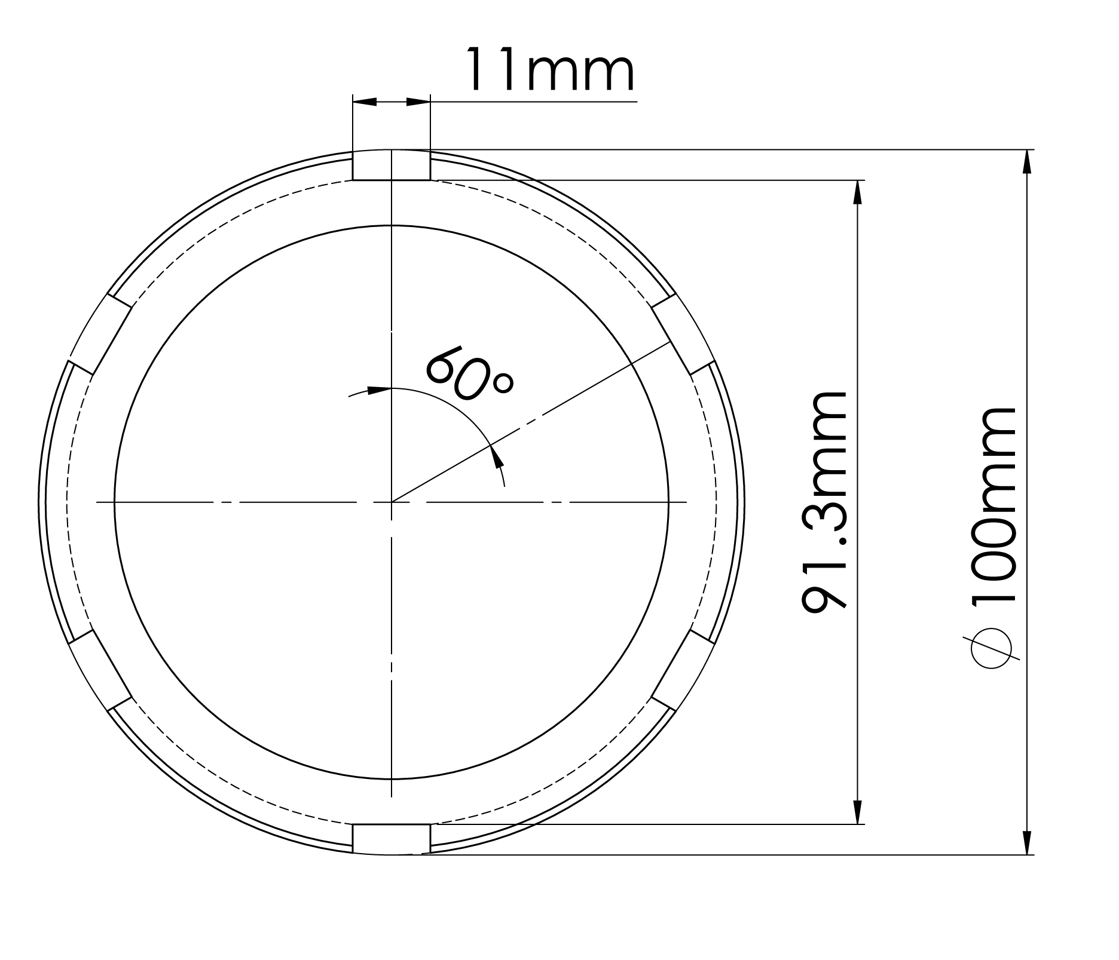

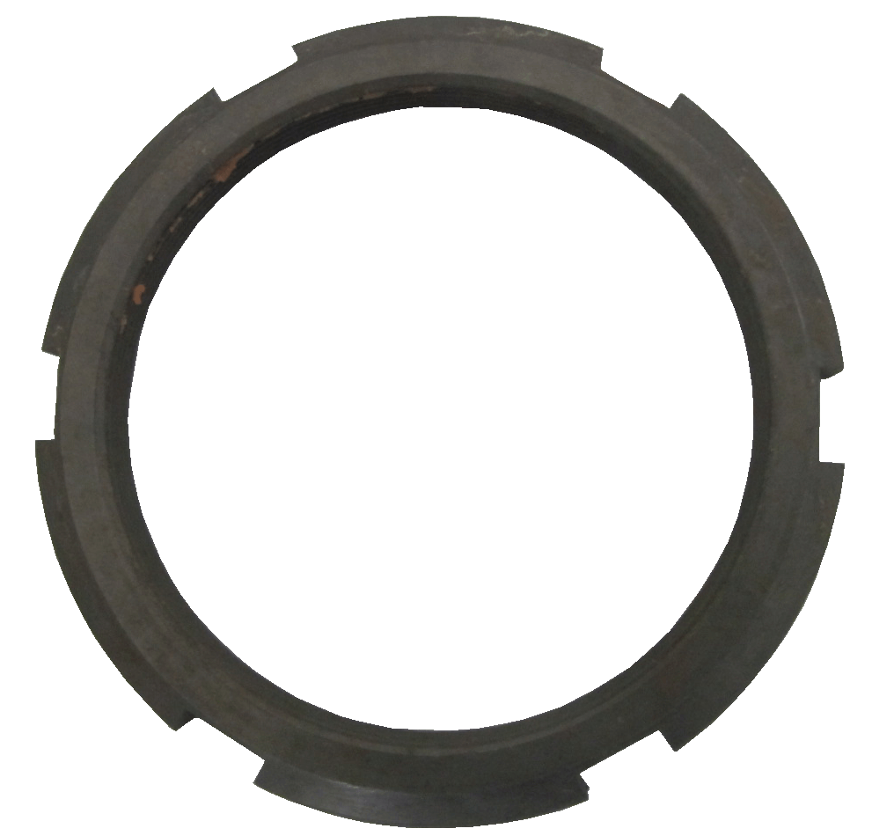
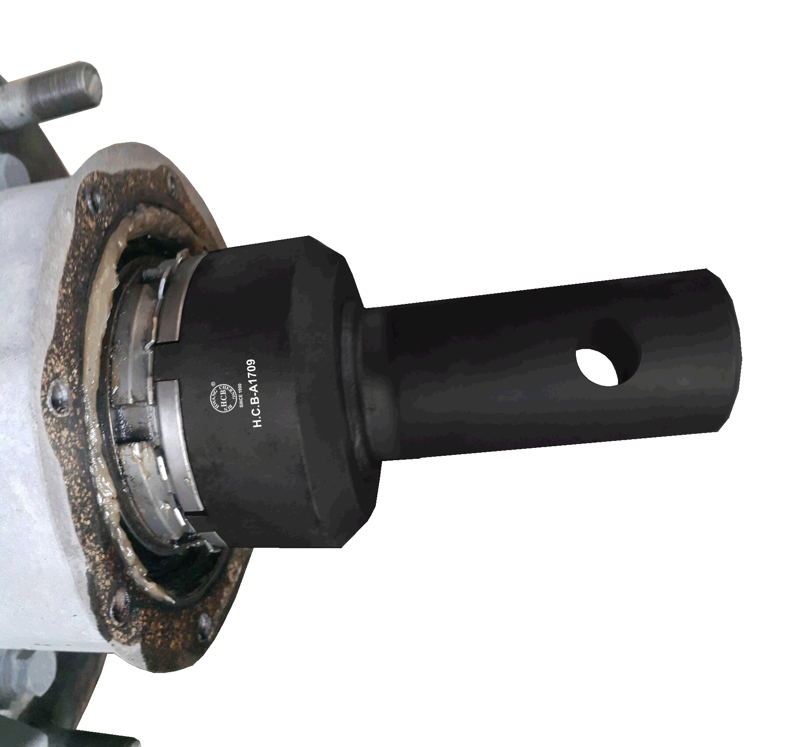

- Instruction: Socket for lift axle nut.
- Grooved lock nut.
- Application: BENZ trailer axle TZ5/2, TE5/2 with conventional bearing

Nut genuine no.:
A 976 356 00 26

