**H.C.B-A1706**

**VIDEO**

**BMW (E70/E90/E91/E92/E93/F01/F02/F04/F06/F07/F10/F13/F15/F16/ F18/F20/F21/F22/F23/F25)**

**FINAL DRIVE INPUT SHAFT OIL SEAL REMOVAL / INSTALLATION TOOL KIT**

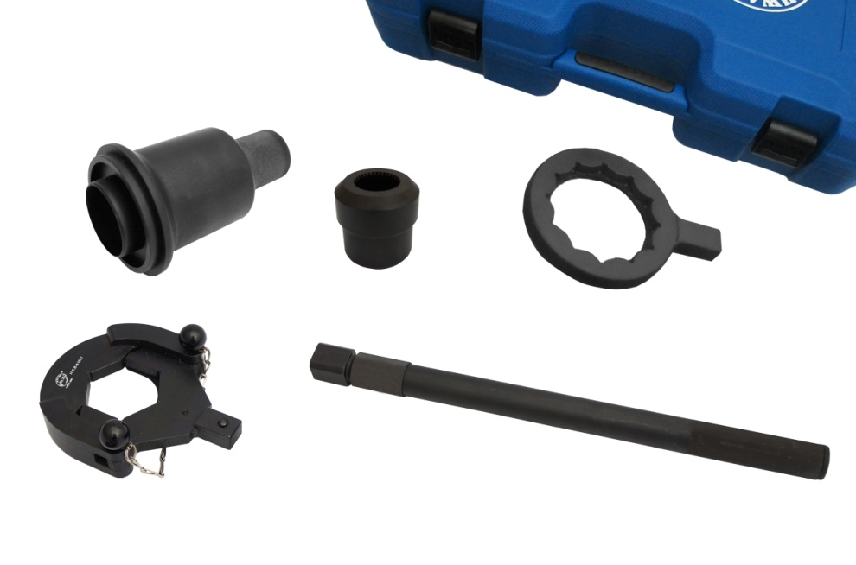

* This is a master tool kit for replacing the oil seal of BMW final drive input shaft .
* Application: BMW E70/E90/E91/E92/E93/F01/F02/F04/F06/F07/F10/F13/F15/F16/ F18/F20/F21/F22/F23/F25

E90 (335d, 335i,335ix)

E91 (335d, 335i,335ix)

E92 (335d, 335i,335ix)

E93 (335ix)

E92 with N54 B30 engine

* Consists of:

|  |  |  |
| --- | --- | --- |
| Item No. | Item | BMW OEM No. |
| H.C.B-A1649 | FINAL DRIVE INPUT SHAFT SEAL INSTALLER | 83 30 0 495 593 (335 080) |
| H.C.B-A1650 | FINAL DRIVE INPUT SHAFT SEAL SOCKET | 83 30 0 495 553 (335 060) |
| H.C.B-A1651 | DRIVESHAFT INNER NUT WRENCH | 83 30 0 495 551 (335 040) |
| H.C.B-A1652 | DIFFERENTIAL FLANGE NUT WRENCH | 83 30 0 495 552 (335 050) |
| H.C.B-A1653 | Extension bar for A1651 and A1652 | 83 30 0 495 554 (335 070) |

* Instructions:

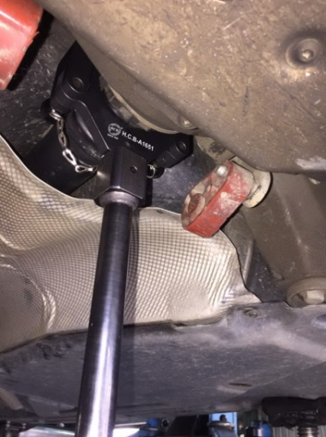

Step1:

Use H.C.B-A1651 wrench and H.C.B-A1653 extension bar to loosen the driveshaft inner nut (final drive end).

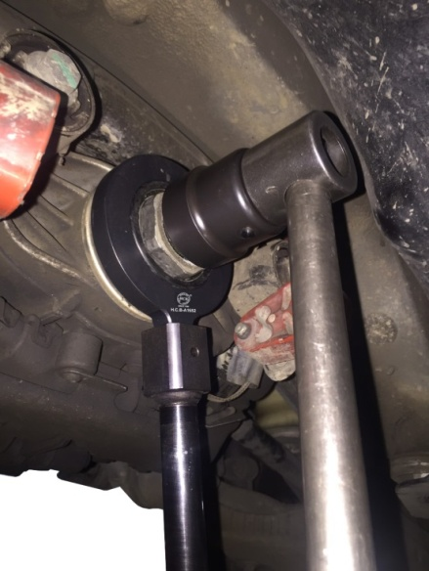

Step2:

Use H.C.B-A1650 socket to hold the input shaft. And then use H.C.B-A1652 wrench and A1653 extension bar to loosen loosening the flange nut.

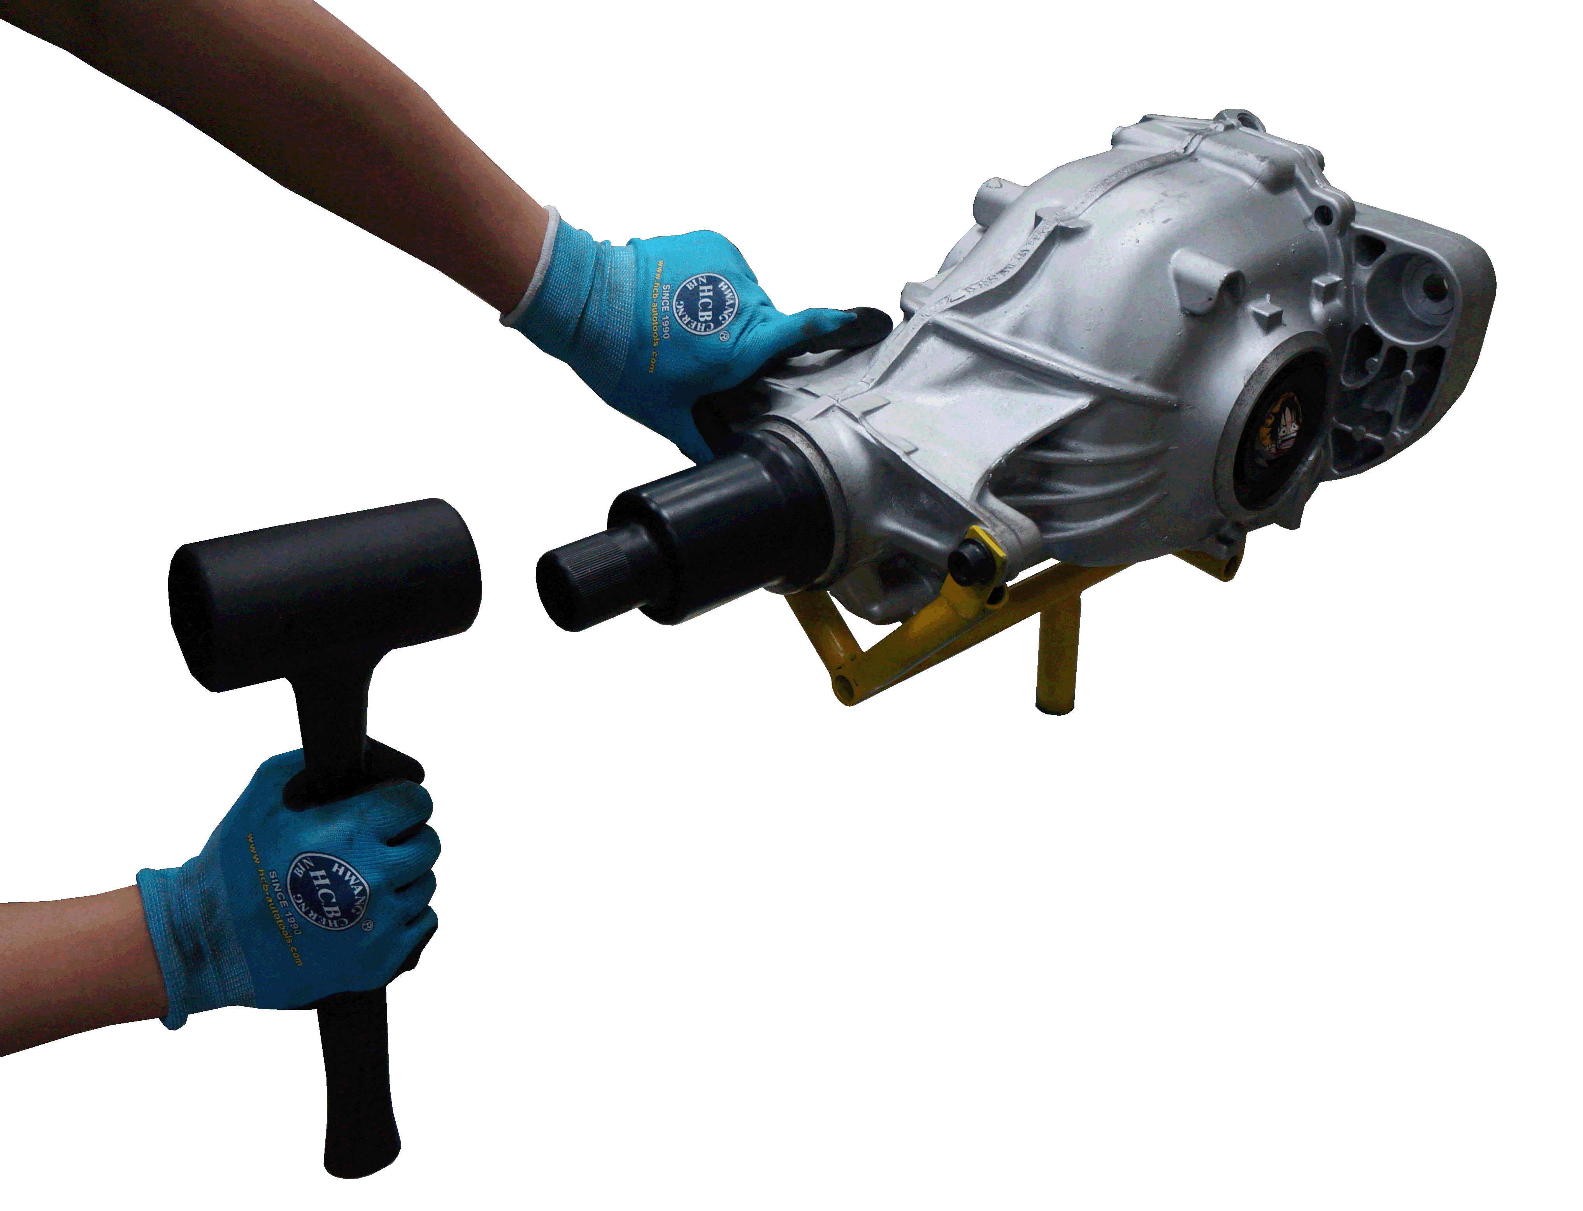

Step3:

Final drive input shaft oil seal is reachable. Remove the old, damaged oil seal, and use H.C.B-A1649 to install the new oil seal.

Step4:

Reverse step 2 and 1 in order to complete the servicing.