**H.C.B-A1702**



**BENZ DIESEL PRE-CHAMBER RETAINER RING SOCKET (Dr. 1/2” x 58 TEETH)**

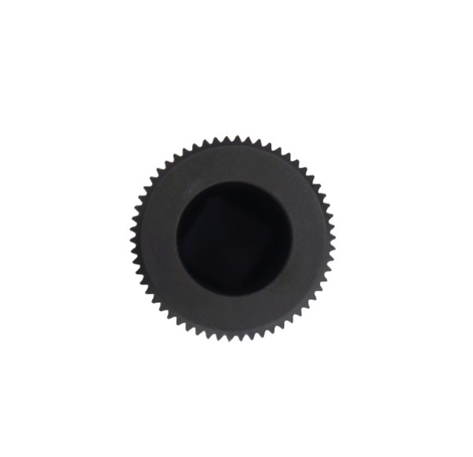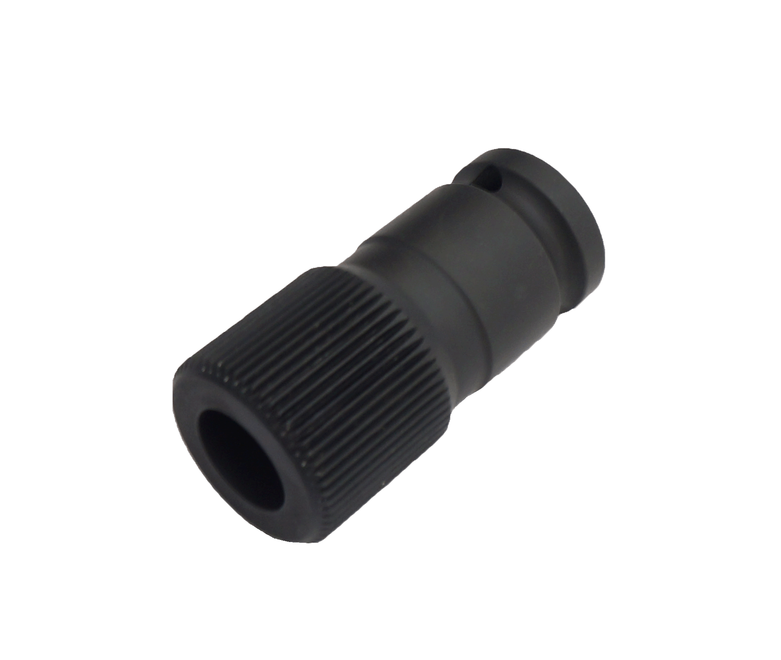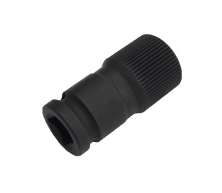

* 1/2" Drive multi-spline socket d:ψ15 mm x 58L mm
* Used for removing pre-chamber retainer ring on indirect injection diesel engines.
* Application: Mercedes diesel engines OM601/OM602/OM602.9/OM603/
* OM604/OM605/OM606/OM617.95/OM661/OM662.
* Spline with 28 mm outside diameter.
* BENZ OEM no. ref.: 604-589-01-09-00

**H.C.B-A1702**



**BENZ DIESEL PRE-CHAMBER RETAINER RING SOCKET (Dr. 1/2” x 58 TEETH)**



* 1/2" Drive multi-spline socket d:ψ15 mm x 58L mm
* Used for removing pre-chamber retainer ring on indirect injection diesel engines.
* Application: Mercedes diesel engines OM601/OM602/OM602.9/OM603/
* OM604/OM605/OM606/OM617.95/OM661/OM662.
* Spline with 28 mm outside diameter.
* BENZ OEM no. ref.: 604-589-01-09-00