
H.C.B-A1695
VOLVO DIFFERENTIAL FLANGE NUT SOCKETS (Dr. 1/2”)(H15/H18)
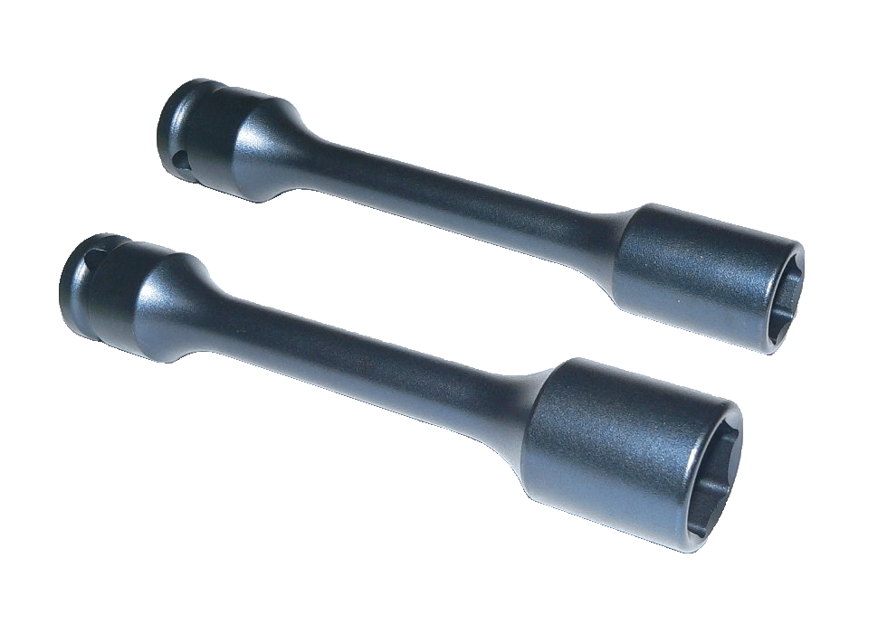

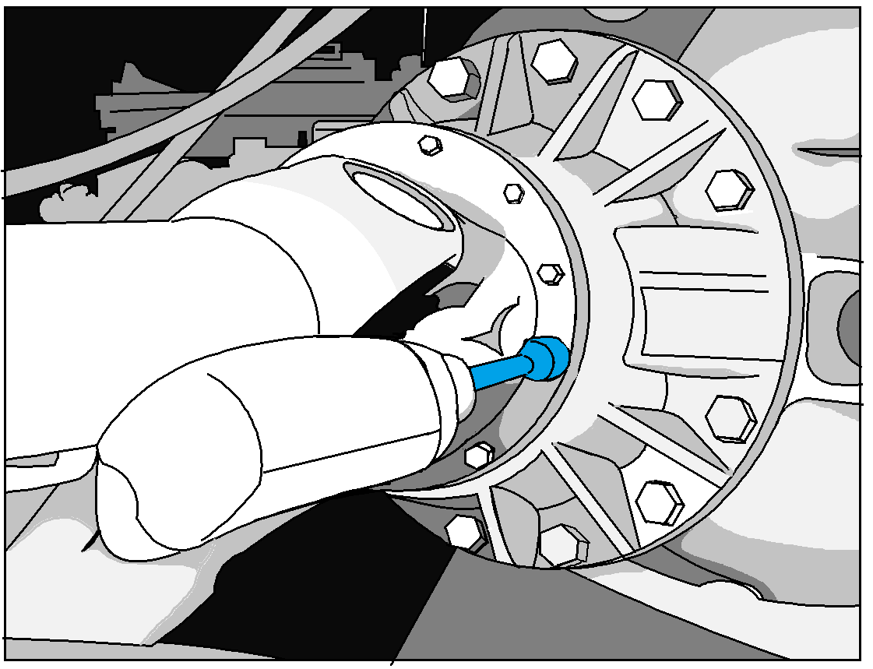

■Dr. 1/2” Impact sockets for VOLVO truck differential flange nut.
■Suitable to use with air impact wrench for quick removal.
■If the disassembly of drive shaft is required, these sockets can remove the differential flange nuts to detach the drive shaft.
■Dimensions: H15 × 150 mmL
H18 × 150 mmL
■VOLVO OEM no. ref.: 9996369, 9996785
■Application: VOLVO truck

H.C.B-A1695
VOLVO DIFFERENTIAL FLANGE NUT SOCKETS (Dr. 1/2”) (H15/H18)

■Dr. 1/2” Impact sockets for VOLVO truck differential flange nut.
■Suitable to use with air impact wrench for quick removal.
■If the disassembly of drive shaft is required, these sockets can remove the differential flange nuts to detach the drive shaft.
■Dimensions: H15 × 150 mmL
H18 × 150 mmL
■VOLVO OEM no. ref.: 9996369, 9996785
■Application: VOLVO truck

