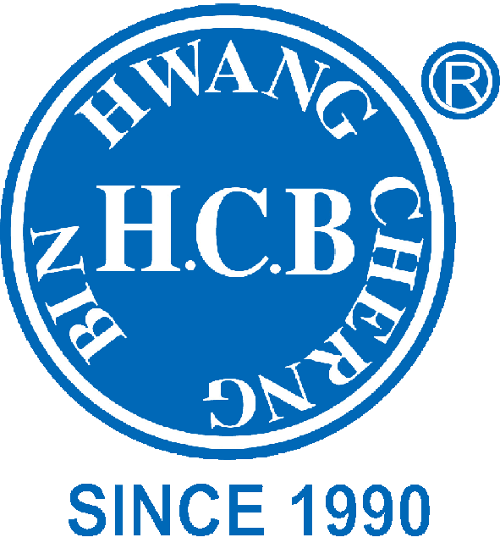
H.C.B-A1690
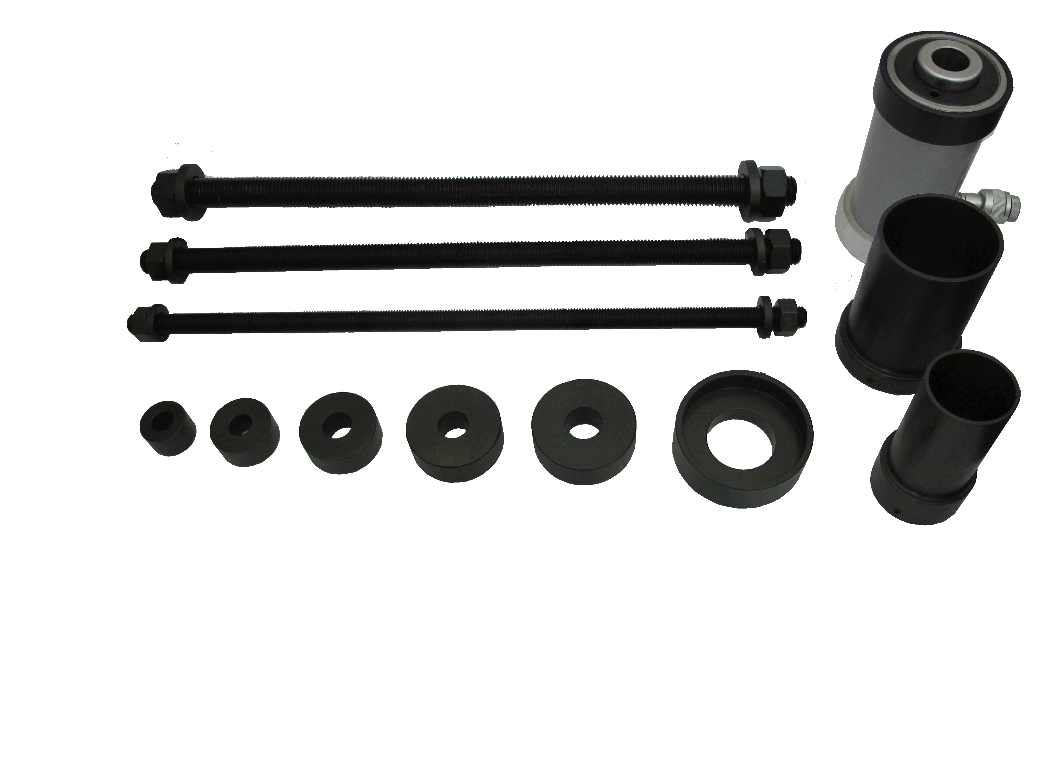
UNIVERSAL TRUCK BUSH REPLACEMENT TOOL KIT (W/18 TONS HYDRAULIC )

- H.C.B-A1690 is a time saving tool for bushings, axles, bearings replacement. It makes bushings, axles, bearings replacement far faster than old-fashion way, and more importantly it saves labor.

- Using H.C.B-A1690 18 ton capacity hollow bore cylinder and the comprehensive set of accessories contained within the kits the equipment can be easily used on any vehicle and give the following major benefits:

- All makes and models of HGV catered for safe, simple and speedy hands free process

- Up to 60% time and labor cost saving on traditional methods

- Can be easily and cheaply upgraded should new vehicle types be introduced onto the market.

- Applications:
H.C.B-A1690 is used for a wide variety of applications on truck and bus. It is suitable for brands like Scania, Volvo, MAN, Mercedes, Renault, Iveco and DAF.

- Sequence of operation:

- Several vehicle makes now use met-elastic spring eye bushes, thus H.C.B has developed H.C.B-1181 series for spring eye bush replacement.

- PLEASE NOTE THAT THIS KIT DOES NOT INCLUDE A PUMP TO OPERATE IT. If you already have a H.C.B pump or a pump operating at 700 Bar/10,000 PSI, this can be used. H.C.B recommended pump option for this kit is A3036/B3036 air/hydraulic foot pump.

- H.C.B-A1690 contains:

Cylinder: H.C.B-A1690-15-2 (Capacity: 18 tons, stroke: 50 mm)

Sleeve:
H.C.B-A1690 -1 (Ø90*73*117 L mm)
H.C.B-A1690 -2 (Ø64*49*117 L mm)

Rod:
H.C.B-A1690-3 (M16*P2.0*500L)
H.C.B-A1690-4 (M20*P2.5*500L)
H.C.B-A1690-5 (M24*P3.0*500L)

Press plates:
H.C.B-A1690-09 (Ø35 mm / Ø16 mm / 22 L mm)
H.C.B-A1690-10 (Ø55 mm / Ø20 mm / 22 L mm)
H.C.B-A1690-11 (Ø70 mm / Ø24 mm / 24 L mm)
H.C.B-A1690-12 (Ø45 mm / Ø16 mm / 22 L mm)
H.C.B-A1690-13 (Ø65 mm / Ø20 mm / 24 L mm)
H.C.B-A1690-14 (Ø90/80 mm / Ø45 mm / 30 L mm)

- BUSHING TOOL KIT IMPORTANT SAFETY INSTRUCTIONS :

Thank you for purchasing H.C.B-A1690. Please read the following safety instructions to ensure the best use and longest service life for the equipment.

(1) Keep these instructions and other applicable H.C.B manuals during the life of this equipment and make sure they are available for all personnel that install, use and maintain this equipment
(2) Before commencing work with this equipment, the operator should wear all personal protective equipment recommended by his/her company and should wear safety glasses/visa at all times.
(3) Read all relevant operating and safety instructions provided with these kits prior to use. H.C.B is not responsible for any personal injury or machine damages that can occur if these instructions are not followed.
(4) Never allow unauthorized personnel to use the equipment.
(5) Ensure that the maximum rated loads for the screw rods provided are not exceeded, as stated on the cylinder, and in the box These are: M12 rod: max load 6 ton (12.9) M16 rod: max load 10 ton (12.9) M20 rod: max load 16 ton (10.9) M24 rod: max load 23 ton (10.9) M30 rod: max load 36 ton (10.9) M36 rod: max load 52 ton (10.9) M48 rod: max load 71 ton (8.8) (6) Never tamper with the safety valve setting in the hydraulic Pump.
(7) Ensure threads are clean and free from dirt at all times. Never use rods that are bent or have damaged threads
(8) Ensure cylinder, rod, adaptors, and bush, are aligned as - accurately as possible before applying full stated maximum loads.
(9) Never stand in line with application when applying force to the equipment.
(10) Ensure no unauthorized personnel stay within the risk area when the equipment is in use.
(11) Never leave the working area with the equipment loaded.
(12) Always use a genuine H.C.B power source to operate the kit equipment.
(13) Maintenance should be made by authorized service workshop
(14) H.C.B is not responsible for any personal injury or machine damages that can occur due to use of not approved or rebuilt equipment.

