
H.C.B-A1679
DAF 17 TONS (LF55) & (CF65) TRANSMISSION INPUT SHAFT OIL SEAL INSTALLER

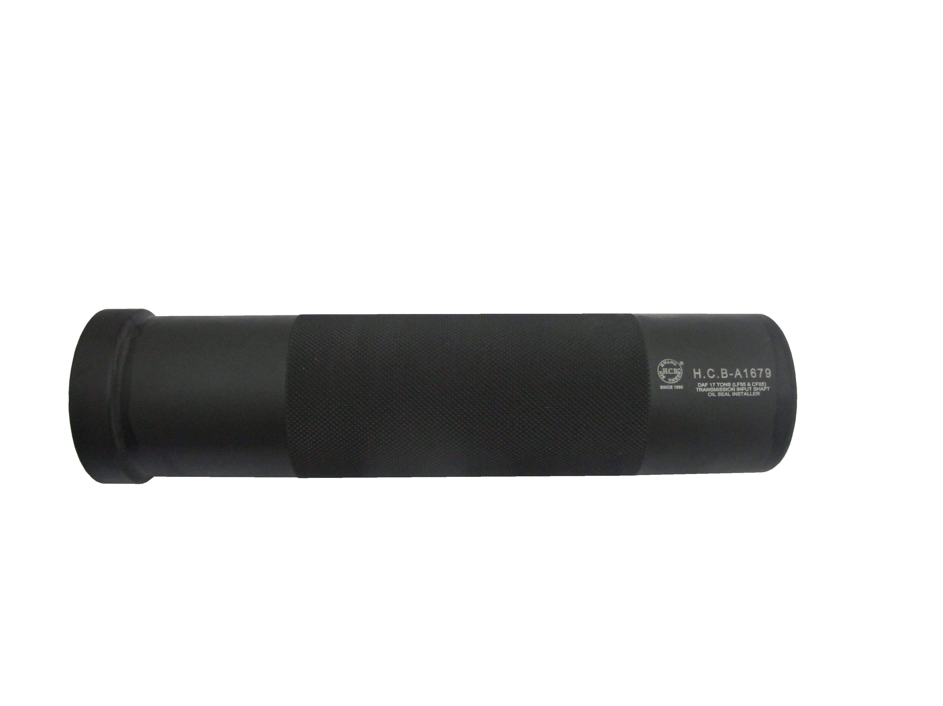

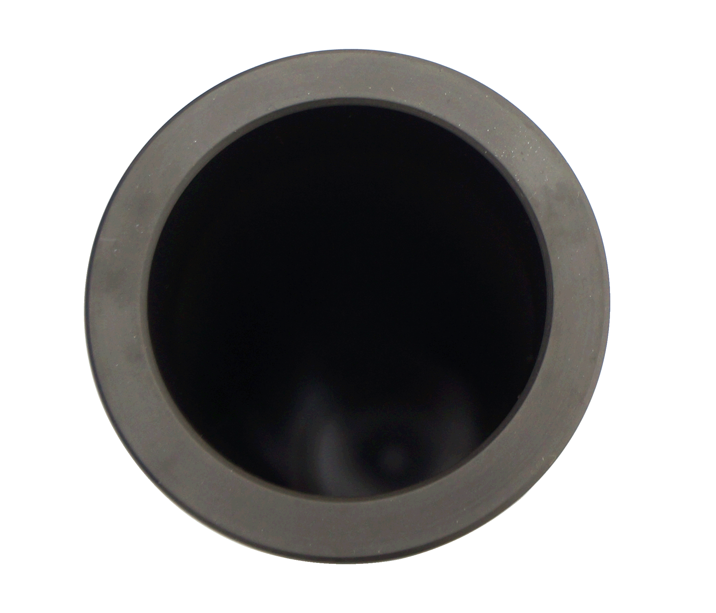

- Instructions: Due to the convex of front gear of input shaft, it won’t be possible to install the new oil seal if this tool is unavailable.
This tool is designed to avoid the front gear for installing the oil seal accurately back to its place.

- Application: DAF 17 tons (LF55)
DAF 17 tons (CF65)

H.C.B-A1679
DAF 17 TONS (LF55) & (CF65) TRANSMISSION INPUT SHAFT OIL SEAL INSTALLER

- Instructions: Due to the convex of front gear of input shaft, it won’t be possible to install the new oil seal if this tool is unavailable.
This tool is designed to avoid the front gear for installing the oil seal accurately back to its place.

- Application: DAF 17 tons (LF55)
DAF 17 tons (CF65)

