
H.C.B-A1675
VOLVO TRUCK CAMSHAFT LIFTING TOOL
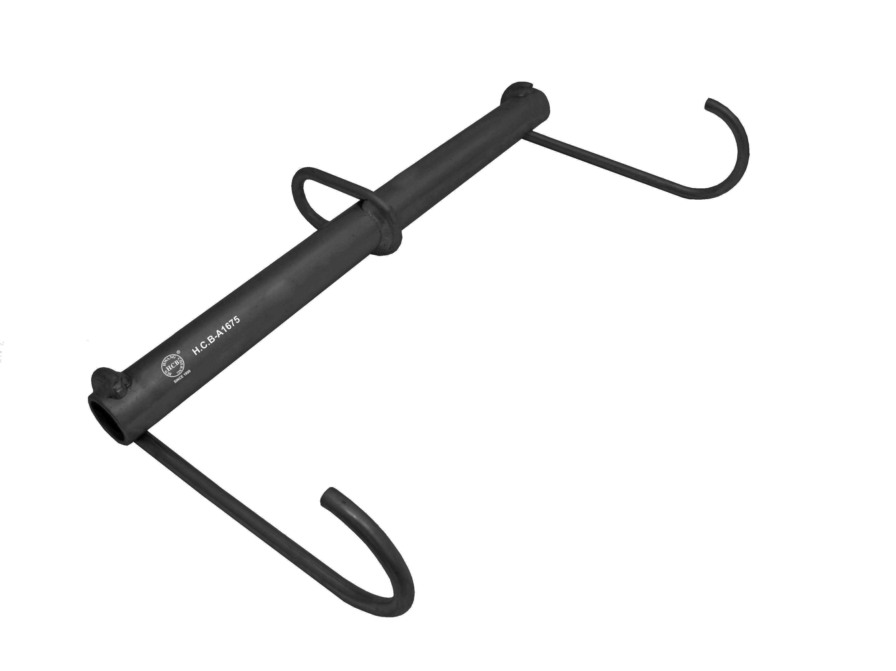

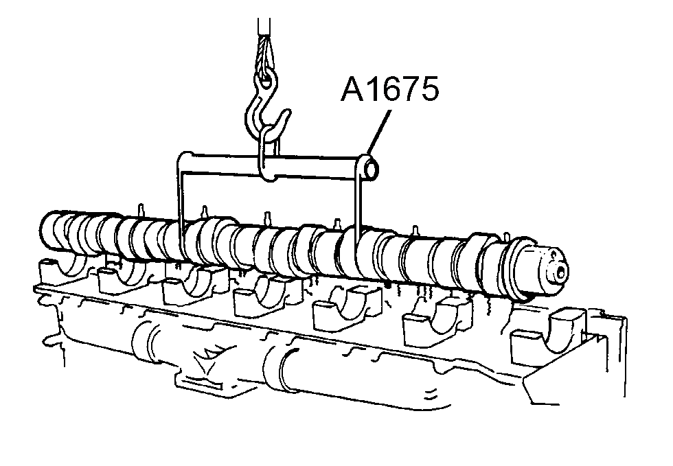

■Instructions: While servicing a damaged engine, use this lifting tool with a lifting device to hang the camshaft up to avoid collision. Make marks before removing the camshaft for quick and precise installation.
■OEM No.: 9998264
■Application: All Volvo (Ex: D12, D13 engine)
※Load capacity: 40KG. For lifting the camshaft only. NOT suitable for other purposes.

