
H.C.B-A1669
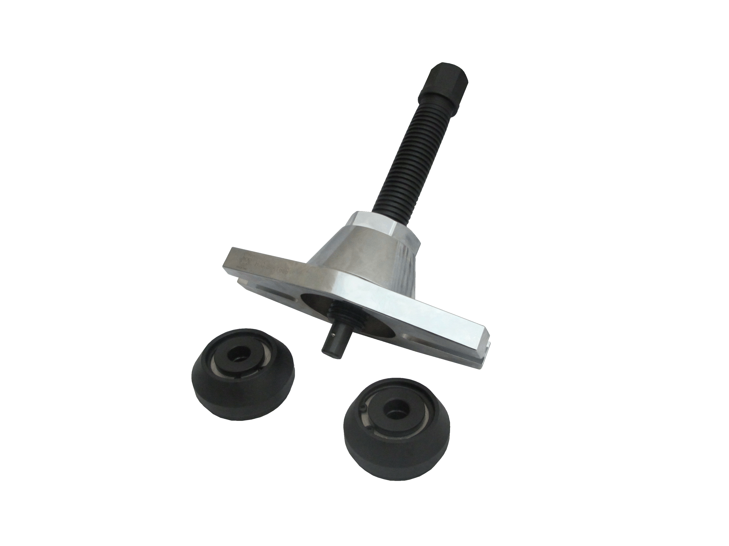
UNIVERSAL TRUCK REAR WHEEL HUB PULLER

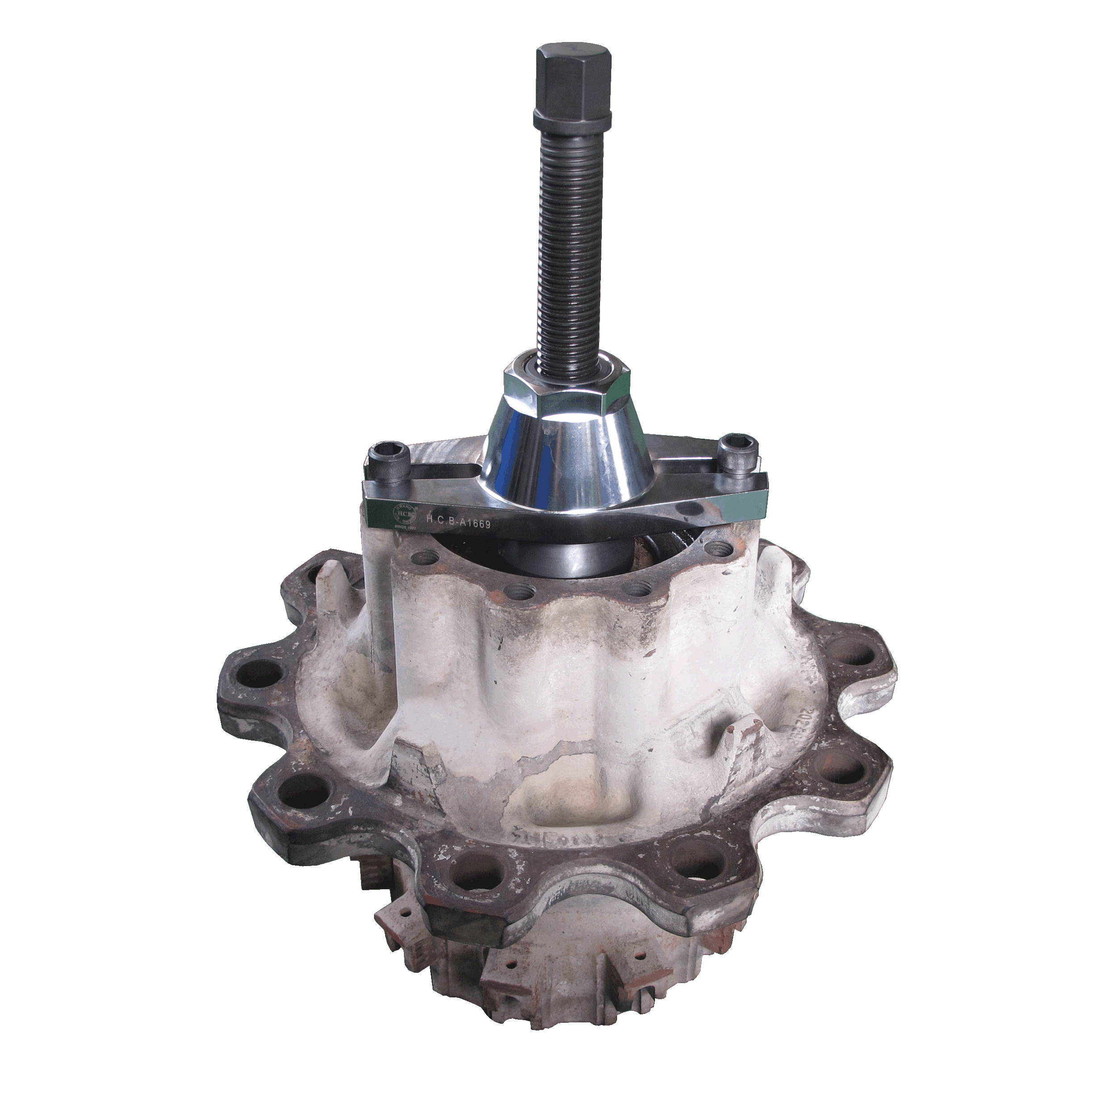

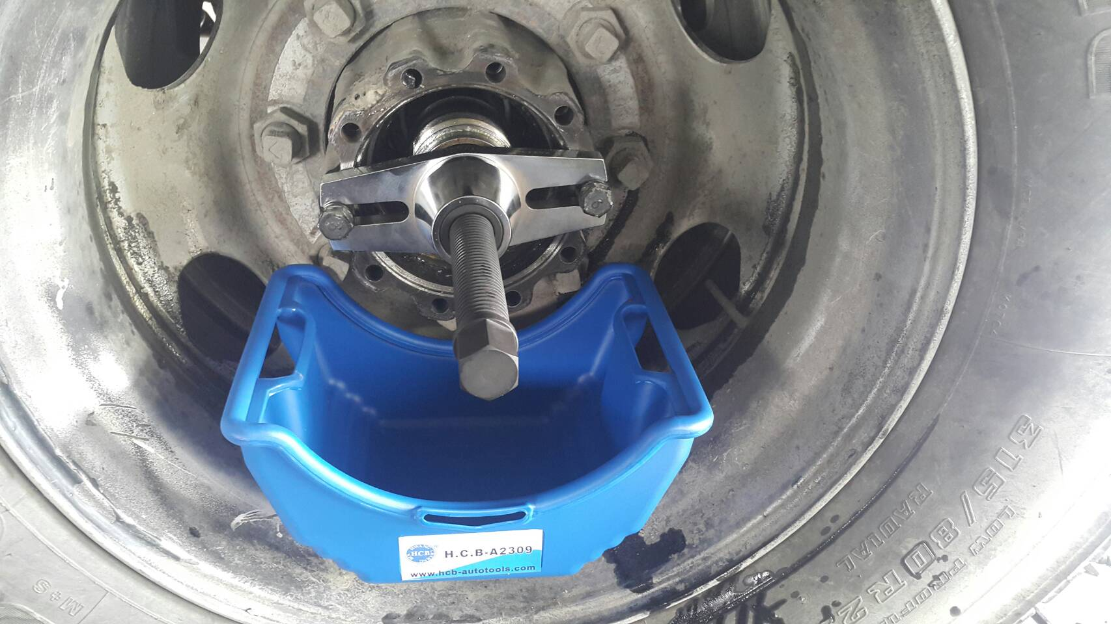

- When the axle bearing of truck is stuck due to overheating, use this tool with an air impact wrench to remove the axle easily.
- Application: Scania, DAF (CF), Volvo (FM), Japaneses truck

