
H.C.B-A1667
BENZ TRUCK LIFT SHAFT WRENCH
(360 / 410 / 440 / 460 / 480 / 550)

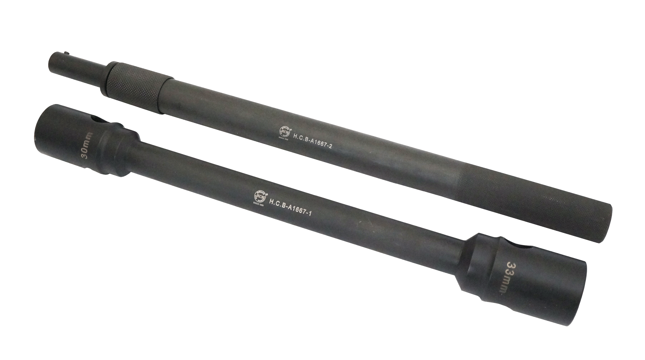

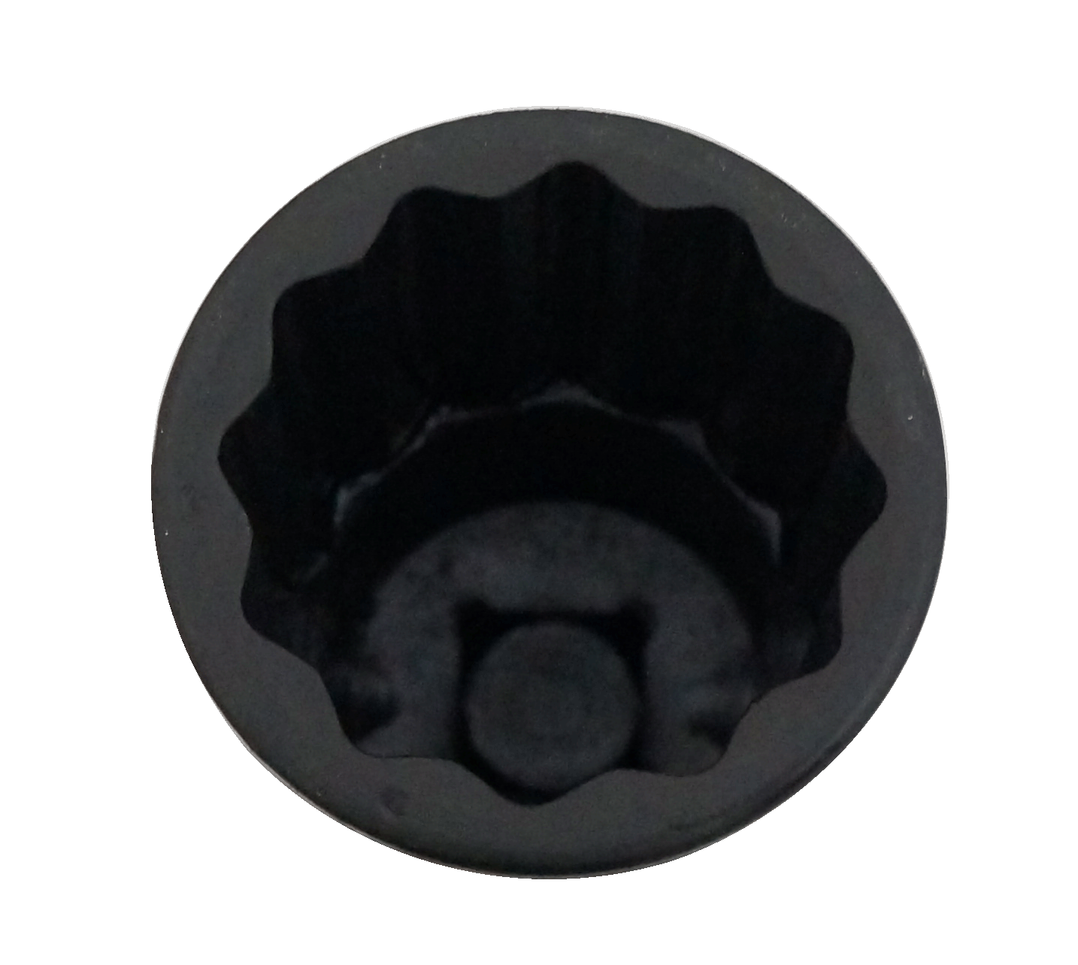
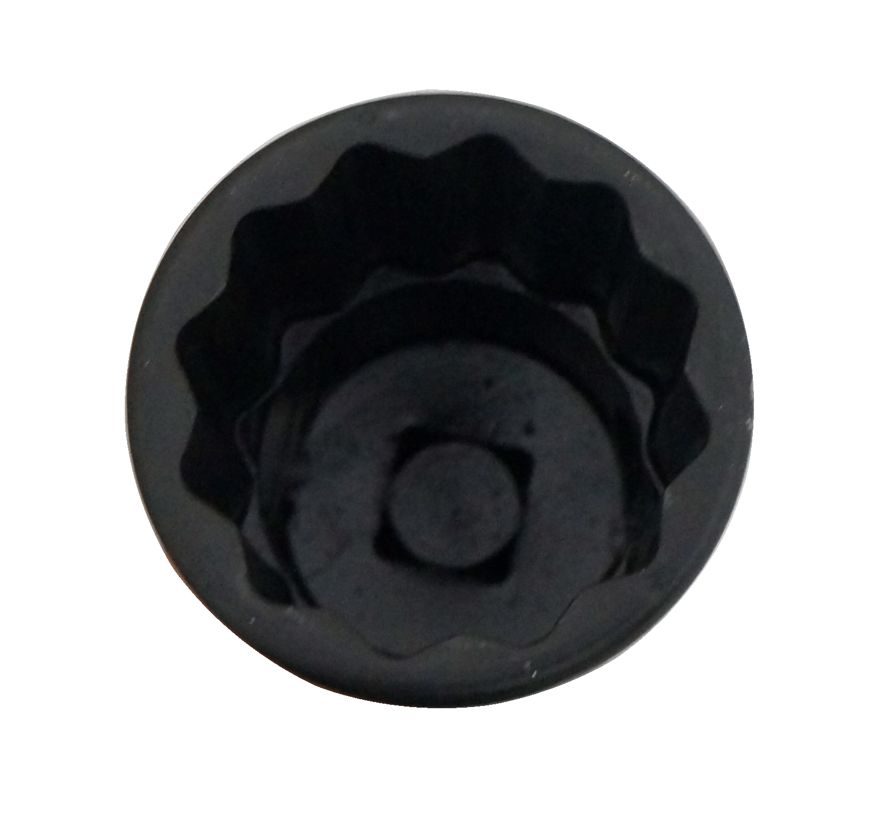
30 mm
33 mm

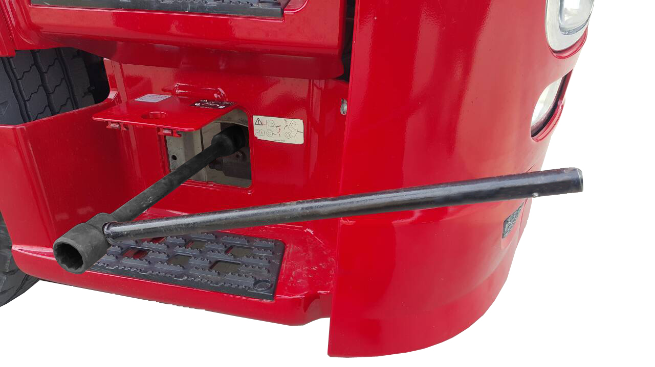

■ Introduction: When you service engine, you will need these tools to lift the truck head.
■ Application: BENZ truck (360 / 410 / 440 / 460 / 480 / 550)

