
H.C.B-A1654
VOLVO (FM) OUTPUT SHAFT TOOL
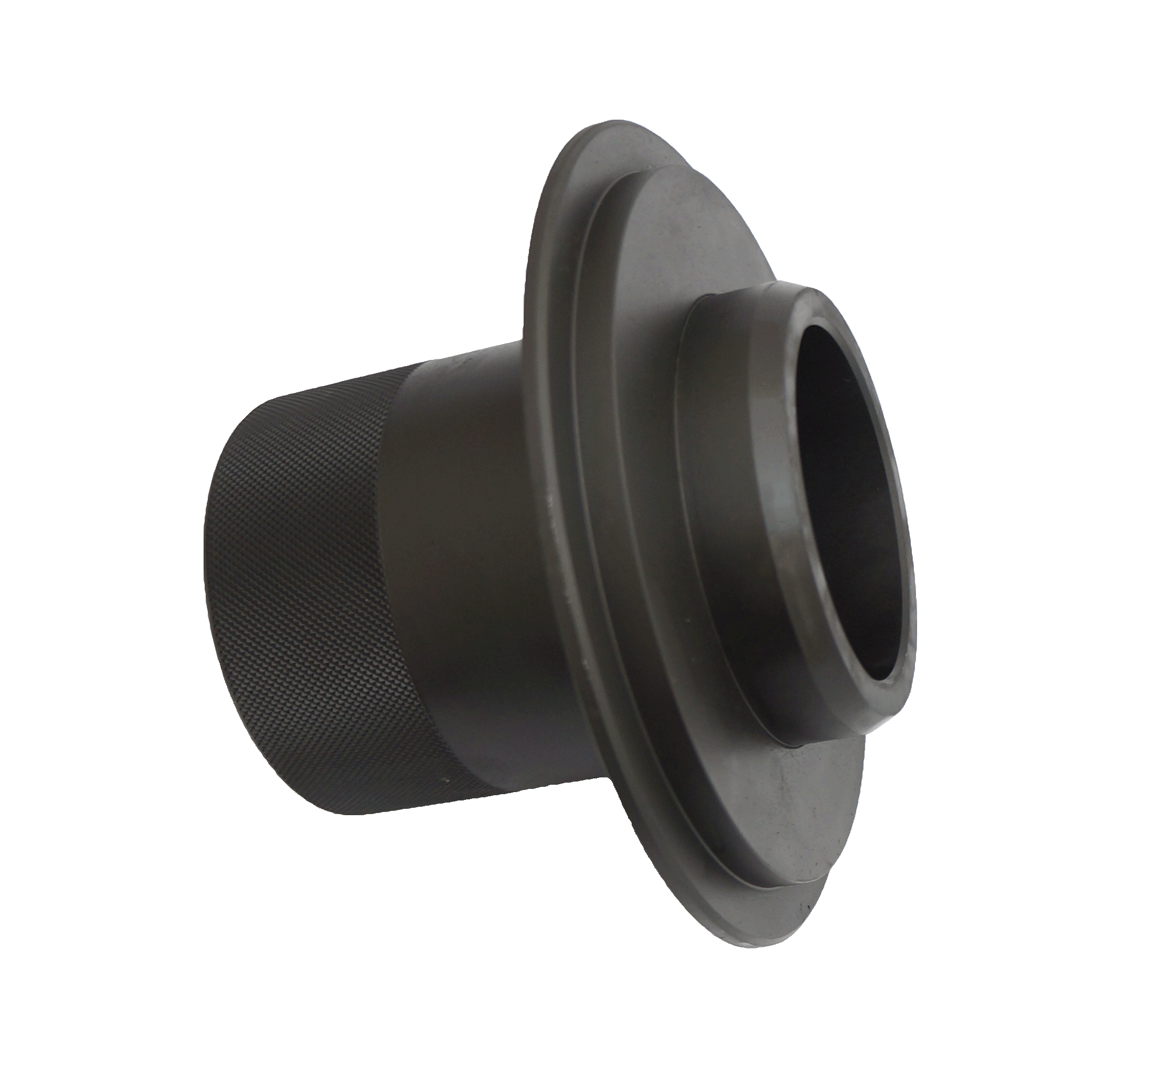

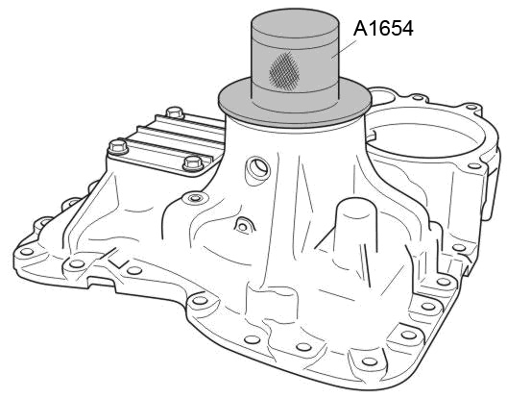

■ Feature: Use this tool can install transmission rear oil seal easily and conveniently.
■ Application: VOLVO (FM) truck
■ OEM no. ref.: 9998575

