

H.C.B-A1653
VIDEO
BMW EXTENSION BAR
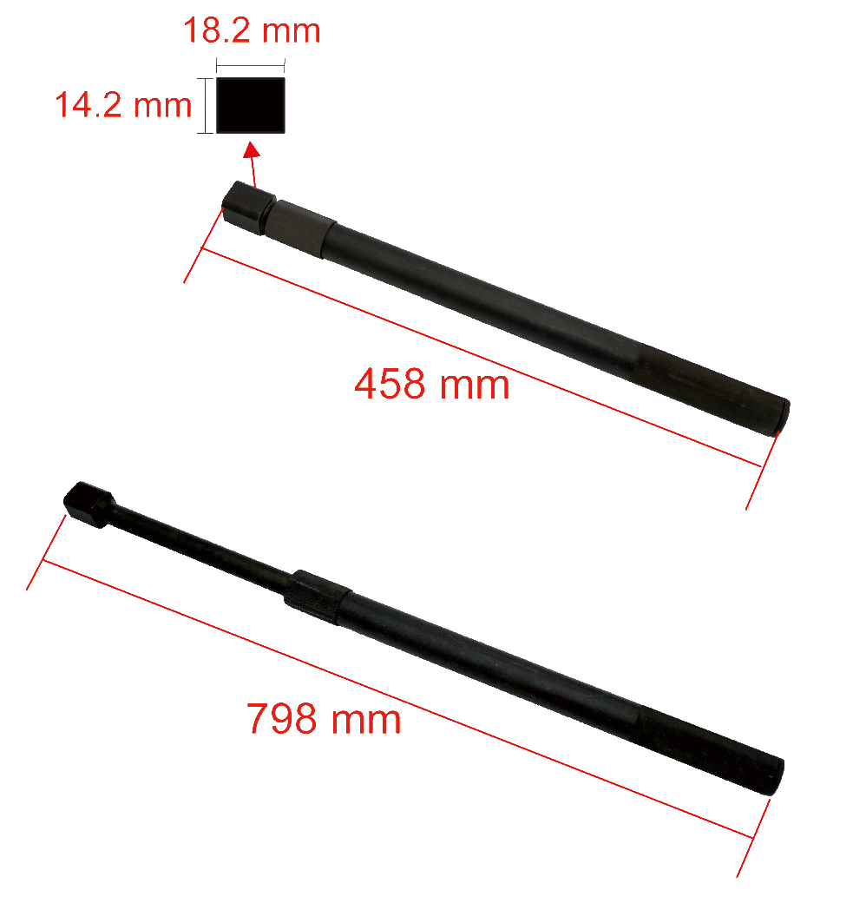

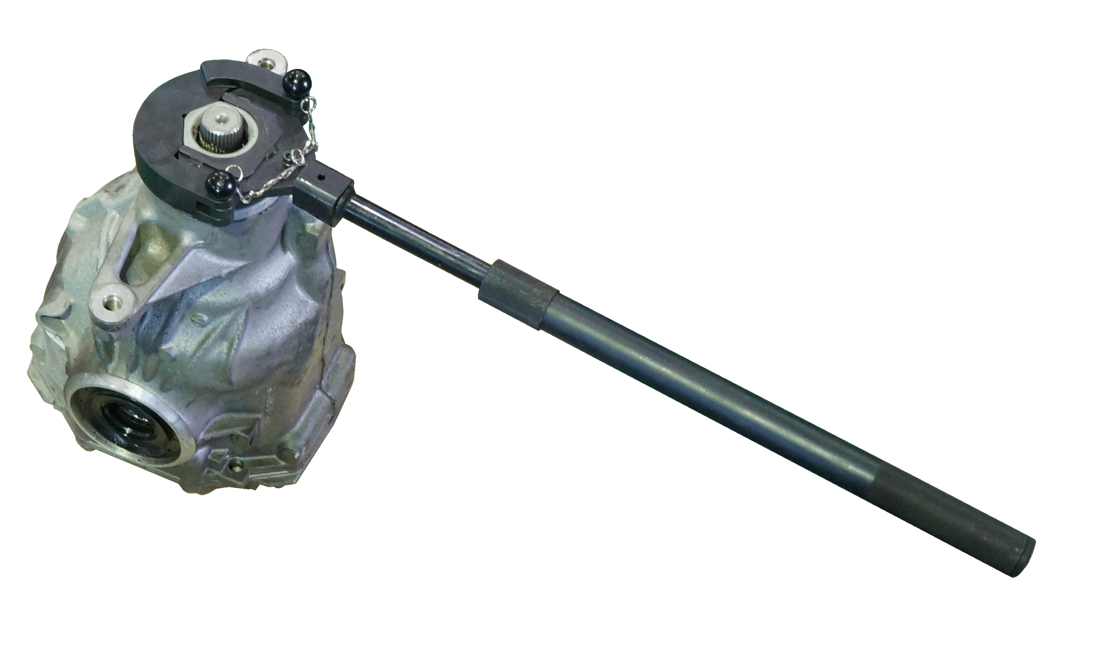
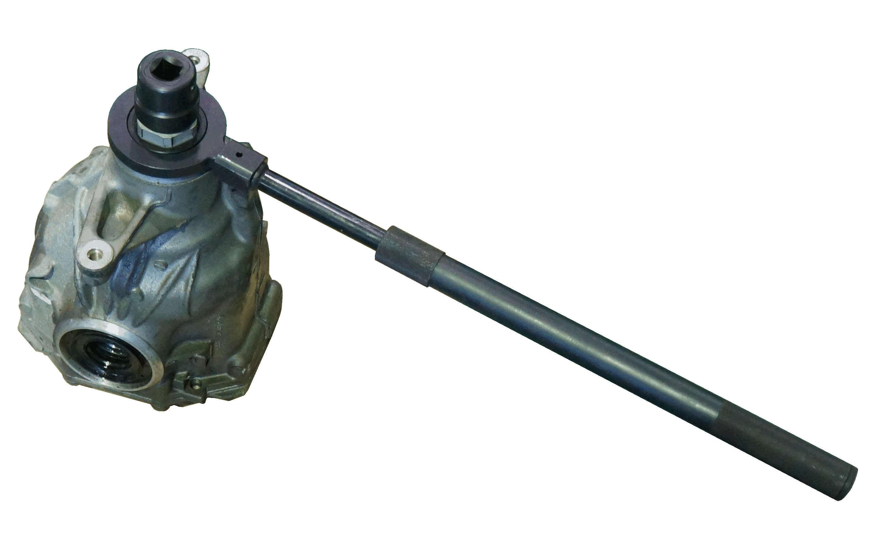

- Extension bar for A1651 and A1652
- BMW OEM no. ref.: 83 30 0 495 554 (335 070)

H.C.B-A1653
VIDEO
BMW EXTENSION BAR

- Extension bar for A1651 and A1652
- BMW OEM no. ref.: 83 30 0 495 554 (335 070)

