**H.C.B-A1652**

**VIDEO**



**BMW (E70/E90/E91/E92) DIFFERENTIAL FLANGE NUT WRENCH**

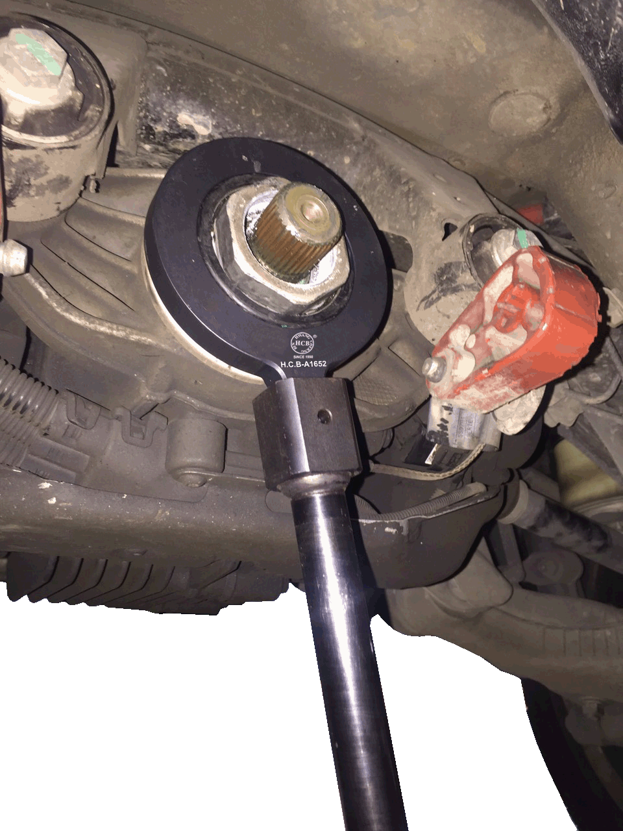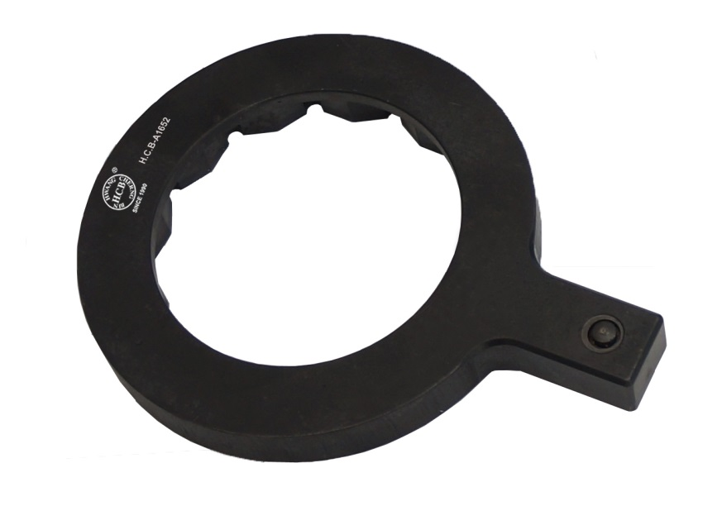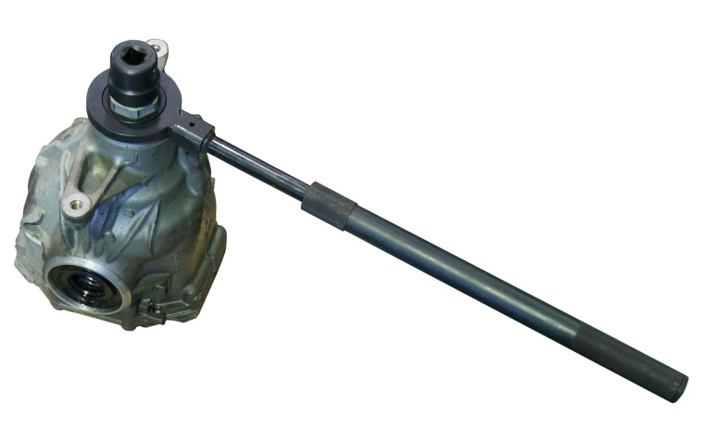

* Designed for loosening the flange nut on rear axle differential
* **Application:** BMW E70/E90/E91/E92 with N54 B30 engine
* **BMW OEM no.ref.**: 83 30 0 495 552 (335 050)

**H.C.B-A1652**

**VIDEO**



**BMW (E70/E90/E91/E92) DIFFERENTIAL FLANGE NUT WRENCH**



* Designed for loosening the flange nut on rear axle differential
* **Application:** BMW E70/E90/E91/E92 with N54 B30 engine
* **BMW OEM no.ref.**: 83 30 0 495 552 (335 050)