**H.C.B-A1651**

**VIDEO**



**BMW (E70/E90/E91/E92)** **DRIVESHAFT INNER NUT WRENCH**

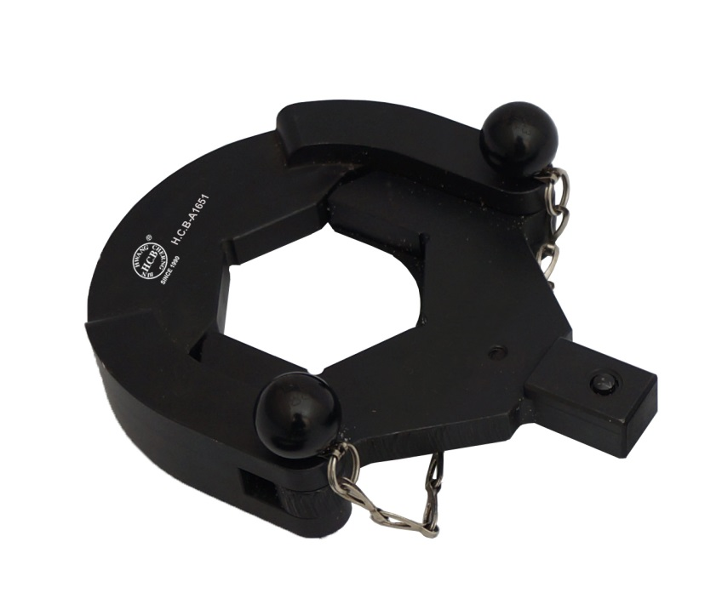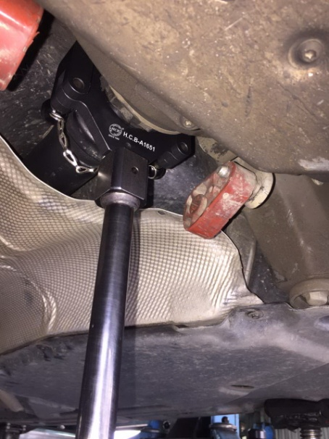

* Designed for R&R the driveshaft inner nut (final drive end).
* **Application:** BMW E70/E90/E91/E92 with N54 B30 engine, E38 (X3)
* **BMW OEM no. ref.**: 83 30 0 495 551 (335 040)

**H.C.B-A1651**

**VIDEO**



**BMW (E70/E90/E91/E92)** **DRIVESHAFT INNER NUT WRENCH**



* Designed for R&R the driveshaft inner nut (final drive end).
* **Application:** BMW E70/E90/E91/E92 with N54 B30 engine, E38 (X3)
* **BMW OEM no. ref.**: 83 30 0 495 551 (335 040)