**H.C.B-A1650**



**BMW (E70/E90/E91/E92) FINAL DRIVE INPUT SHAFT SEAL SOCKET**

**VIDEO**

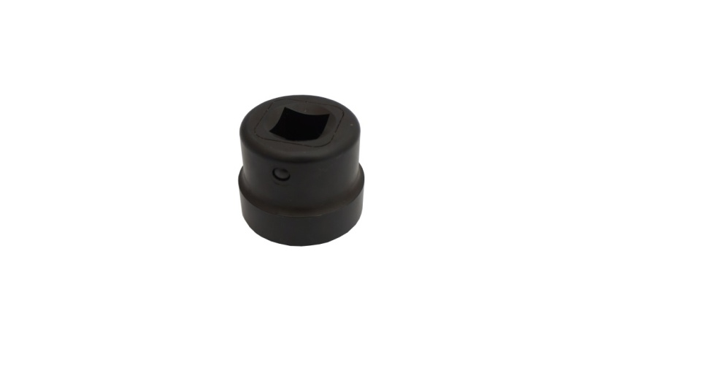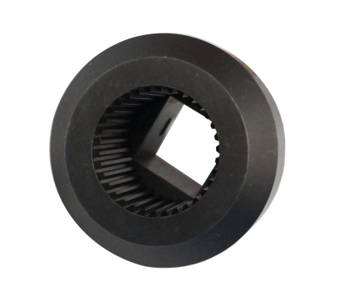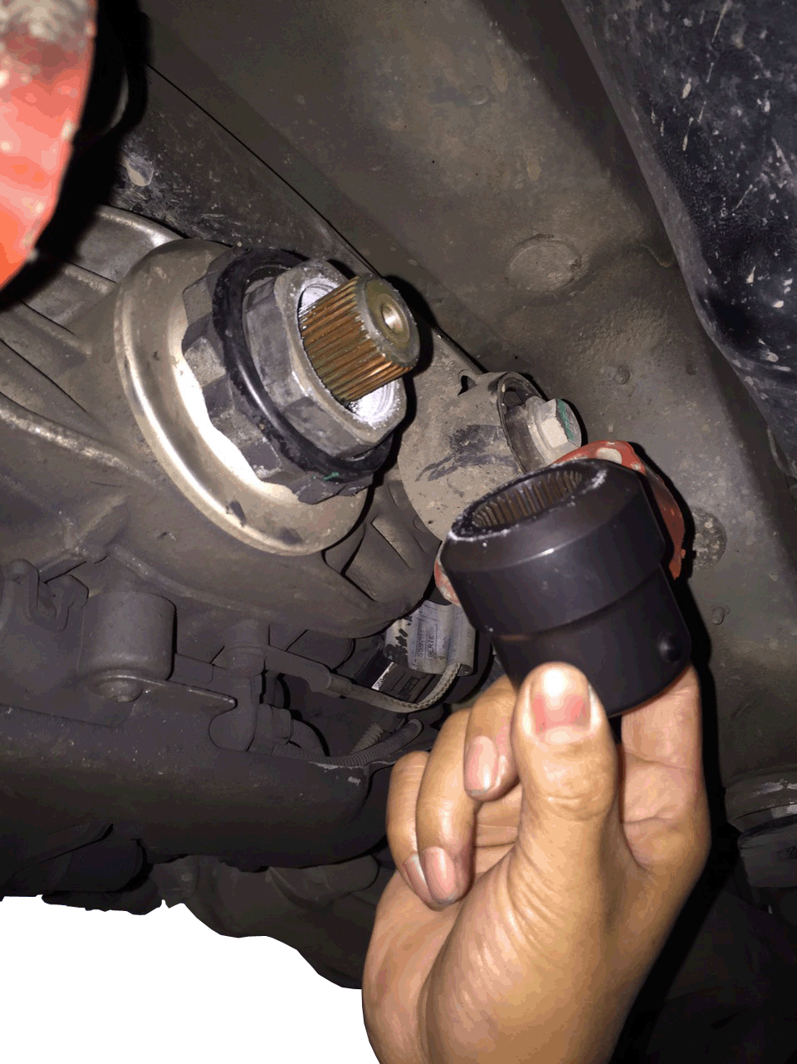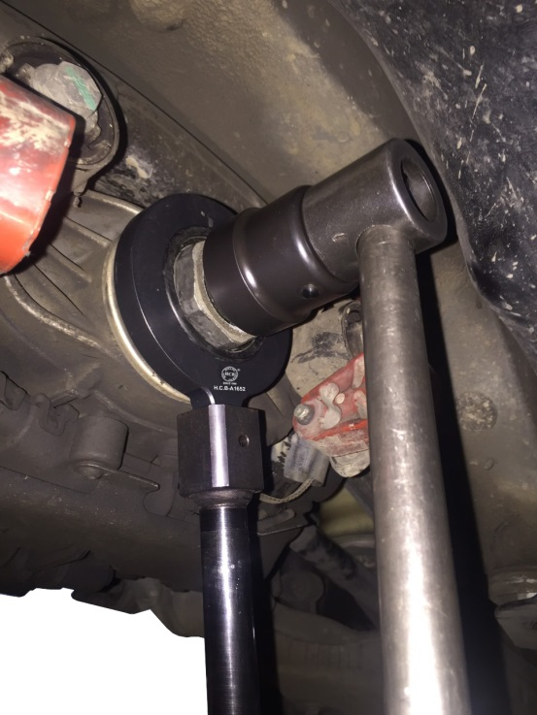

* Designed for holding the input shaft on the final drive when replacing the seal.
* **Application:**BMW E70/E71/E72/E82/E84/E90/E91/E92/E93/F12/F13/F20/F25
* **BMW OEM no.ref.**:83 30 0 495 553(335 060)

**H.C.B-A1650**



**BMW (E70/E90/E91/E92) FINAL DRIVE INPUT SHAFT SEAL SOCKET**

**VIDEO**



* Designed for holding the input shaft on the final drive when replacing the seal.
* **Application:**BMW E70/E71/E72/E82/E84/E90/E91/E92/E93/F12/F13/F20/F25
* **BMW OEM no.ref.**:83 30 0 495 553(335 060)