**H.C.B-A1649**



**BMW (E70/E90/E91/E92) FINAL DRIVE INPUT SHAFT SEAL INSTALLER**



**VIDEO**

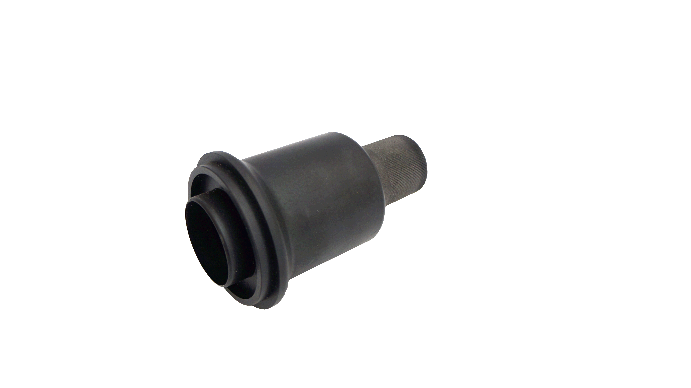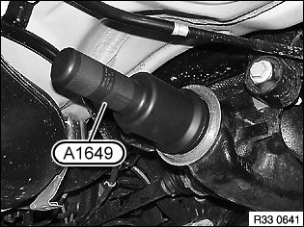

* Used to install the final drive input shaft seal.
* Application: BMW E90/E91/E92 and E70 with N54 B30
* **BMW OEM no.ref.:**83 30 0 495 593 (335 080), 08 32 030