
H.C.B-A1646
VOLVO (FM/FH) (12 SPEED) TRANSMISSION MAINSHAFT BEARING/ GEAR REMOVAL TOOL

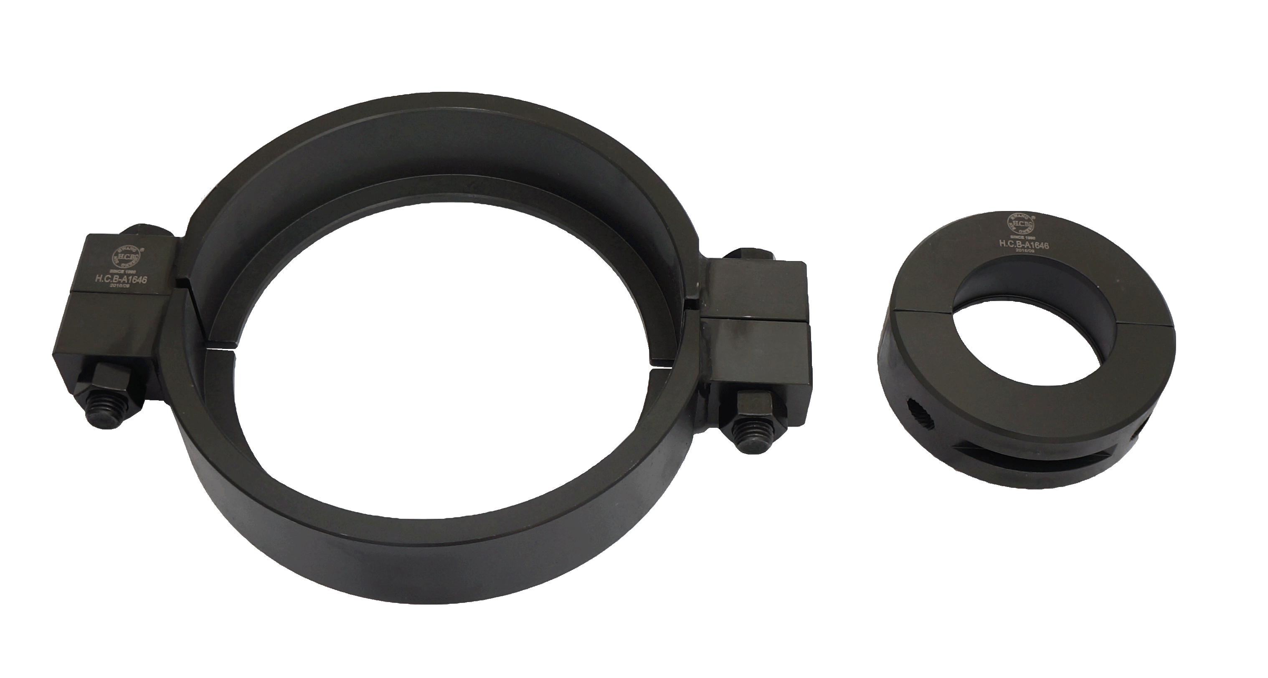
2
1

■ Instruction: No.1 used to remove bearing of 12 speed transmission.
No.2 used to remove gear of 12 speed transmission.
■ Clamp is required while removing.
■ Application: VOLVO truck (12 Speed)
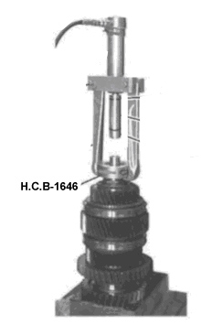
■ OEM ref no.:9998215

