
H.C.B-A1638
VOLVO / FORD / CHRYSLER / DODGE DUAL-CLUTCH
TRANSMISSION REMOVAL/INSTALLATION TOOL KIT
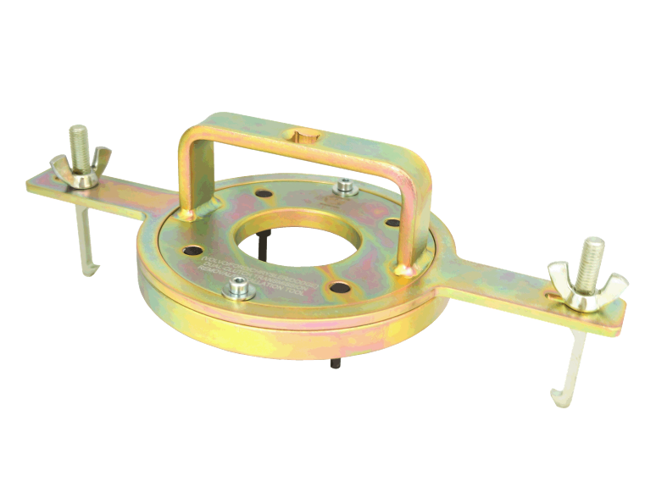

- To remove and install dual-clutch transmission.

- Special designed to fix, turn and take out the dual-clutch.

- Application:
Volvo: C70 (06-), S40 (04-), S60 (11-), S80 (07-), S80L, V40 (13-), V40 Cross Country, V50, V60, V70 (08-), XC60, C30
Volvo Engine: B4164T, Engine: B4164T2, Engine: B4164T3, Engine: B4204S3, Engine: B4204S4, Engine: B4204T6, Engine: B4204T7, Engine: D4162T, Engine: D4204T, Power Transmission: MPS6
Ford: Focus (04~), C-Max, S-Max, Galaxy, Mondeo (07~), Kuga (13~).
Chrysler: Sebring.
Dodge: Avenger, Journey.

- OEM no.ref.: Volvo – 9997435/Ford - 308-763

H.C.B-A1638
VOLVO / FORD / CHRYSLER / DODGE DUAL-CLUTCH
TRANSMISSION REMOVAL/INSTALLATION TOOL KIT

- To remove and install dual-clutch transmission.

- Special designed to fix, turn and take out the dual-clutch.

- Application:
Volvo: C70 (06-), S40 (04-), S60 (11-), S80 (07-), S80L, V40 (13-), V40 Cross Country, V50, V60, V70 (08-), XC60, C30
Volvo Engine: B4164T, Engine: B4164T2, Engine: B4164T3, Engine: B4204S3, Engine: B4204S4, Engine: B4204T6, Engine: B4204T7, Engine: D4162T, Engine: D4204T, Power Transmission: MPS6
Ford: Focus (04~), C-Max, S-Max, Galaxy, Mondeo (07~), Kuga (13~).
Chrysler: Sebring.
Dodge: Avenger, Journey.

- OEM no.ref.: Volvo – 9997435/Ford - 308-763

