
H.C.B-A1630
SCANIA (114) INJECTOR
REMOVAL/ INSTALLATION TOOL KIT

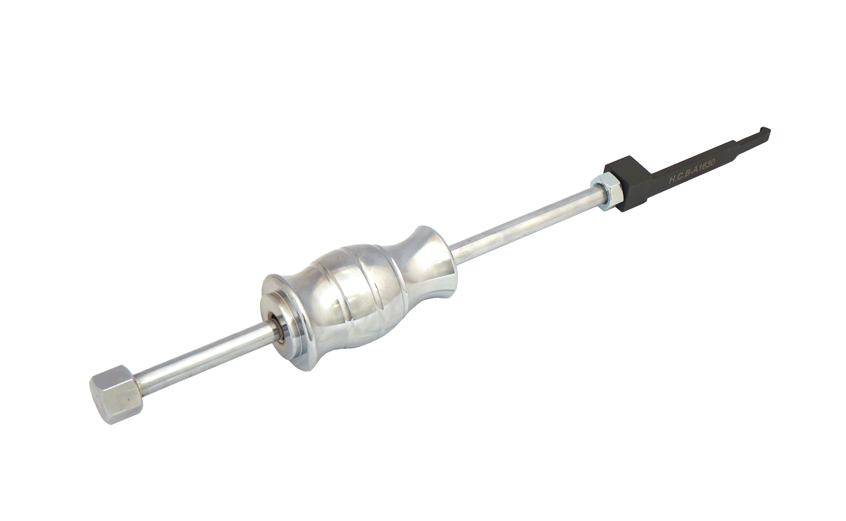

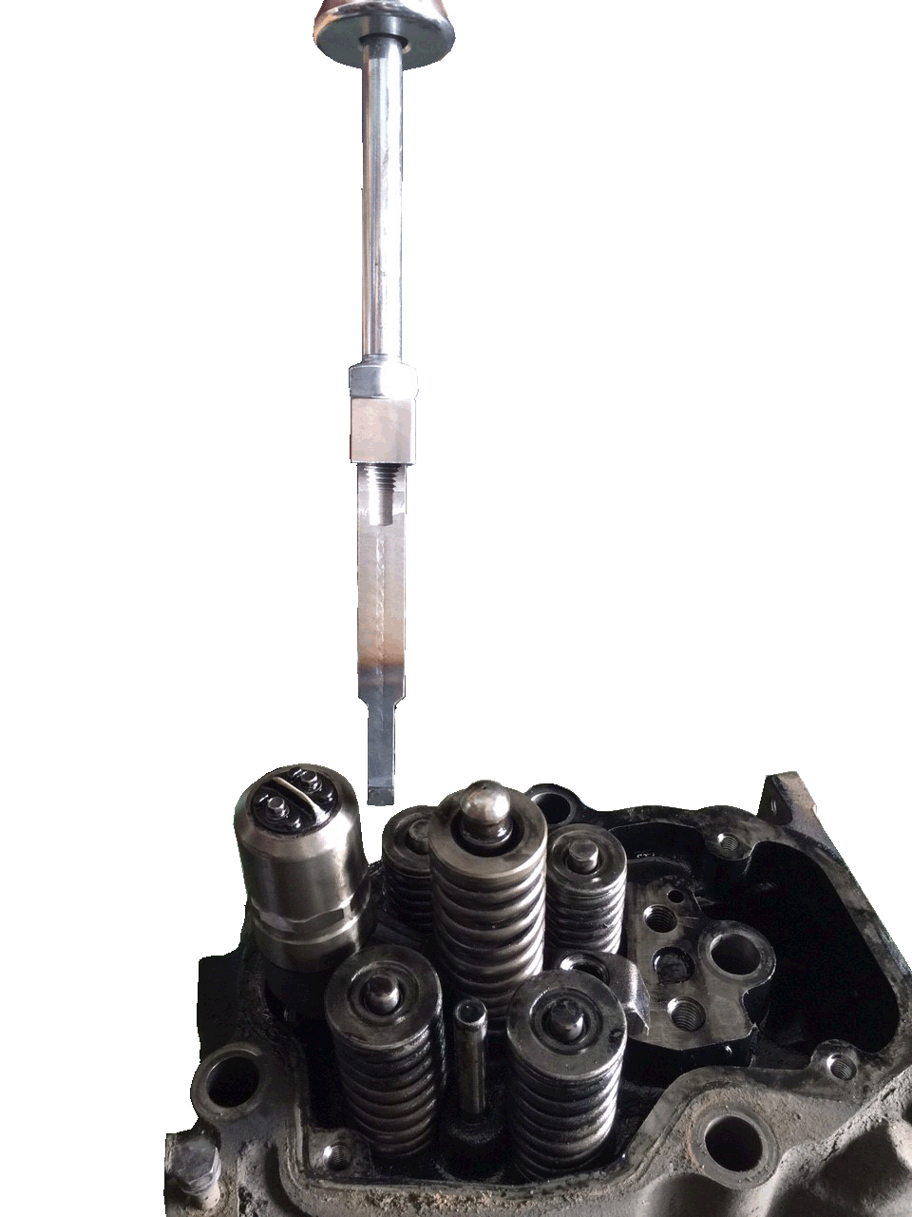

- This tool has the single hook design. When removing the injector, only one hook is required.
Use the slide hammer to remove the injector without damaging the injector or relative parts.
It is a saving-time and saving-labor tool.
■ Application: SCANIA (114) 340.360.380

H.C.B-A1630
SCANIA (114) INJECTOR
REMOVAL/ INSTALLATION TOOL KIT

- This tool has the single hook design. When removing the injector, only one hook is required.
Use the slide hammer to remove the injector without damaging the injector or relative parts.
It is a saving-time and saving-labor tool.
■ Application: SCANIA (114) 340.360.380

