
H.C.B-A1627
VOLVO (FM) TRUCK REAR WHEEL AXLE BEARING/
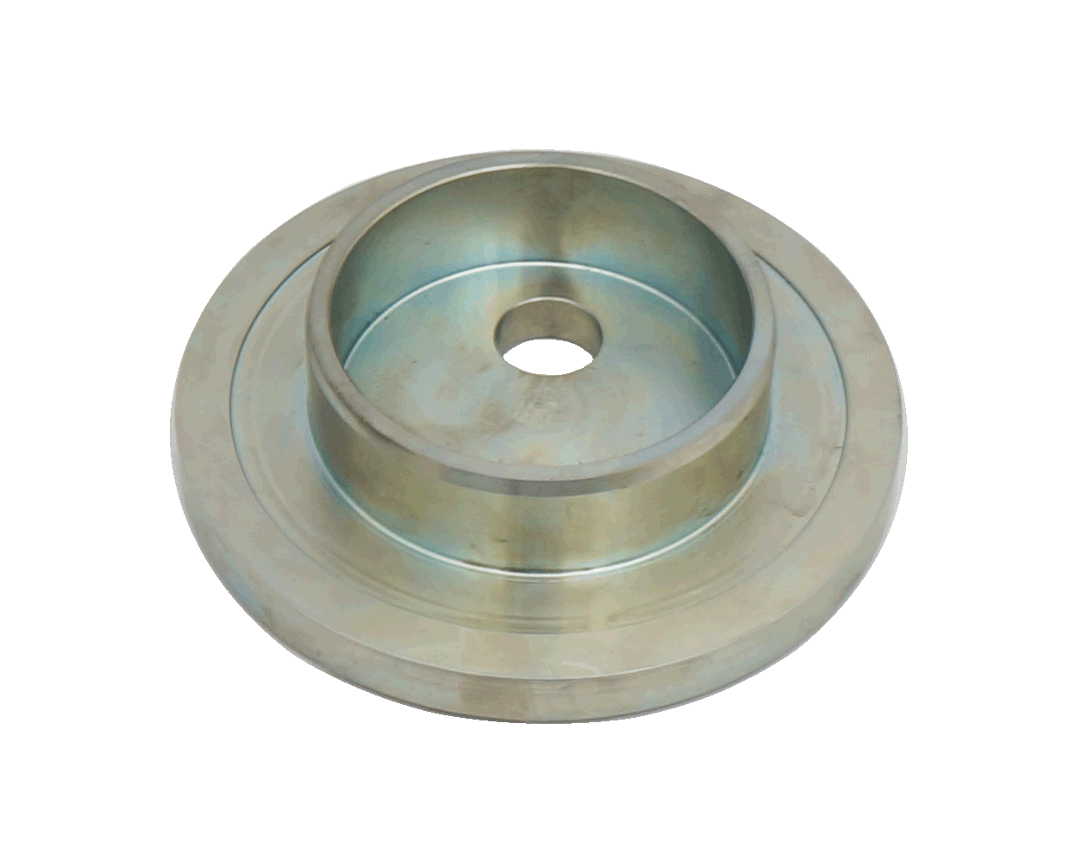
OIL SEAL INSTALLER

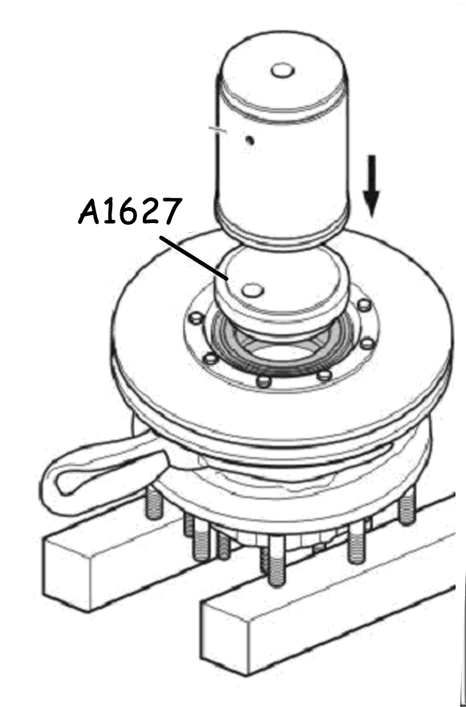

■ Instruction：This tool can help you install the bearing or oil seal with even force. Avoid bad installation.

■ Appication：VOLVO(FM) truck.

■ OEM no. ref.: 88800173

H.C.B-A1627
VOLVO (FM) TRUCK REAR WHEEL AXLE BEARING/
OIL SEAL INSTALLER

■ Instruction：This tool can help you install the bearing or oil seal with even force. Avoid bad installation.

■ Appication：VOLVO(FM) truck.

■ OEM no. ref.: 88800173

