
H.C.B-A1626
VOLVO (FM12) TRUCK DISC BRAKE CALIPER FIXING
SCREW WRENCH (Dr.1")
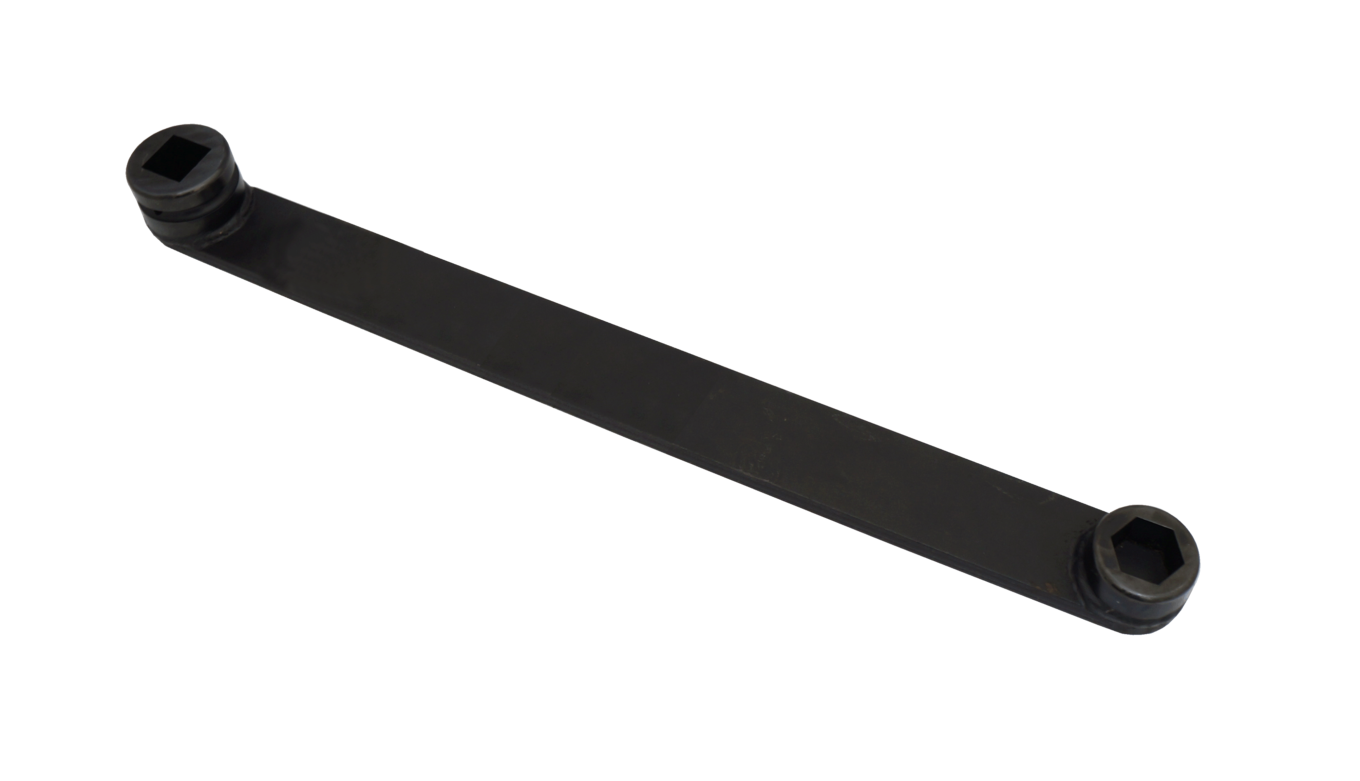
Dr.1”

H27

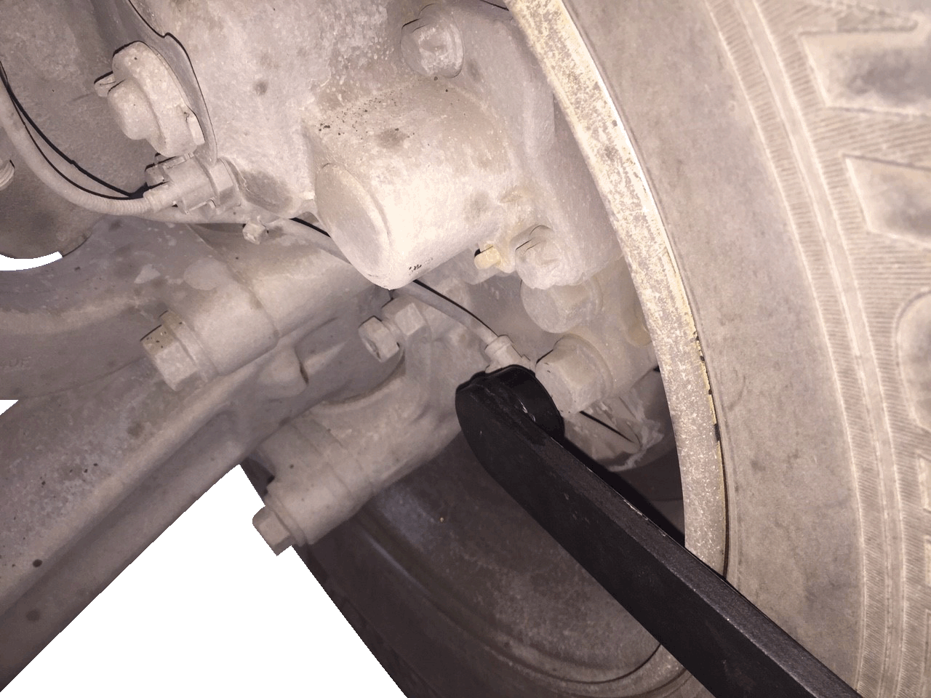
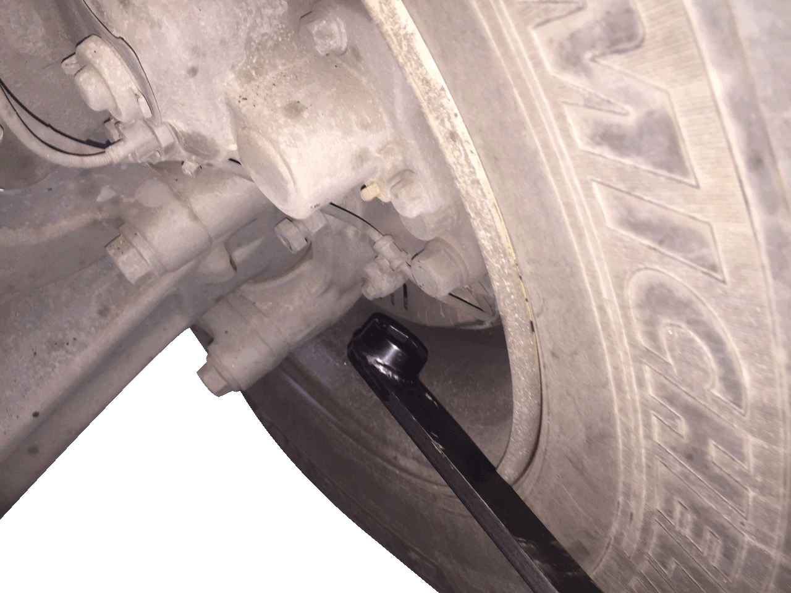

■ Feature：This tool with different ends. One end is H27, it can work on the vehicle directly. The other end is Dr.1", you can lengthen it depending on the situation.

■ Instruction：General handle of tools are shorter. That is inconvenience. This tool with lengthening handle. It can remove/ install the nut of brake caliper directly.

■ Application：VOLVO (FM12) truck.

■ OEM no. ref.: 9998573

