**H.C.B-A1619**



**VOLVO B4204 (8-SPEED TRANSMISSION) CAMSHAFT ALIGNMENT TOOL KIT**

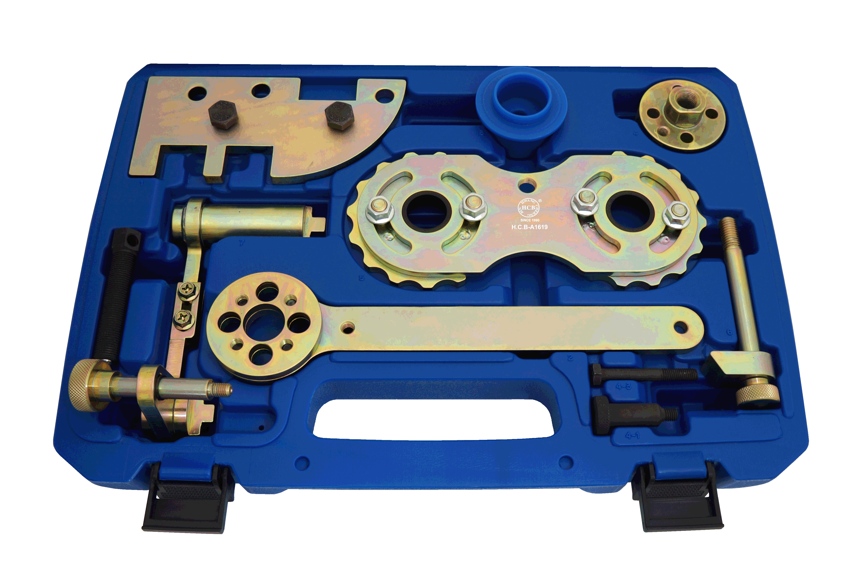

* Special design to align the engine camshaft and crankshaft position, and correct into the side cover.
* Application:
  + Engine: VOLVO B4204 engine (8-Speed Transmission).
  + Model:  
    Volvo S60 (2011~present)  
    Volvo S60L (2007~present)  
    Volvo S80 (2007~present)  
    Volvo V40 (2013~present)  
    Volvo V40 Cross Country (2008~present)  
    Volvo V60 (2008~present)  
    Volvo V60 Cross Country (2008~present)  
    Volvo V70 (2008~present)  
    Volvo XC60 (2008~present)  
    Volvo XC70 (2008~present)  
    Volvo XC70 (2016)
* OEM no.ref.:

9997490 Position setting  
9997493 Puller  
9997495 Counterhold  
9997496 Drift  
9997497 Counterhold

**H.C.B-A1619**



**VOLVO B4204 (8-SPEED TRANSMISSION) CAMSHAFT ALIGNMENT TOOL KIT**



* Special design to align the engine camshaft and crankshaft position, and correct into the side cover.
* Application:
  + Engine: VOLVO B4204 engine (8-Speed Transmission).
  + Model:  
    Volvo S60 (2011~present)  
    Volvo S60L (2007~present)  
    Volvo S80 (2007~present)  
    Volvo V40 (2013~present)  
    Volvo V40 Cross Country (2008~present)  
    Volvo V60 (2008~present)  
    Volvo V60 Cross Country (2008~present)  
    Volvo V70 (2008~present)  
    Volvo XC60 (2008~present)  
    Volvo XC70 (2008~present)  
    Volvo XC70 (2016)
* OEM no.ref.:

9997490 Position setting  
9997493 Puller  
9997495 Counterhold  
9997496 Drift  
9997497 Counterhold