
H.C.B-A1617
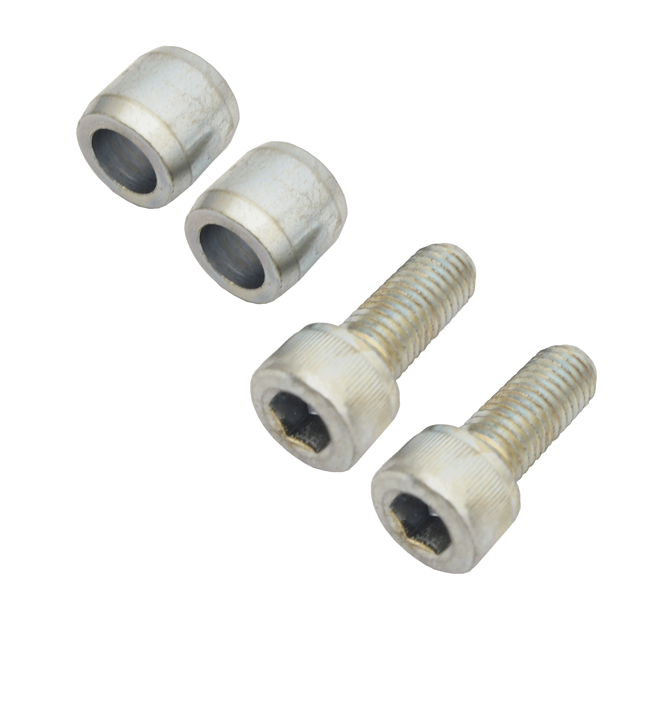
VOLVO TRUCK REMOVING AND FITTING TIMING GEAR PLATE TOOL

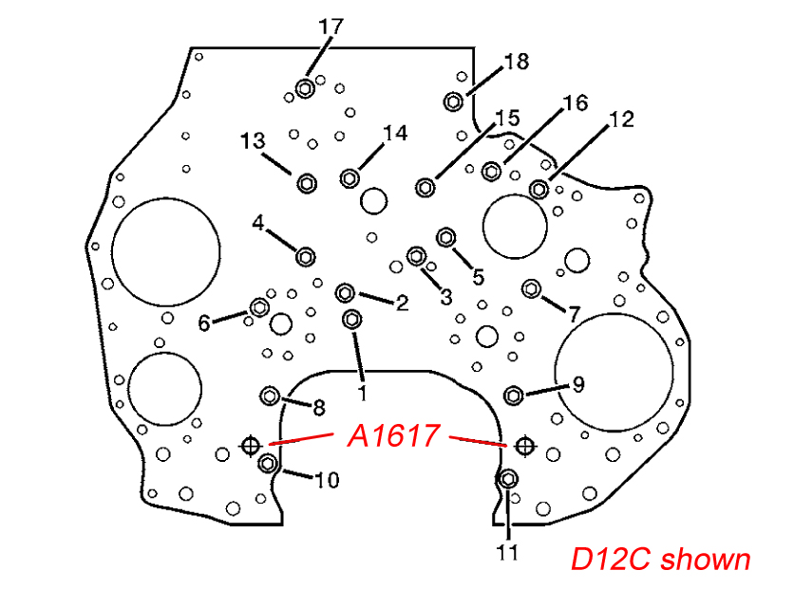
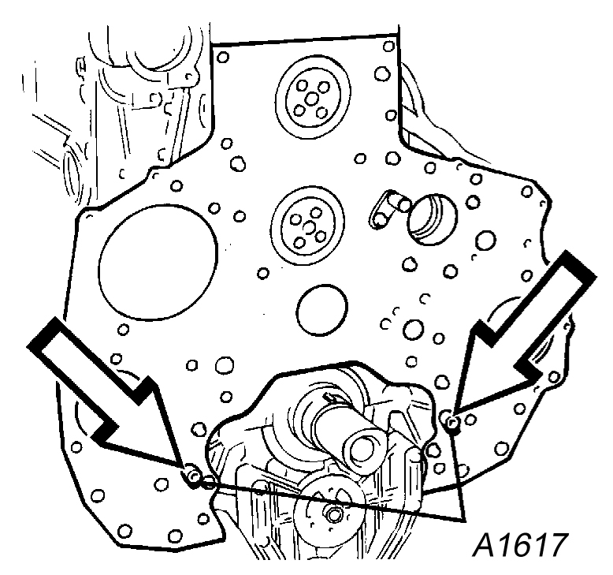
D12B shown

Guide sleeves for timing gear plate
Guide sleeves for timing gear plate
Install two guide sleeves in the guide holes for the timing gear plate. Remove the bolts (1-18) that hold the plate to the cylinder block. Carefully tap the plate free.

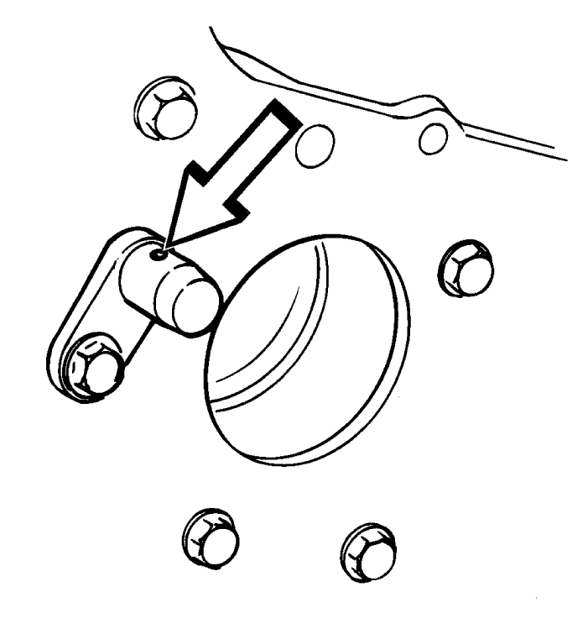

Lube oil nozzle

■ Instruction: The tools are used to replace or repair components.
■ Application: Volvo truck. Engine model: D12, D12A, D12B, D12C
■ OEM ref no.:9998267
H.C.B-A1617
VOLVO TRUCK REMOVING AND FITTING TIMING GEAR PLATE TOOL

D12B shown

Guide sleeves for timing gear plate
Guide sleeves for timing gear plate
Install two guide sleeves in the guide holes for the timing gear plate. Remove the bolts (1-18) that hold the plate to the cylinder block. Carefully tap the plate free.

Lube oil nozzle

■ Instruction: The tools are used to replace or repair components.
■ Application: Volvo truck. Engine model: D12, D12A, D12B, D12C
■ OEM ref no.:9998267

