
H.C.B-A1616
VOLVO TRUCK FITTING TIMING GEAR COVER
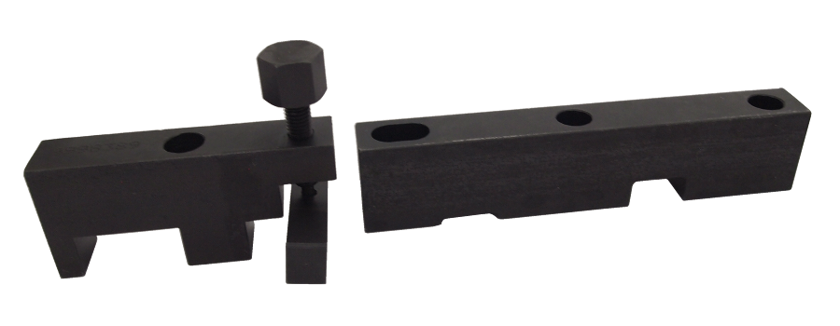

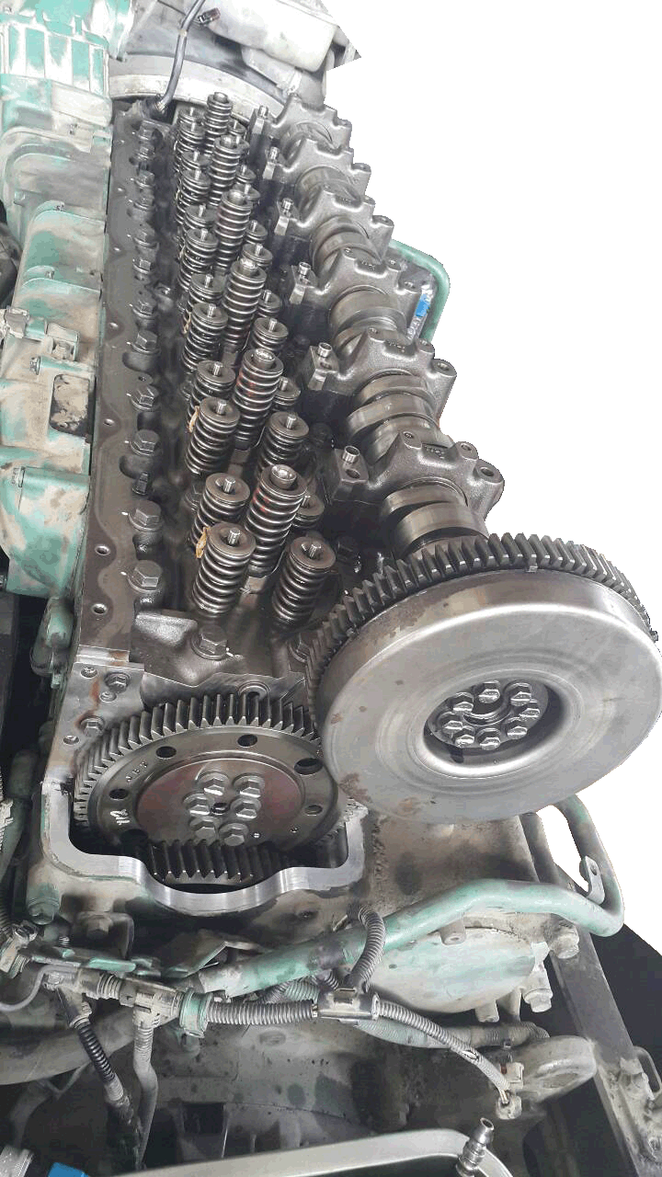
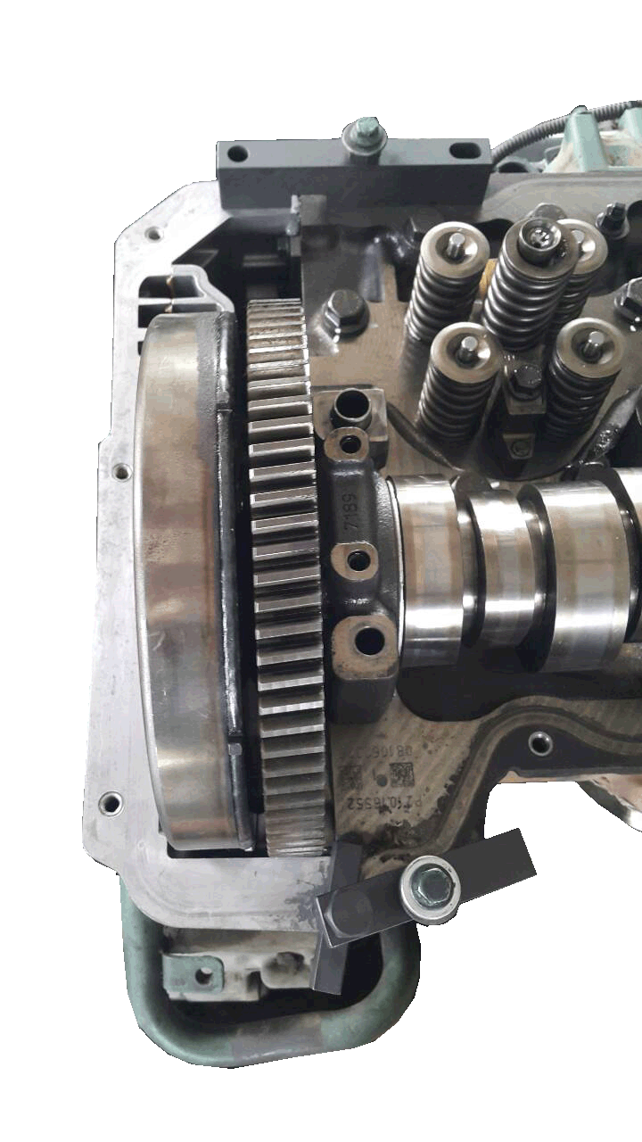

■ Feature：
This tool designed to fix gear cover. If you don’t use the tools, it might cause gear cover leak oil.
■ OEM ref no.: 9998389, 9998601

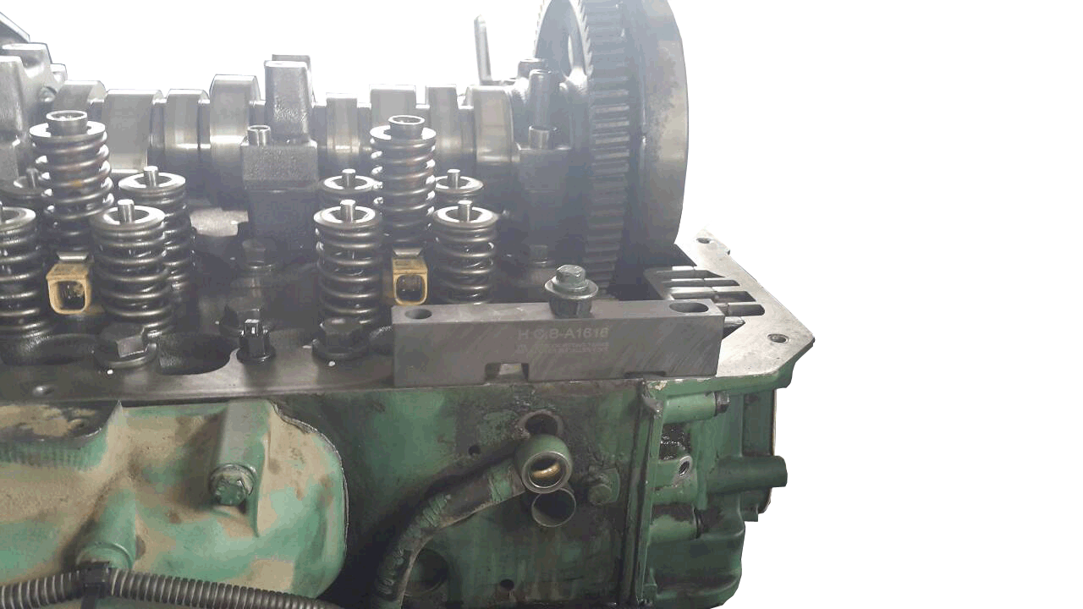
Step 1.
1-1. Install the gear cover. Screw the nut but not be tight.
1-2. Put on the tool, the screw tight.

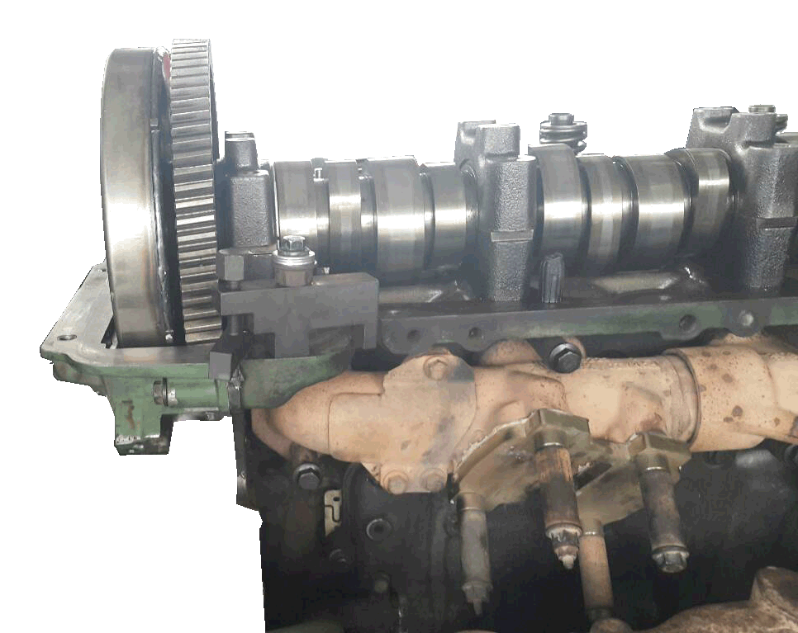
Step 2.
  - Screw the other side until the gear cover is pressed to be flat.
  - Tighten the bolts of the gear cover up, and installation is completed!

