
H.C.B-A1610
VOLVO (FM) CRANKSHAFT FRONT OIL SEAL INSTALLER
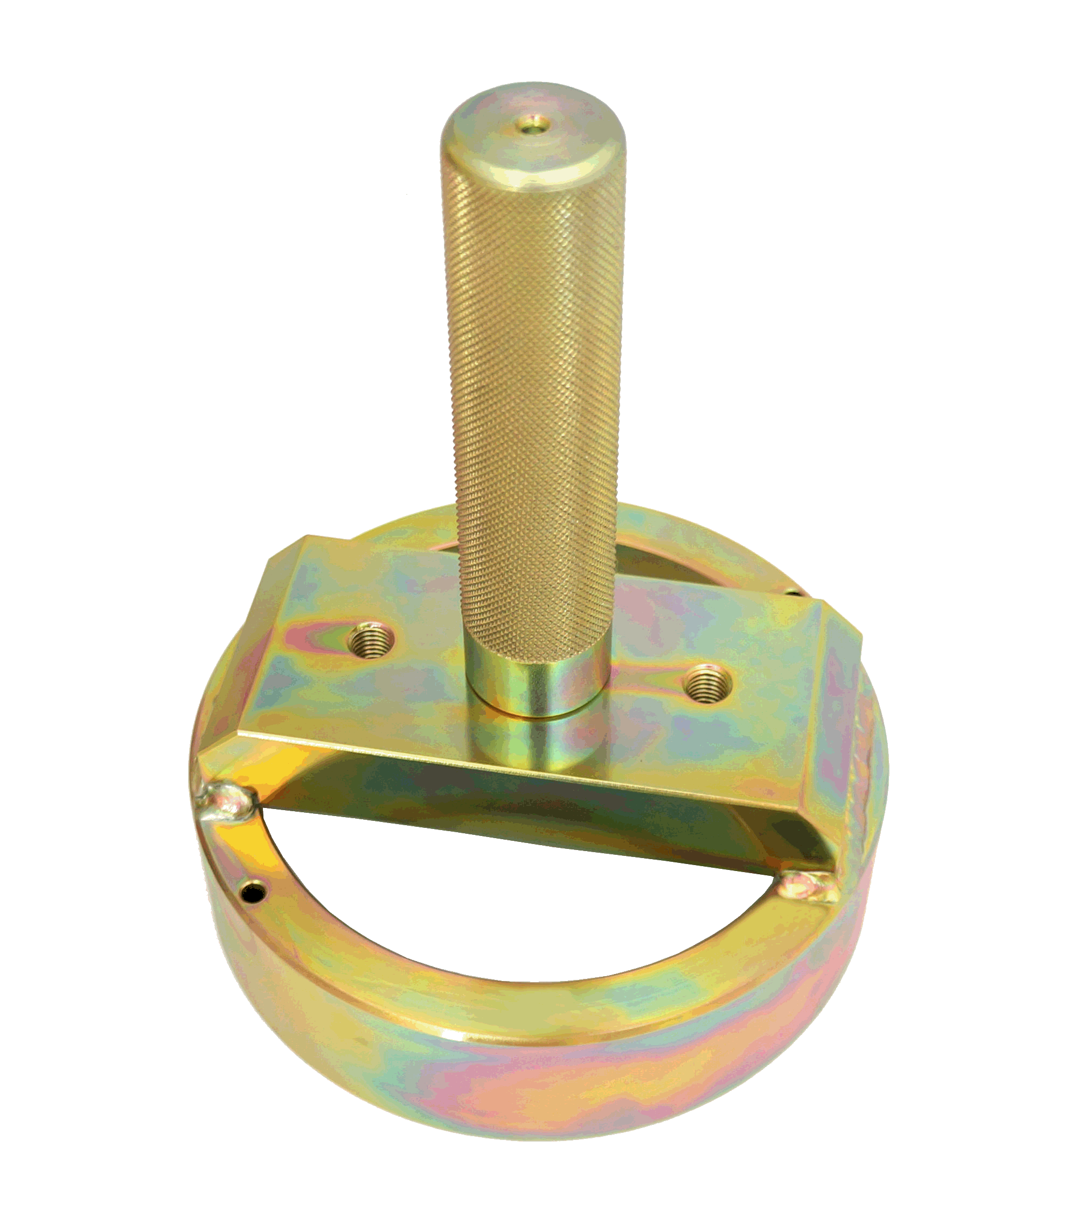

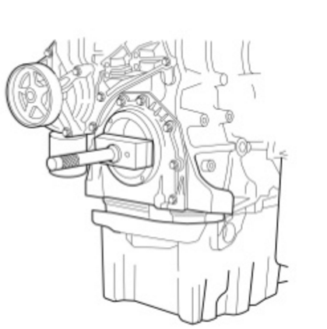
A1610

- If you don’t use special tool to install oil seal. It might causing oil seal bad install and leak oil.Then you will need to extract and install the part again. This tool can make installing quickly and easily.
- Instruction: Put the tool on the crankshaft, hit the handle until finish installing.
- OEM ref. no.: 88800021, 9992000
- Application : D16F

