

H.C.B-A1606
SCANIA 340/380 (EURO 4) CRANKSHAFT FRONT/REAR OIL SEAL INSTALLER (PR SERIES)
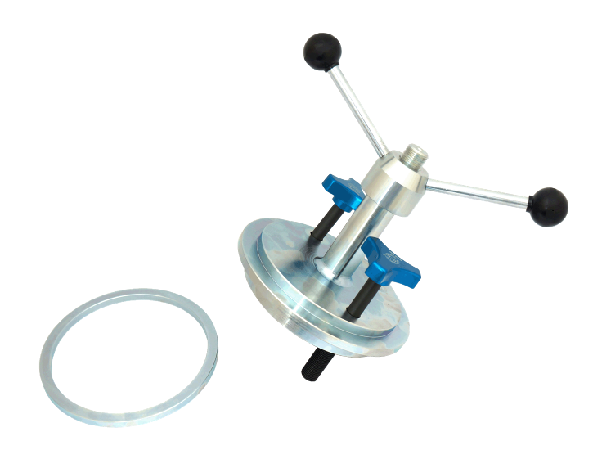

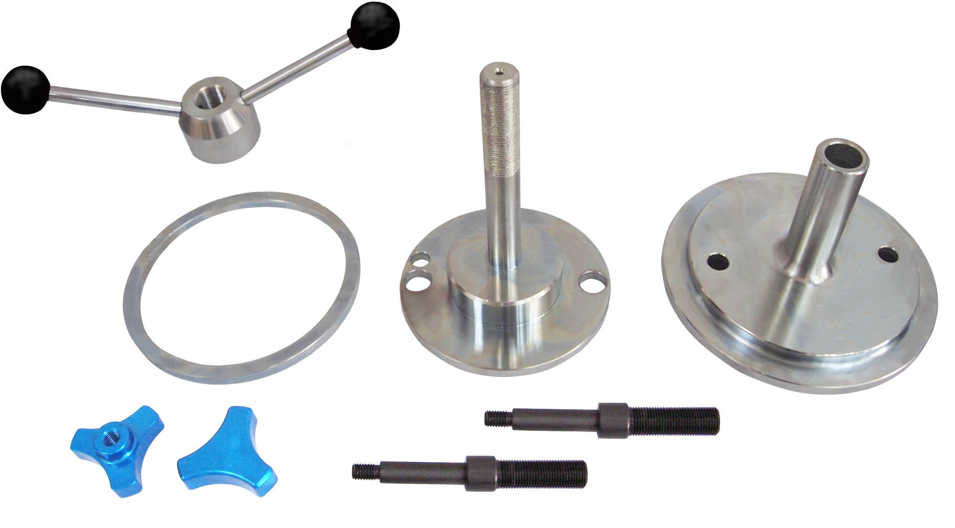
3
4
2
1
1-2-1
1-2-25

No. | Name | Description | Q’ty | Remark
1 | Installing base | D:ψ175x156L | 1 | M16xP1.5
2 | Fixing oil seal base | D:ψ133.2x171L | 1 | M20xP1.5
3 | Installing nut | L49xW296xH101.7 | 1 | M20xP1.5
4 | Front oil seal installing sleeve | D:ψ159.4x7.8L | 1 | d:ψ140.7

■Description: When installing the oil seal, you won’t damage the oil seal. With this tool kit will make
repair be more convenient and easier.
■Application: SCANIA 340/380 (PR Series)
■Oil seal genuine no.: 143 31 83
Front oil seal Installation:
Put the oil seal first, and then put no.4.
Screw crankshaft belt to appropriate place.

Rear oil seal Installation:
Hitch no.2 by oil seal. Screw 1-2-1 and 1-1-2 onto crankshaft.
Screw no.1, and then screw no.3.
Installing finished.

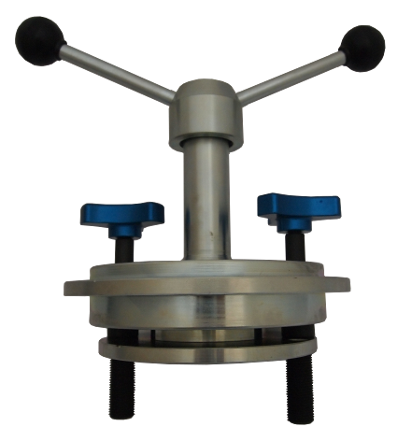
3

Please hitch new oil seal on no. 2

2

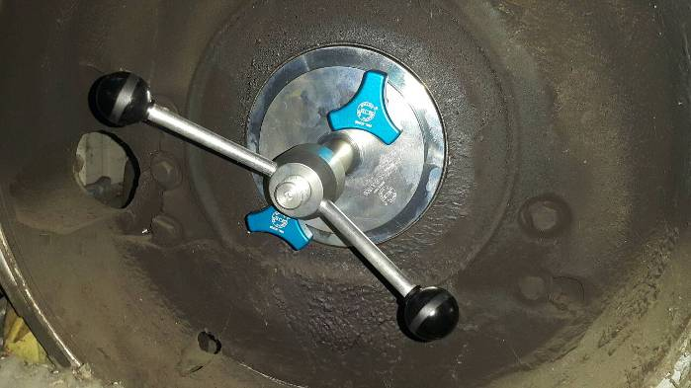

Screw the nut until finish installing.

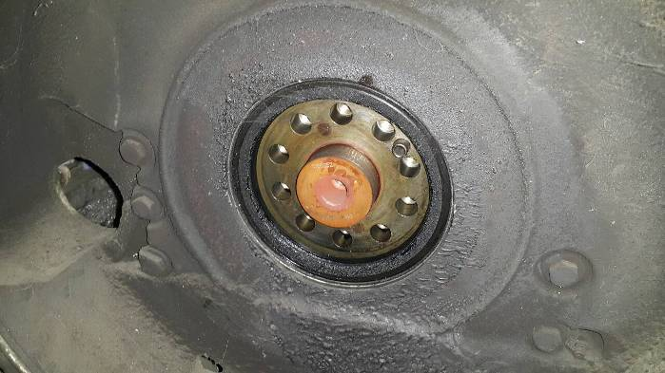

Finish installing.

