
H.C.B-A1582
VOLVO (FM) TRANSMISSION OIL TUBE NUT WRENCH
(74 mm)

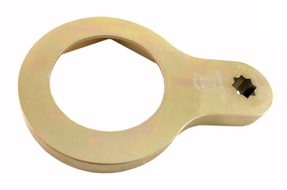
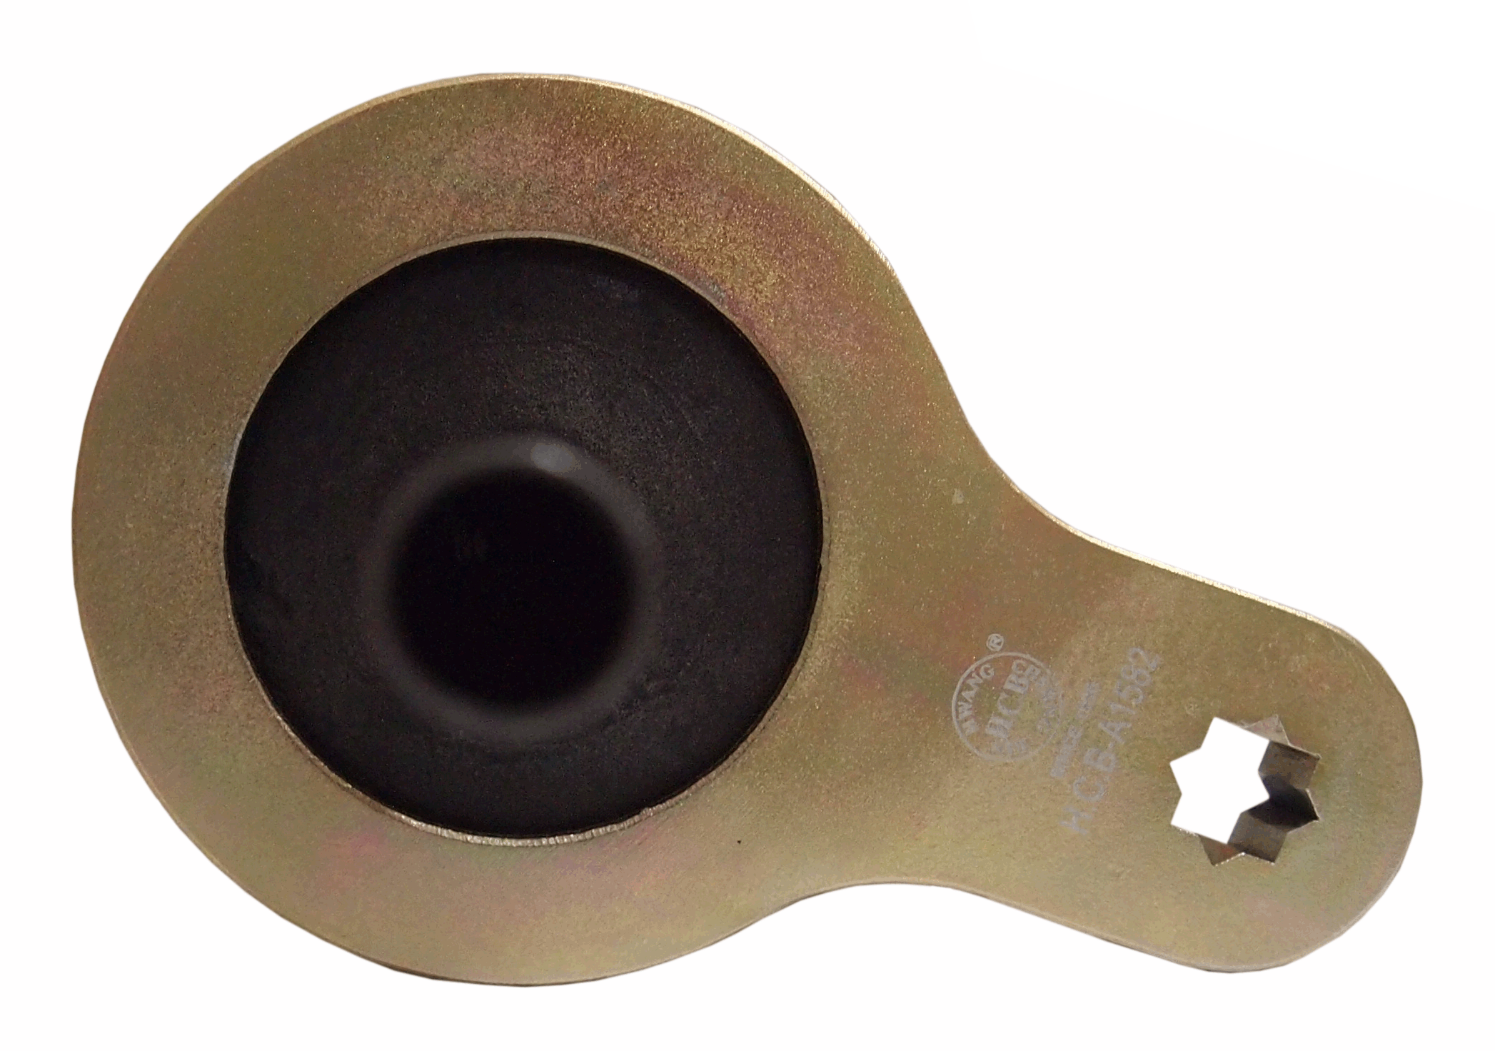
Dr. 1/2”

- Applicable: VOLVO FM12
- Size: Dr. 1/2", 6 Points, 74mm

H.C.B-A1582
VOLVO (FM) TRANSMISSION OIL TUBE NUT WRENCH
(74 mm)

Dr. 1/2”

- Applicable: VOLVO FM12
- Size: Dr. 1/2", 6 Points, 74mm

