
H.C.B-A1571
VAUXHALL/OPEL/CHEVROLET/SAAB/ALFA/FIAT
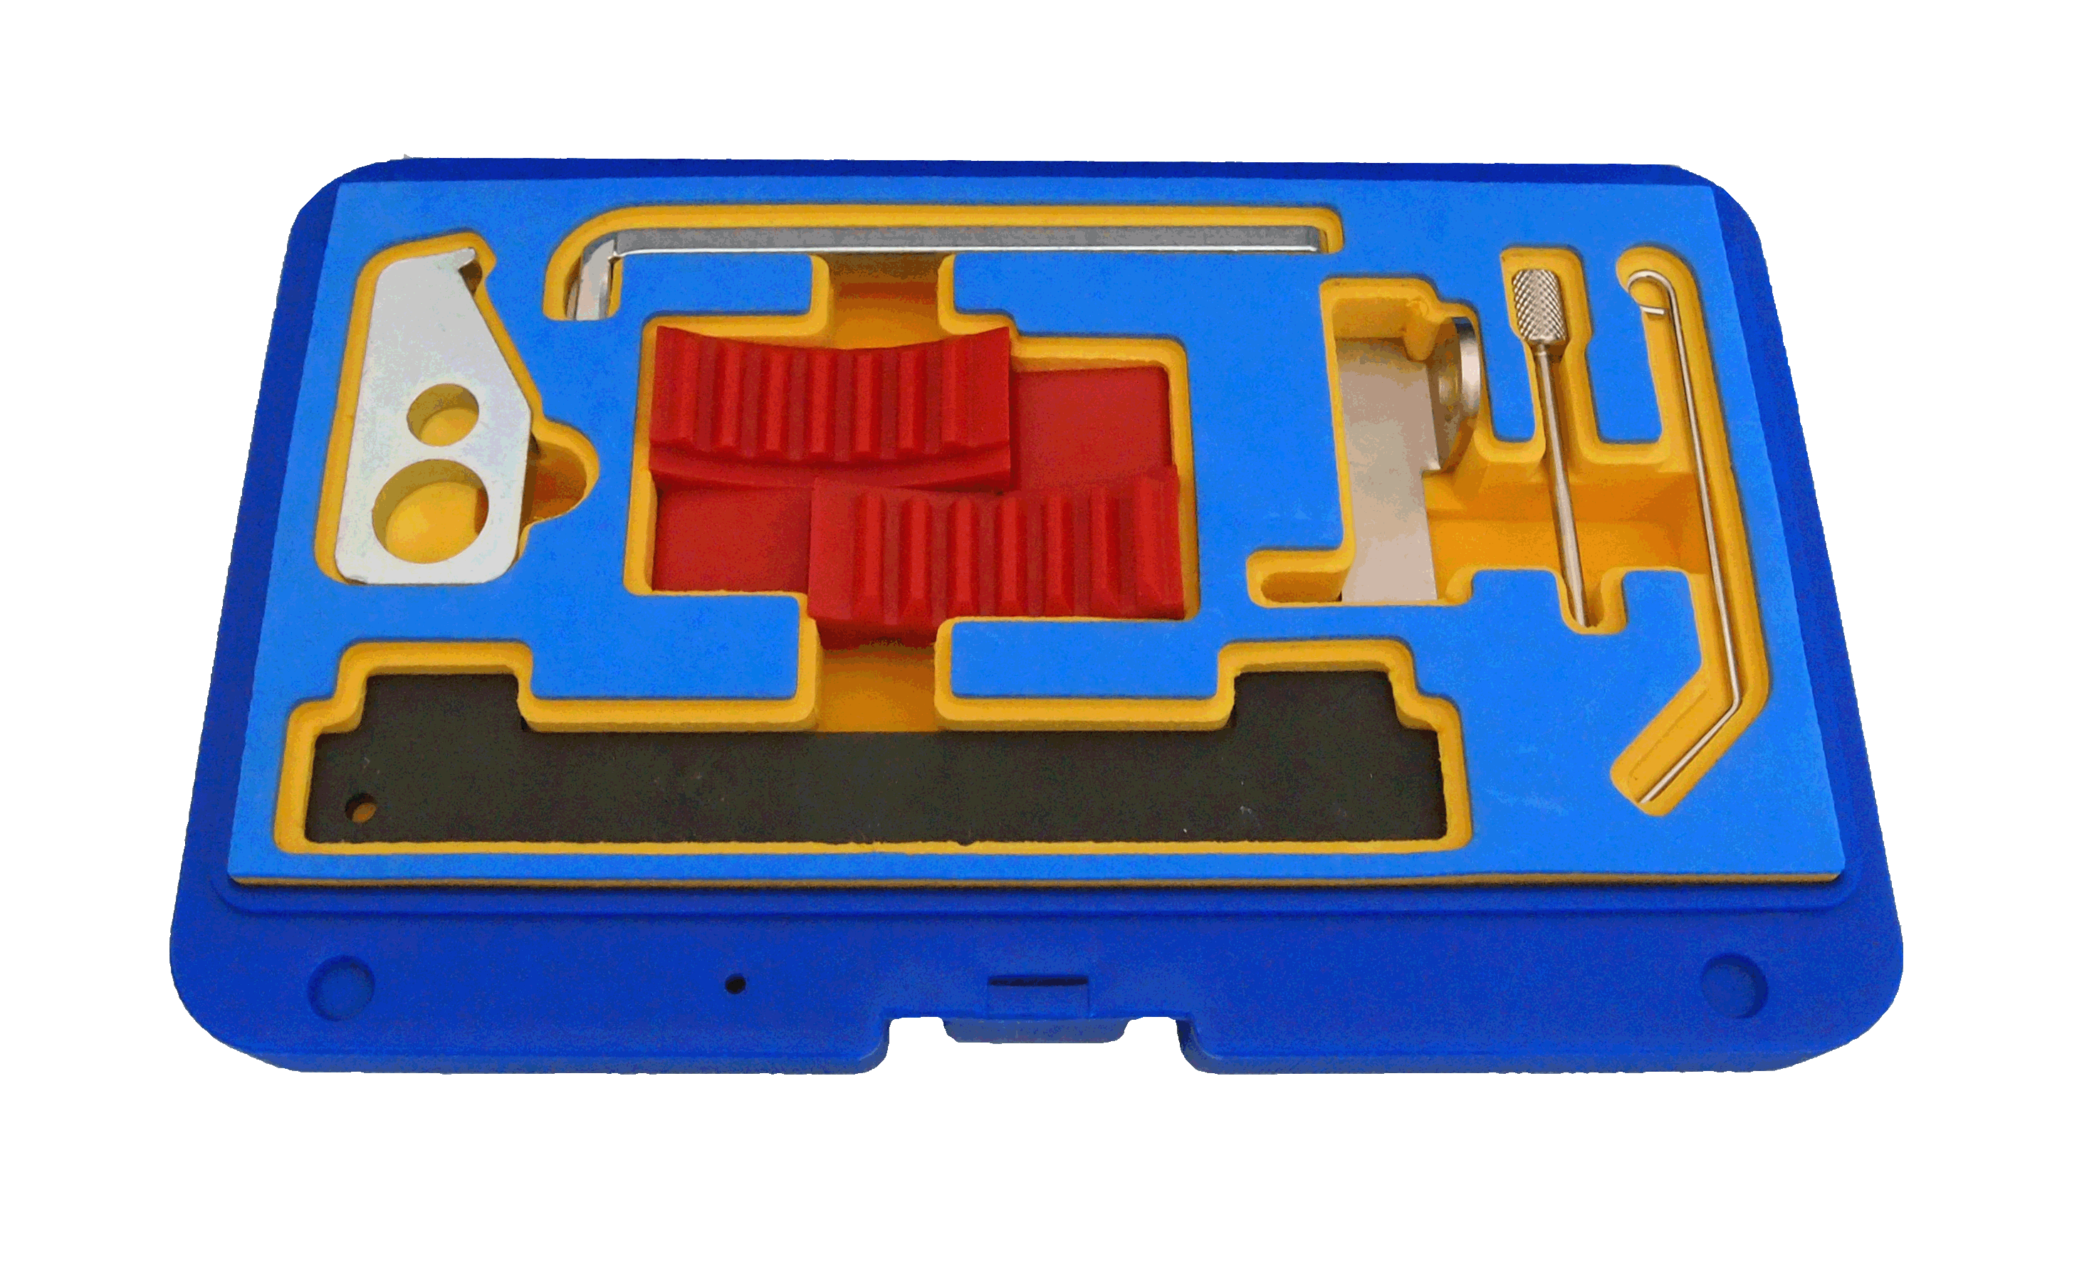
PETROL ENGINE TIMING TOOL KIT
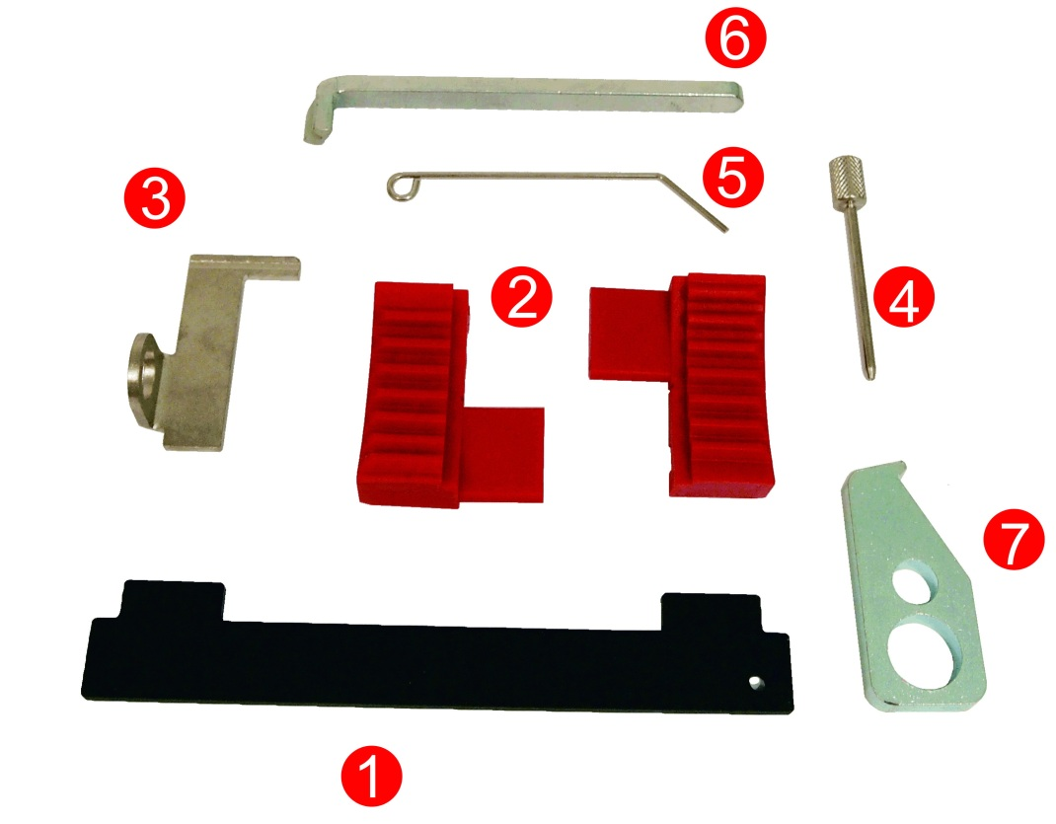

Item no. | OEM Tool | Description
1 | KM 6628A | Camshaft Locking Bar
1 | 2 000 012 000 | Camshaft Locking Bar
2 | KM 6340 | Camshaft Pulley Locking Tool(2)
2 | 2 000 012 100 | Camshaft Pulley Locking Tool(2)
3 | KM 6625 | Flywheel Holding Tool
3 | 2 000 012 800 | Flywheel Holding Tool
4 | KM 6130 | Tensioning Pin
4 | KM 6349 | Tensioning Pin
5 | KM 6333 | Tensioner Locking Pin
6 | KM 911 | Flywheel Locking Tool
7 | KM 652 | Flywheel Locking Device

Application:
Vauxhall, Opel: Corsa-D, Agila, Astra-G-H, Meriva, Zafira-B, Vectra-C, Signum, Insigna
Engine: 1.6, 1.8
Engine codes: Z16LEL, Z16LER, Z16LET, Z16XE1, Z16XEP, Z16XER, A16XER, 18XER, A18XER, 2HO/A18XEL
Chevrolet: Aveo, Cruze, Orlando
Engine: 1.4, 1.6, 1.8
Engine codes: G14D, LDD, LXV (F16D4), 2HO(Z18XER)
Alfa Romeo: 159
Fiat: Croma
Engine: 1.8
Engine codes: 939A4.000

H.C.B-A1571
VAUXHALL/OPEL/CHEVROLET/SAAB/ALFA/FIAT
PETROL ENGINE TIMING TOOL KIT

Item no. | OEM Tool | Description
1 | KM 6628A | Camshaft Locking Bar
1 | 2 000 012 000 | Camshaft Locking Bar
2 | KM 6340 | Camshaft Pulley Locking Tool(2)
2 | 2 000 012 100 | Camshaft Pulley Locking Tool(2)
3 | KM 6625 | Flywheel Holding Tool
3 | 2 000 012 800 | Flywheel Holding Tool
4 | KM 6130 | Tensioning Pin
4 | KM 6349 | Tensioning Pin
5 | KM 6333 | Tensioner Locking Pin
6 | KM 911 | Flywheel Locking Tool
7 | KM 652 | Flywheel Locking Device

Application:
Vauxhall, Opel: Corsa-D, Agila, Astra-G-H, Meriva, Zafira-B, Vectra-C, Signum, Insigna
Engine: 1.6, 1.8
Engine codes: Z16LEL, Z16LER, Z16LET, Z16XE1, Z16XEP, Z16XER, A16XER, 18XER, A18XER, 2HO/A18XEL
Chevrolet: Aveo, Cruze, Orlando
Engine: 1.4, 1.6, 1.8
Engine codes: G14D, LDD, LXV (F16D4), 2HO(Z18XER)
Alfa Romeo: 159
Fiat: Croma
Engine: 1.8
Engine codes: 939A4.000

