
H.C.B-A1562

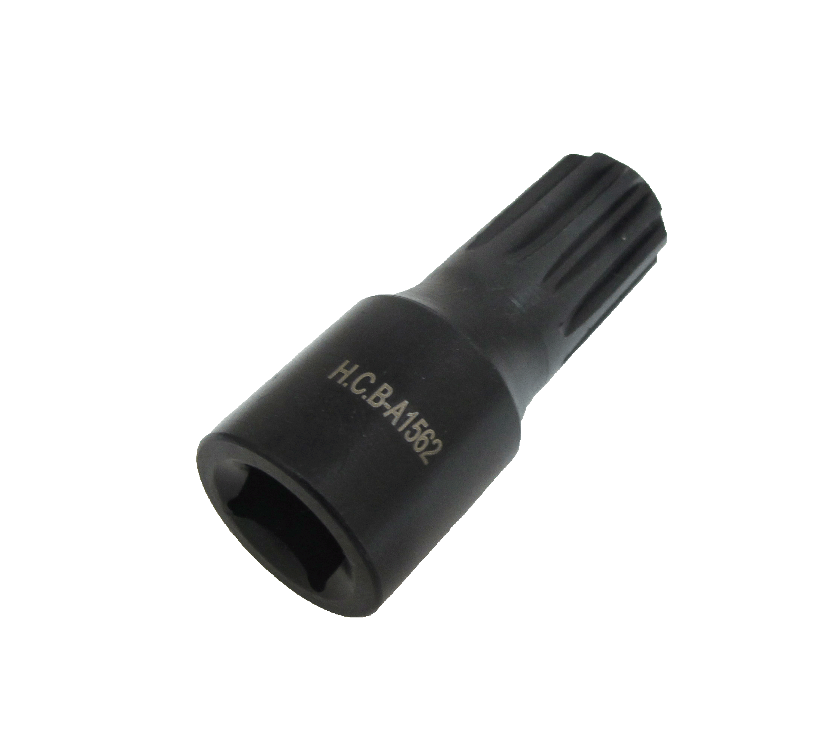
DAF (CF) 85 COMPRESSOR REAR SEAT BEARING FIX BOLT SOCKET (11 RIBS)
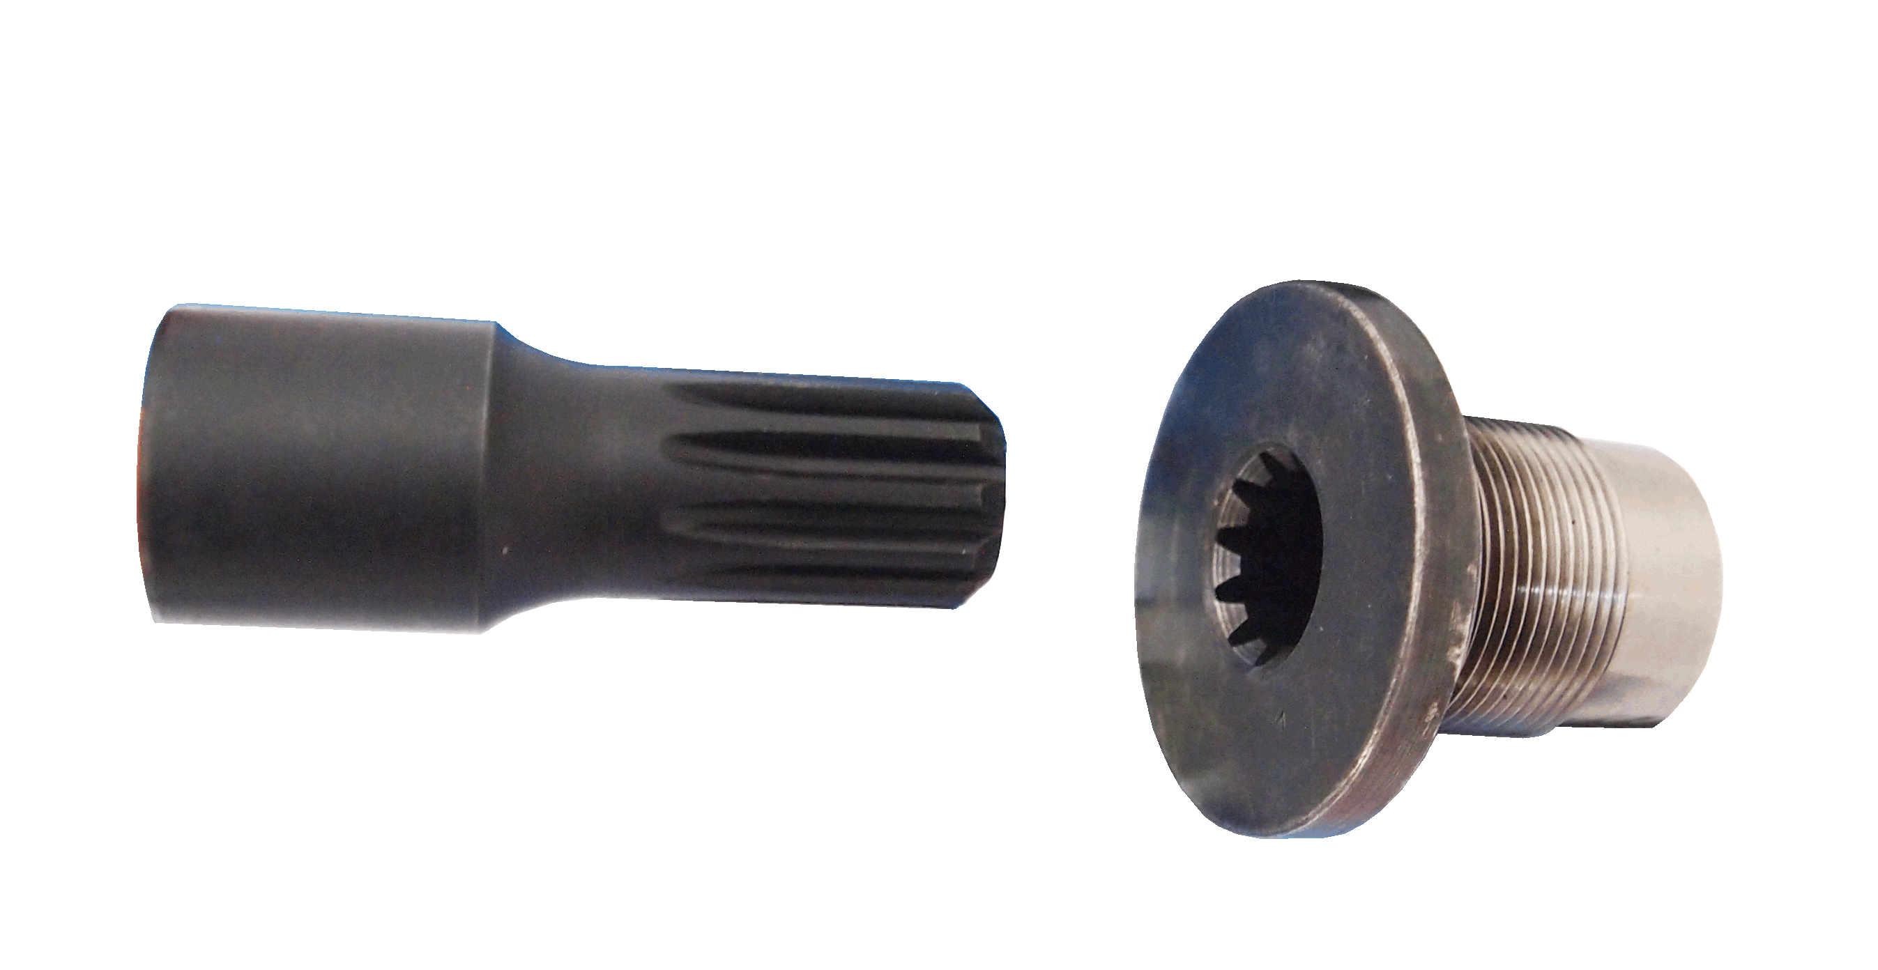

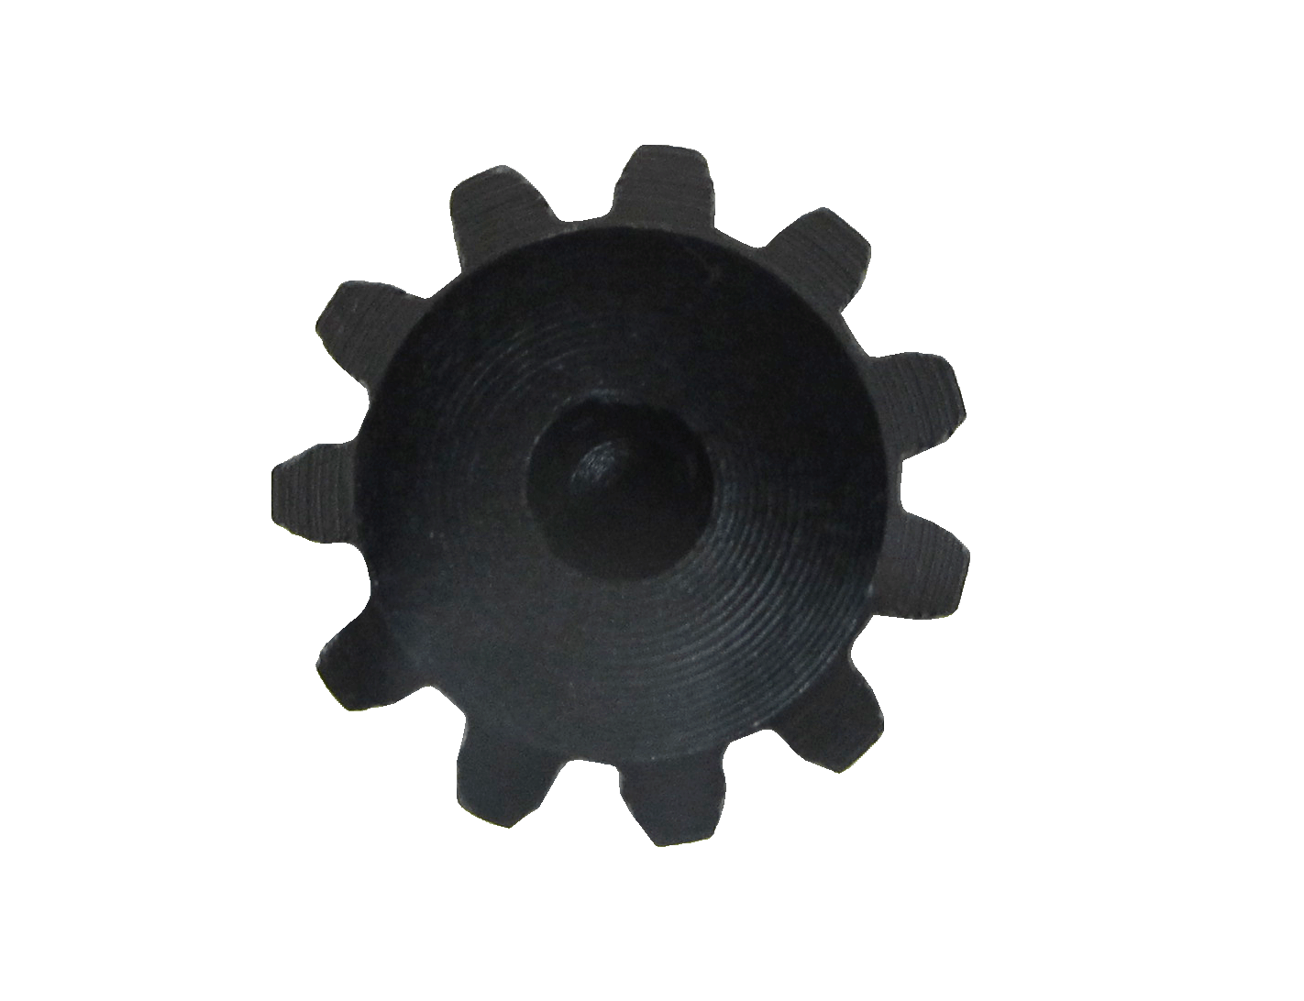
Dr.1/2’’

- Use for remove the bolt of compressor rear seat bearing.
- Application: DAF (CF) 85
- Size: Dr.1/2, 65mm(L), 11Ribs

