
H.C.B-A1557-90
BENZ ACTROS AXLE BOLT SOCKET (32 EPL, L: 90 mm)

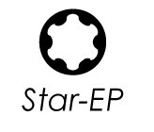
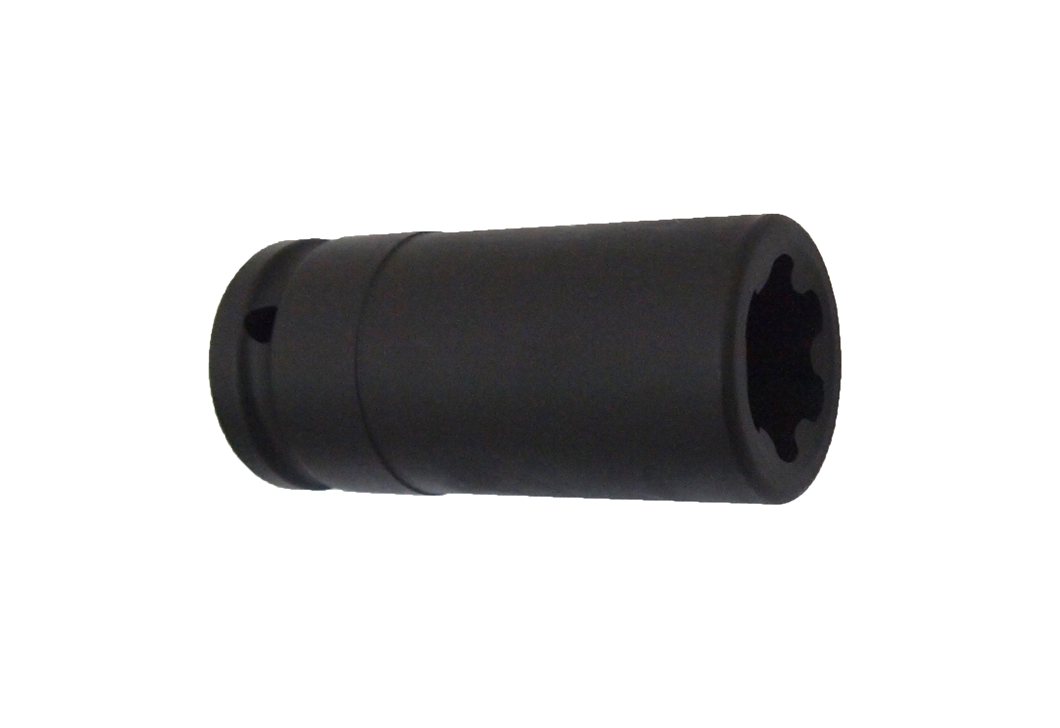

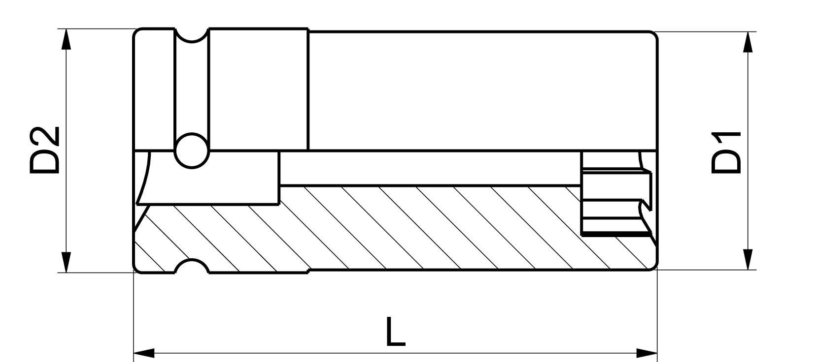

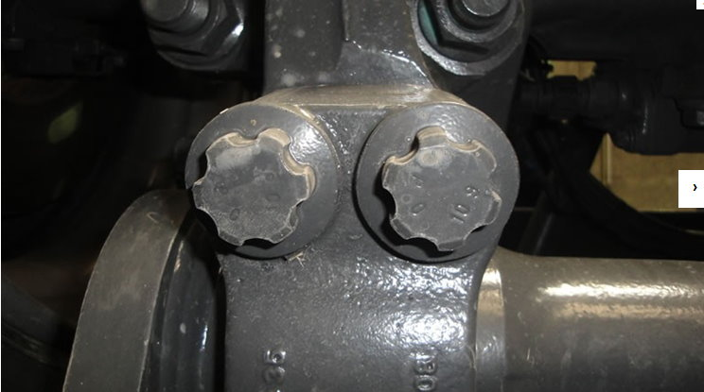
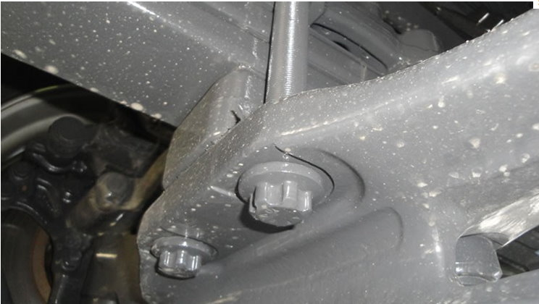

- For removing the mounting bolts of the axle on the Mercedes Benz
Actros.
- Size: Drive: 3/4", 32 EPL, L: 90 mm
- Impact resistant
- Application: MB Actros

H.C.B-A1557-90
BENZ ACTROS AXLE BOLT SOCKET (32 EPL, L: 90 mm)

- For removing the mounting bolts of the axle on the Mercedes Benz
Actros.
- Size: Drive: 3/4", 32 EPL, L: 90 mm
- Impact resistant
- Application: MB Actros

