
H.C.B-A1557-50
BENZ ACTROS AXLE BOLT SOCKET(32 EPL, L: 50mm)


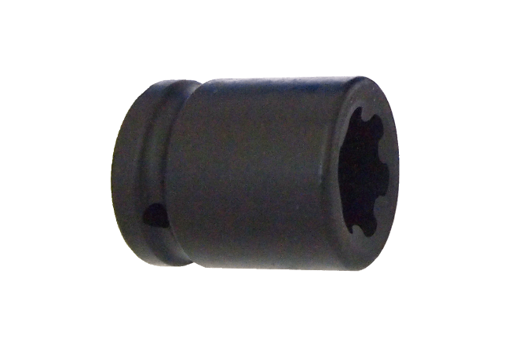
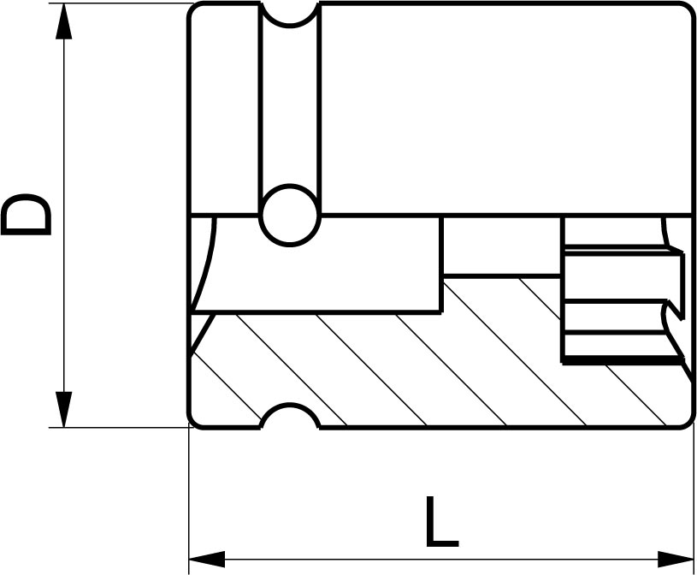

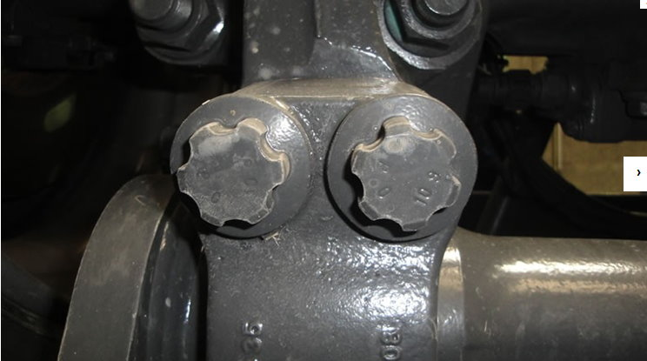
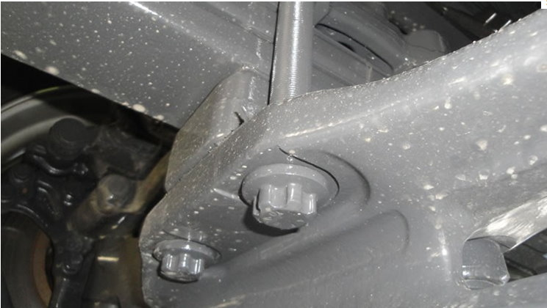

- For removing the mounting bolts of the axle on the Mercedes Benz Actros.
- Size: Drive: 3/4", 32 EPL, L:50mm
- Impact resistant
- Application：MB Actros

H.C.B-A1557-50
BENZ ACTROS AXLE BOLT SOCKET(32 EPL, L: 50mm)

- For removing the mounting bolts of the axle on the Mercedes Benz Actros.
- Size: Drive: 3/4", 32 EPL, L:50mm
- Impact resistant
- Application：MB Actros

