
H.C.B-A1482
BENZ REAR AXLE NUT SOCKET(Dr. 3/4",105-125mm)
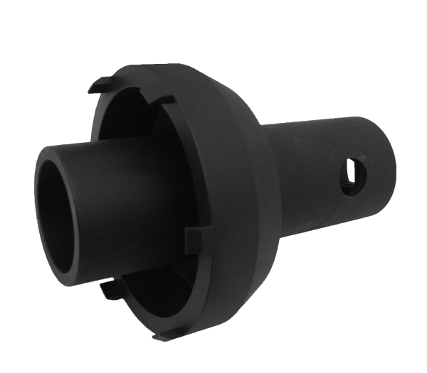
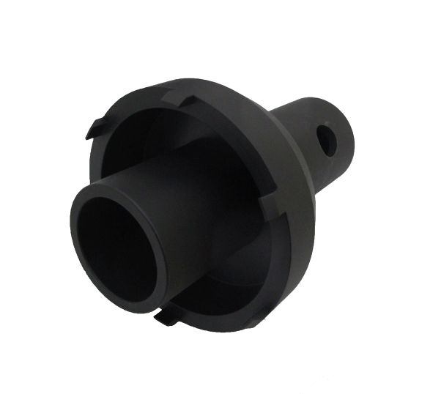

- Fix bearing while removing and installing real axle nut.
- It can be used with torque wrench for installing and removing.
- Material: SCM440.
- Application:Mercedes Benz Actros Rear axle HL/HL 8 (Hypoid).

ITEM | lnner  mm | Outer  mm | H  mm | Stud | Stud  width mm
A1482 | 105 | 125 | 180 | 116 | 10

H.C.B-A1482
BENZ REAR AXLE NUT SOCKET(Dr. 3/4",105-125mm)

- Fix bearing while removing and installing real axle nut.
- It can be used with torque wrench for installing and removing.
- Material: SCM440.
- Application:Mercedes Benz Actros Rear axle HL/HL 8 (Hypoid).

ITEM | lnner  mm | Outer  mm | H  mm | Stud | Stud  width mm
A1482 | 105 | 125 | 180 | 116 | 10

