
H.C.B-A1466
SAF WHEEL SHAFT COVER SOCKET
( Dr.1’’,8 POINTS,130mm)
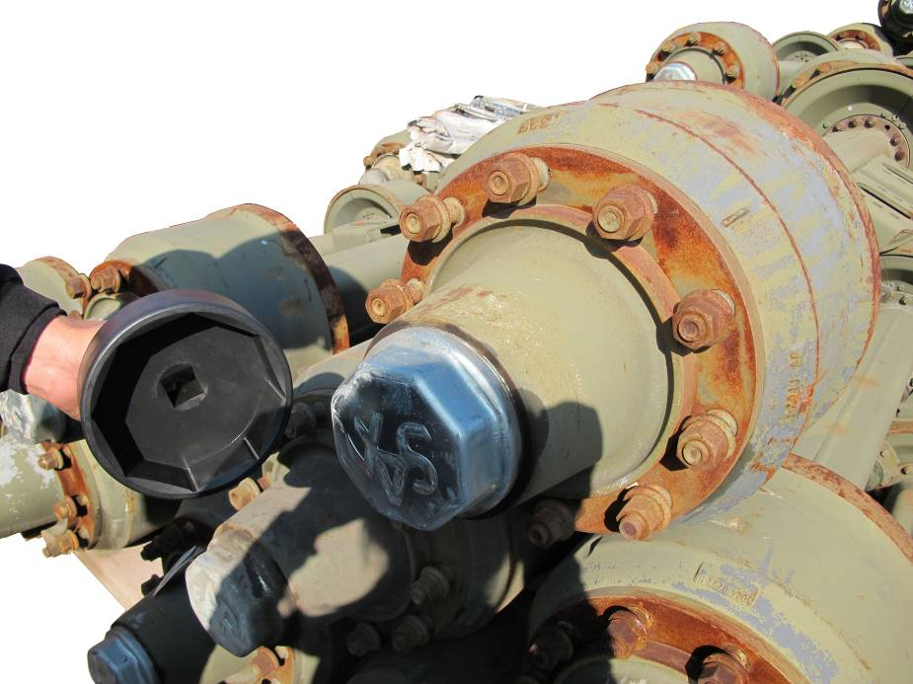
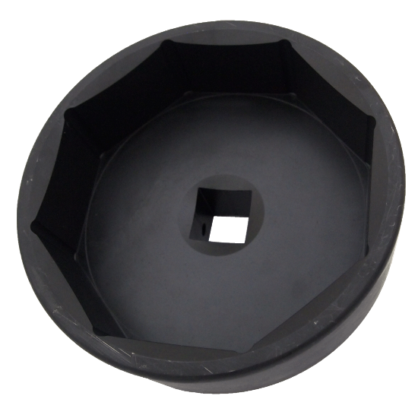
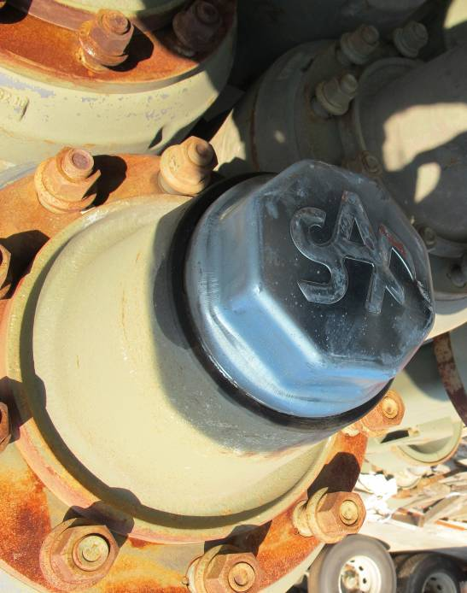
- For extracting the wheel cover.
- Application: SAF

