
H.C.B-A1461
BENZ (W221) WHEEL LUG SOCKET
(17 mm, L: 50 mm)

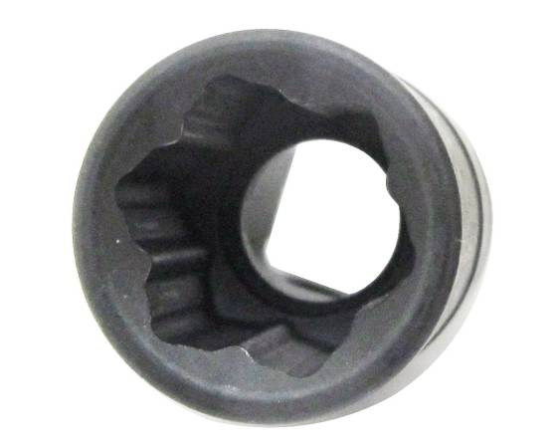
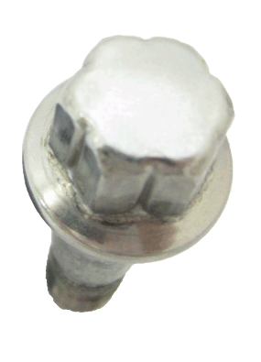

Mercedes # 000 990 5407
Dr. 1/2”

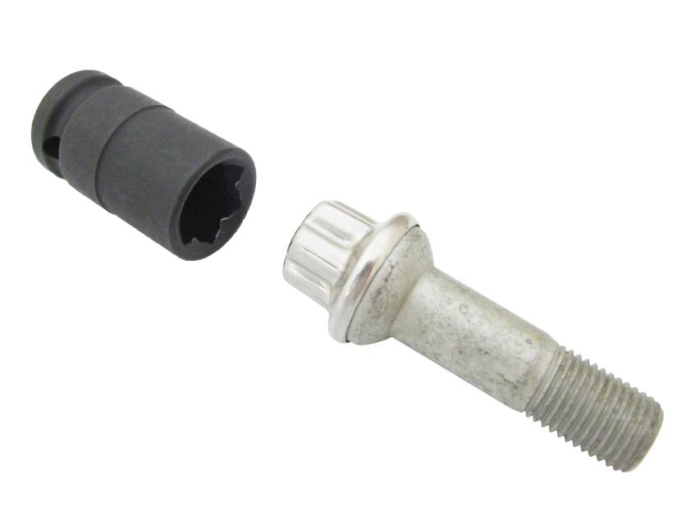

- Material: CR-V
- Size: Dr. 1/2”x 50mm (L)
- Application: Maybach, W221 (S-class) and late CL-class Mercedes which came installed with unique convex lug bolts (Mercedes # 000 990 5407).
H.C.B-A1461
BENZ (W221) WHEEL LUG SOCKET
(17 mm, L: 50 mm)

Mercedes # 000 990 5407
Dr. 1/2”

- Material: CR-V
- Size: Dr. 1/2”x 50mm (L)
- Application: Maybach, W221 (S-class) and late CL-class Mercedes which came installed with unique convex lug bolts (Mercedes # 000 990 5407).

