
H.C.B-A1454
DAF CF85 43 TONS TRAILER DRIVE SHAFT SOCKET (EURO 4 & EURO 5) (Dr. 3/4")
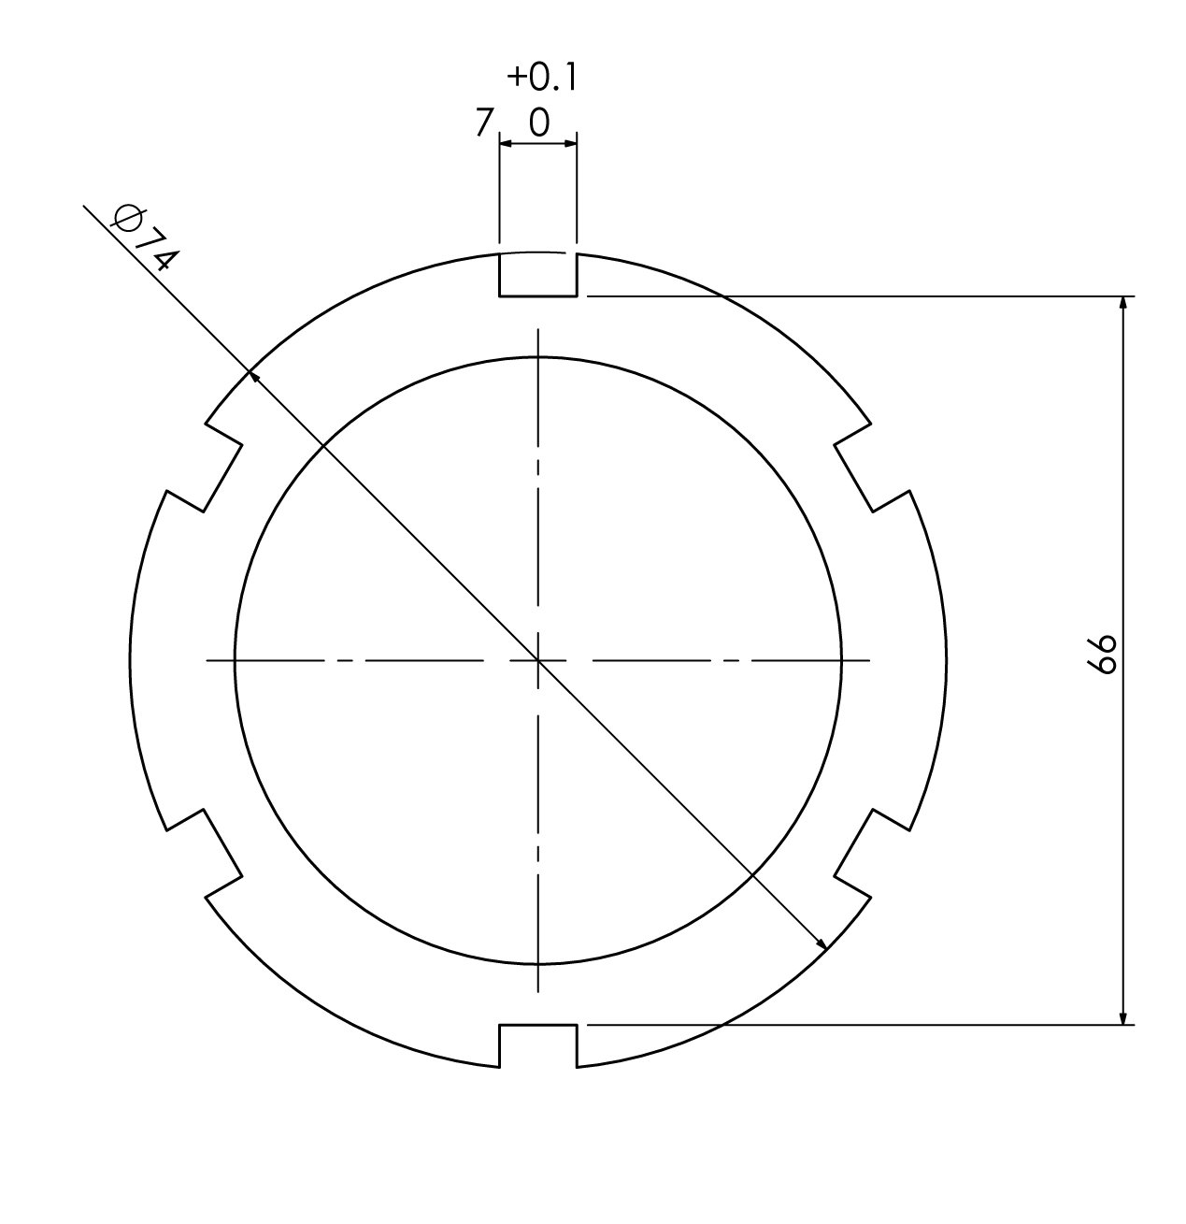
Dr. 3/4”
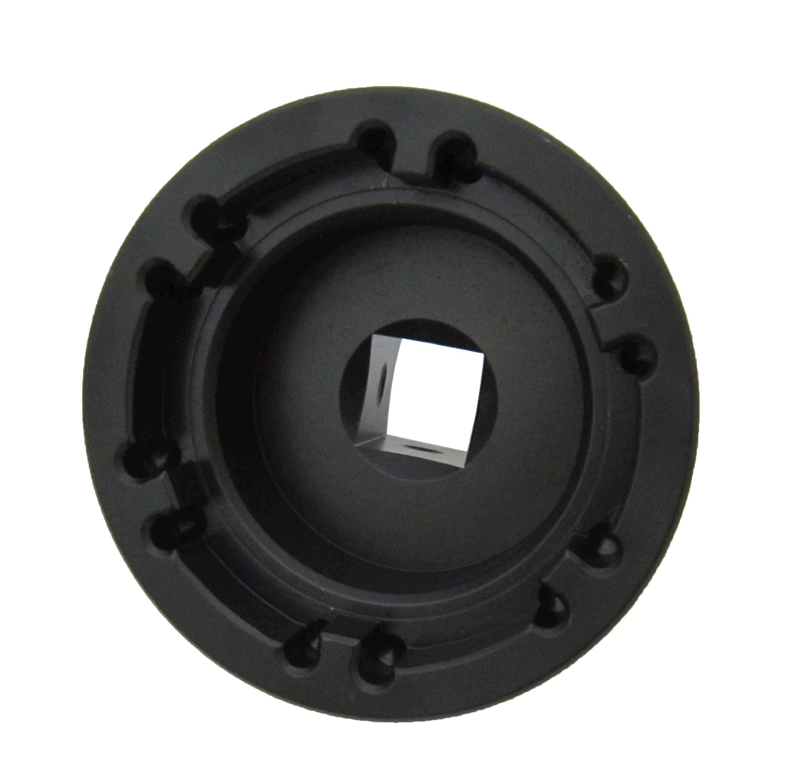

NUT SIZE

- Use the torque wrench to control the nut to tighten or loosen bearing.
- Material: SCM440.
- Application: DAF CF85 43 TONS (EURO 4 & EURO 5)

H.C.B-A1454
DAF CF85 43 TONS TRAILER DRIVE SHAFT SOCKET (EURO 4 & EURO 5) (Dr. 3/4")
Dr. 3/4”

NUT SIZE

- Use the torque wrench to control the nut to tighten or loosen bearing.
- Material: SCM440.
- Application: DAF CF85 43 TONS (EURO 4 & EURO 5)

