
H.C.B-A1432
DAF TRANSMISSION NEUTRAL POSITION ADJUSTMENT TOOL
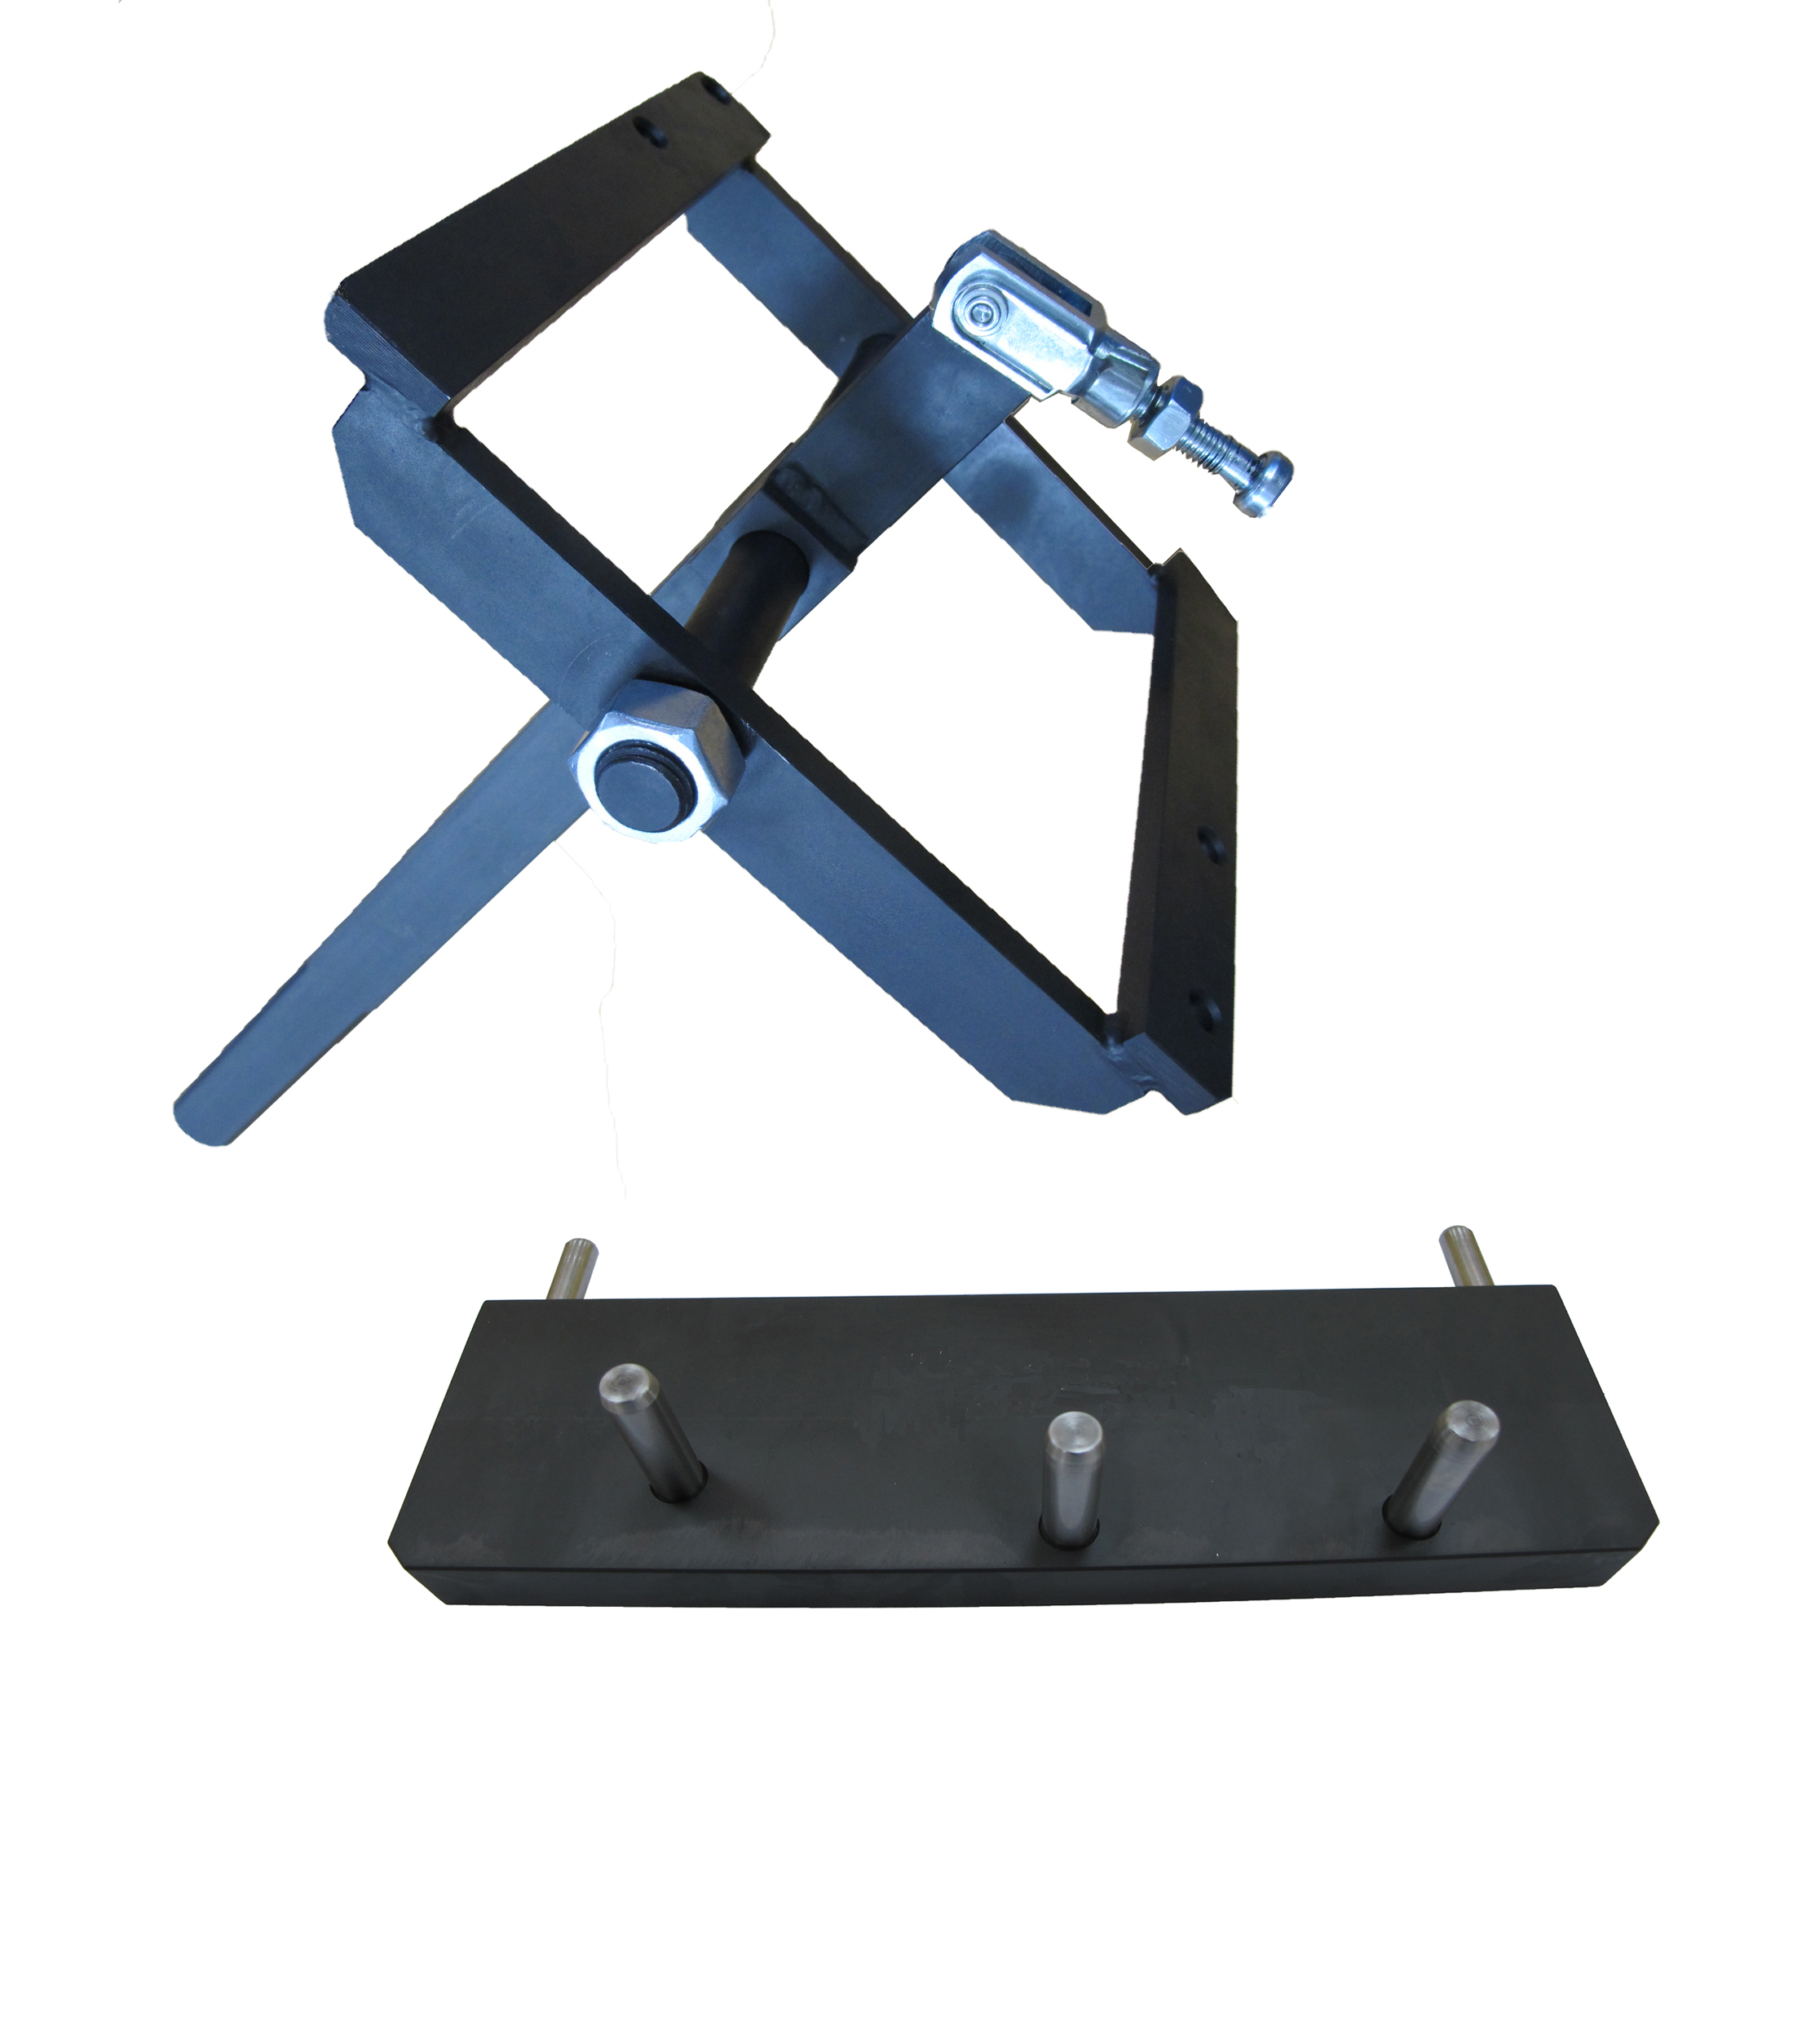
2

1
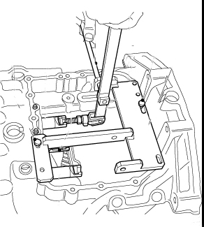

Step:
Before using this tool, seal the opening of the transmission in case object falls into it.
- Put the central selector shaft in the neutral position, and then fix H.C.B-A1432-1 to the upper lid of transmission to align the control rod.
- Screw H.C.B-A1432-2 to the transmission. To start align the central selector shaft first.
- Use the same way to align the rest selector shafts.

- Used to adjust the neutral position of transmission.
- H.C.B-A1432-1 is for adjusting the control-rods in the upper part of transmission.
H.C.B-A1432-2 is for adjusting the selector shafts of transmission.
- Application: DAF Tiptronic truck (EURO 3.4.5).

