
H.C.B-A1418
FUEL FILTER LID WRENCH (Dr. 3/8”, 8 RIBS, 109 mm)
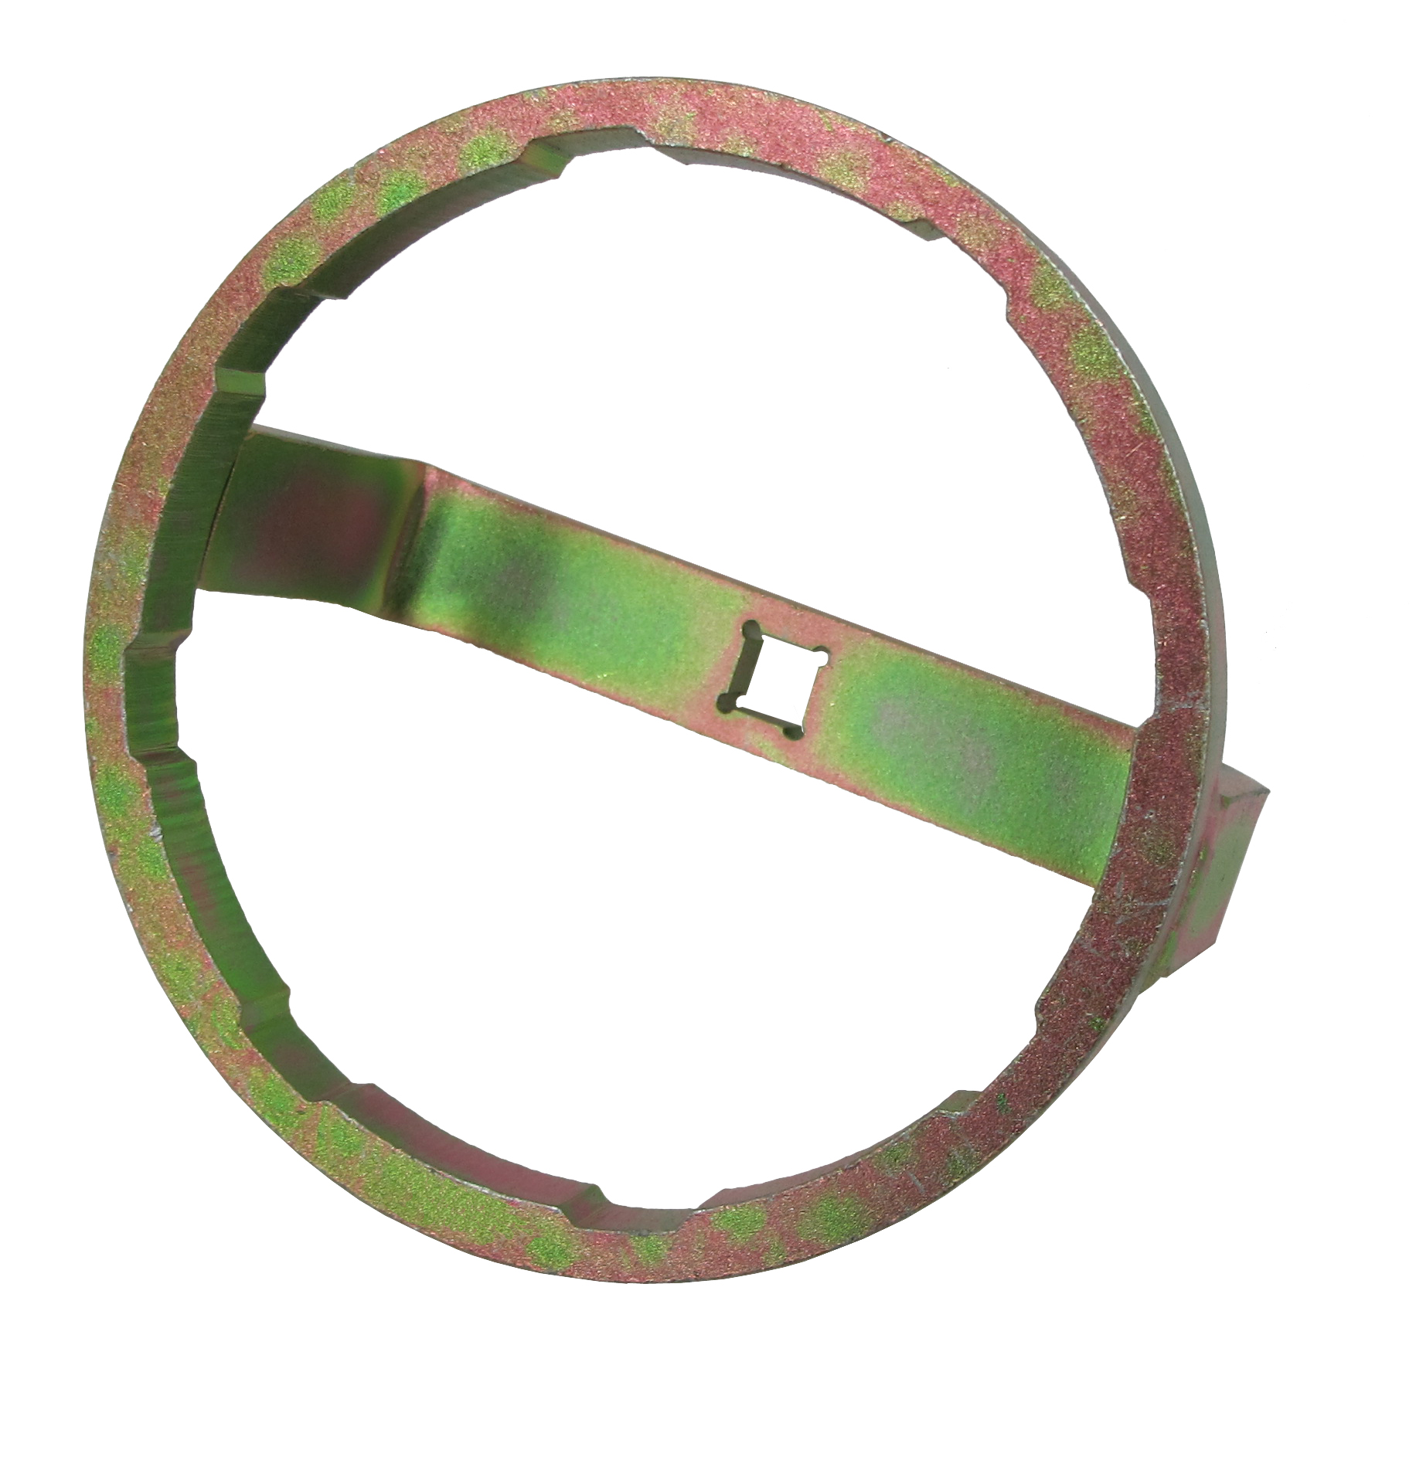

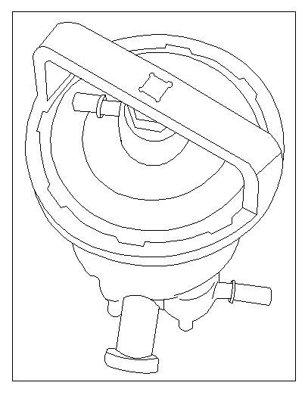
- For removing and installing fuel filters.
- Size: Dr. 3/8”, 8 RIBS, 109 mm
- Used to avoid damage to components when working on fuel system.
- Application: PEUGOET, CITROEN, RENAULT

H.C.B-A1418
FUEL FILTER LID WRENCH (Dr. 3/8”, 8 RIBS, 109 mm)

- For removing and installing fuel filters.
- Size: Dr. 3/8”, 8 RIBS, 109 mm
- Used to avoid damage to components when working on fuel system.
- Application: PEUGOET, CITROEN, RENAULT

