
H.C.B-A1417
FUEL FILTER LID WRENCH (Dr. 3/8”, 108 mm)

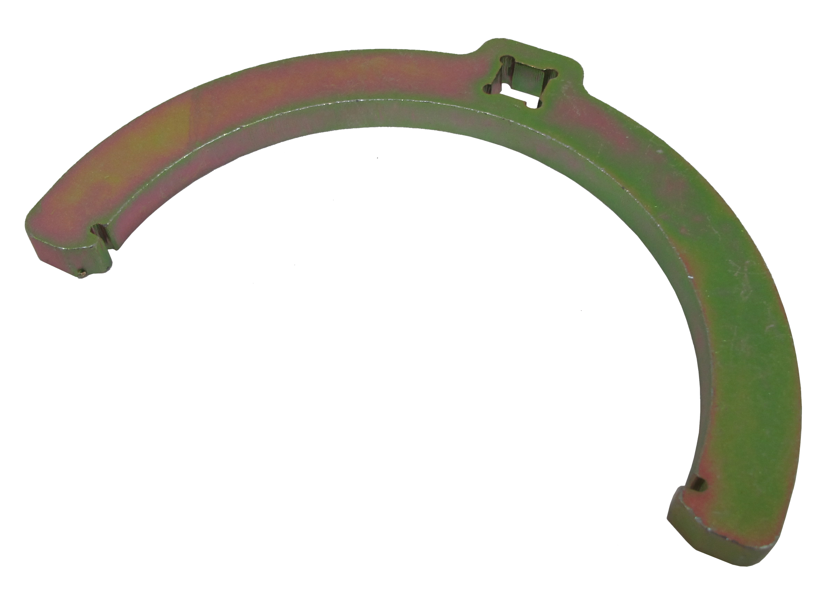
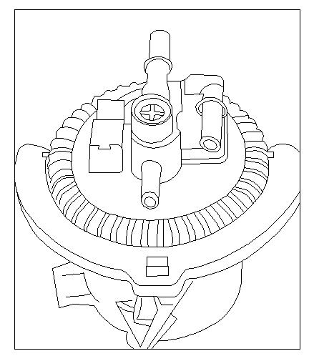

- Size: Dr. 3/8”, 108 mm
- For removing and installing the fuel filter cap when replacing the fuel
cartridge.
- Used to avoid damage to components when working on fuel system.
- Application: PEUGOET, CITROEN,RENAULT with HDI ENGINES

H.C.B-A1417
FUEL FILTER LID WRENCH (Dr. 3/8”, 108 mm)

- Size: Dr. 3/8”, 108 mm
- For removing and installing the fuel filter cap when replacing the fuel
cartridge.
- Used to avoid damage to components when working on fuel system.
- Application: PEUGOET, CITROEN,RENAULT with HDI ENGINES

