
H.C.B-A1404
ROR TRAILER REAR WHEEL NUT SOCKET
(DRUM BRAKE) (Dr.1", 8 POINTS, 83mm,3 1/4”)


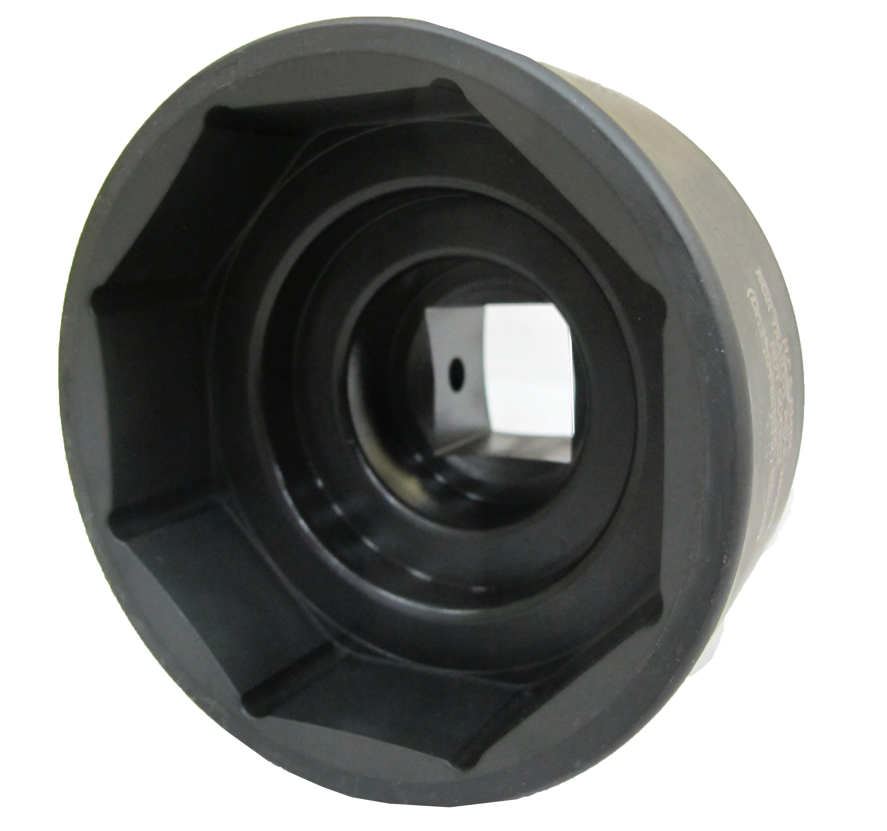
Dr. 1”

- Remove the rear wheel nut of ROR trailer to change the bearing.
- The robust socket is manufactured from a piece of material.
- It can be used with torque wrench for installing and removing.
- Material: SCM440.
- Size: Dr. 1” ， 8 POINTS，3 1/4” ，83 mm
- Application: ROR TM series Trailer rear wheel nut.

H.C.B-A1404
ROR TRAILER REAR WHEEL NUT SOCKET
(DRUM BRAKE) (Dr.1", 8 POINTS, 83mm,3 1/4”)

Dr. 1”

- Remove the rear wheel nut of ROR trailer to change the bearing.
- The robust socket is manufactured from a piece of material.
- It can be used with torque wrench for installing and removing.
- Material: SCM440.
- Size: Dr. 1” ， 8 POINTS，3 1/4” ，83 mm
- Application: ROR TM series Trailer rear wheel nut.

