
H.C.B-A1402
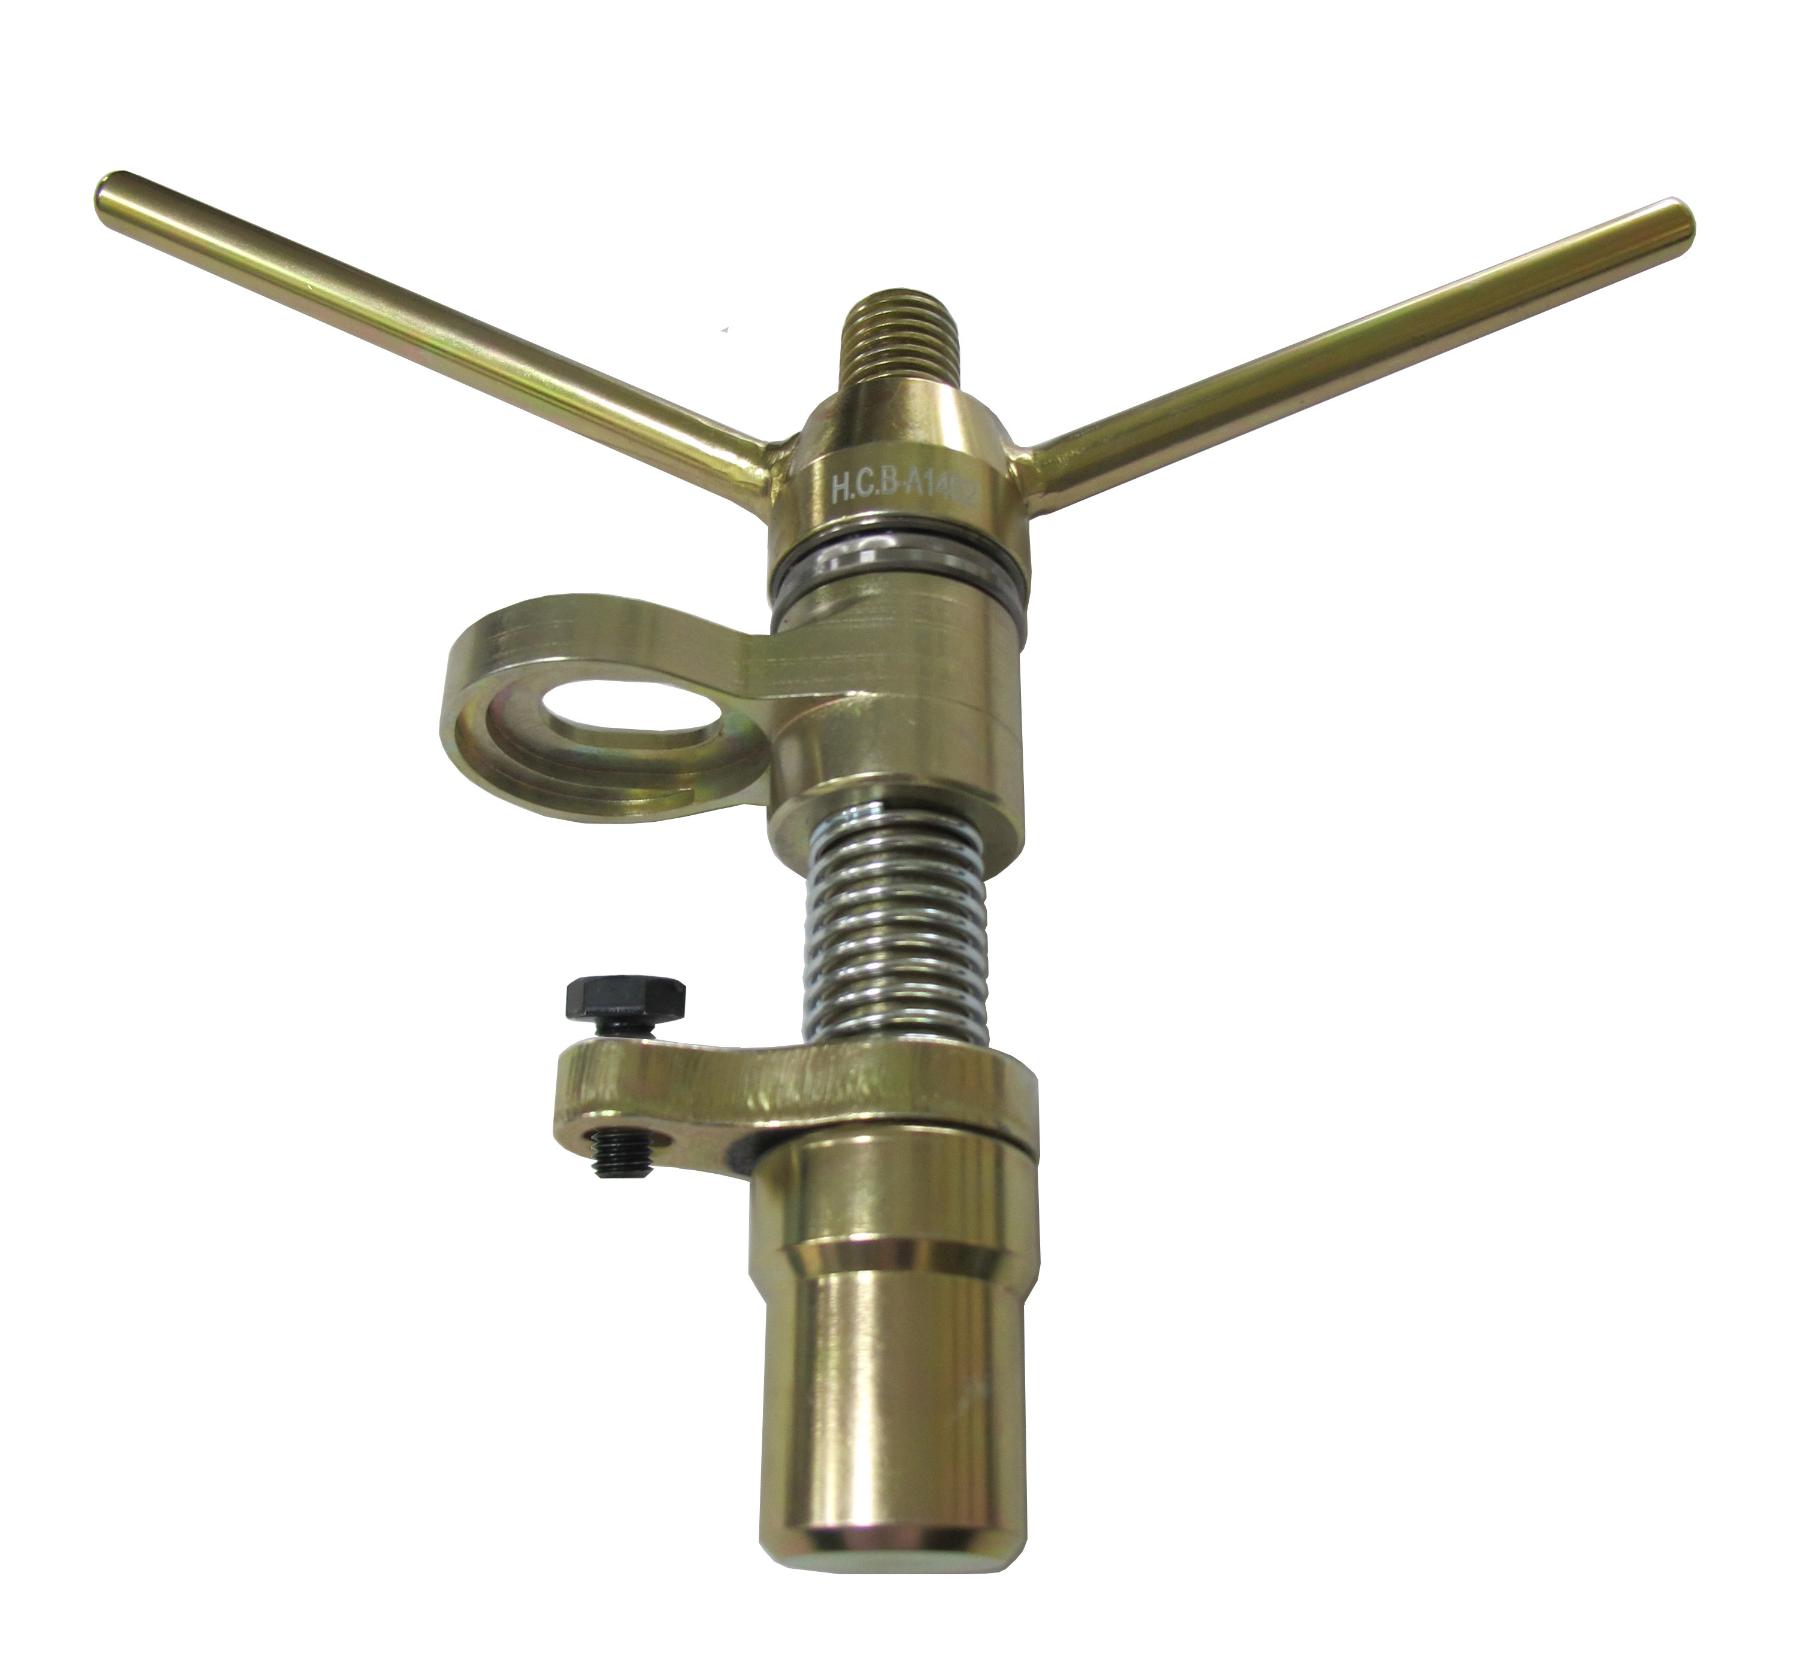
VOLVO (FM) VALVE SPRING COMPRESSOR TOOL KIT

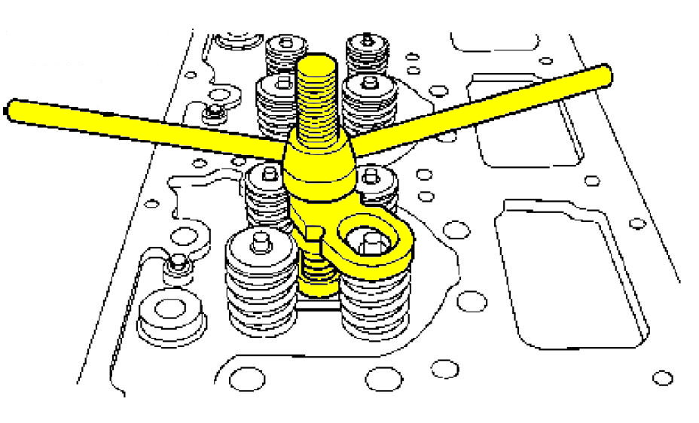
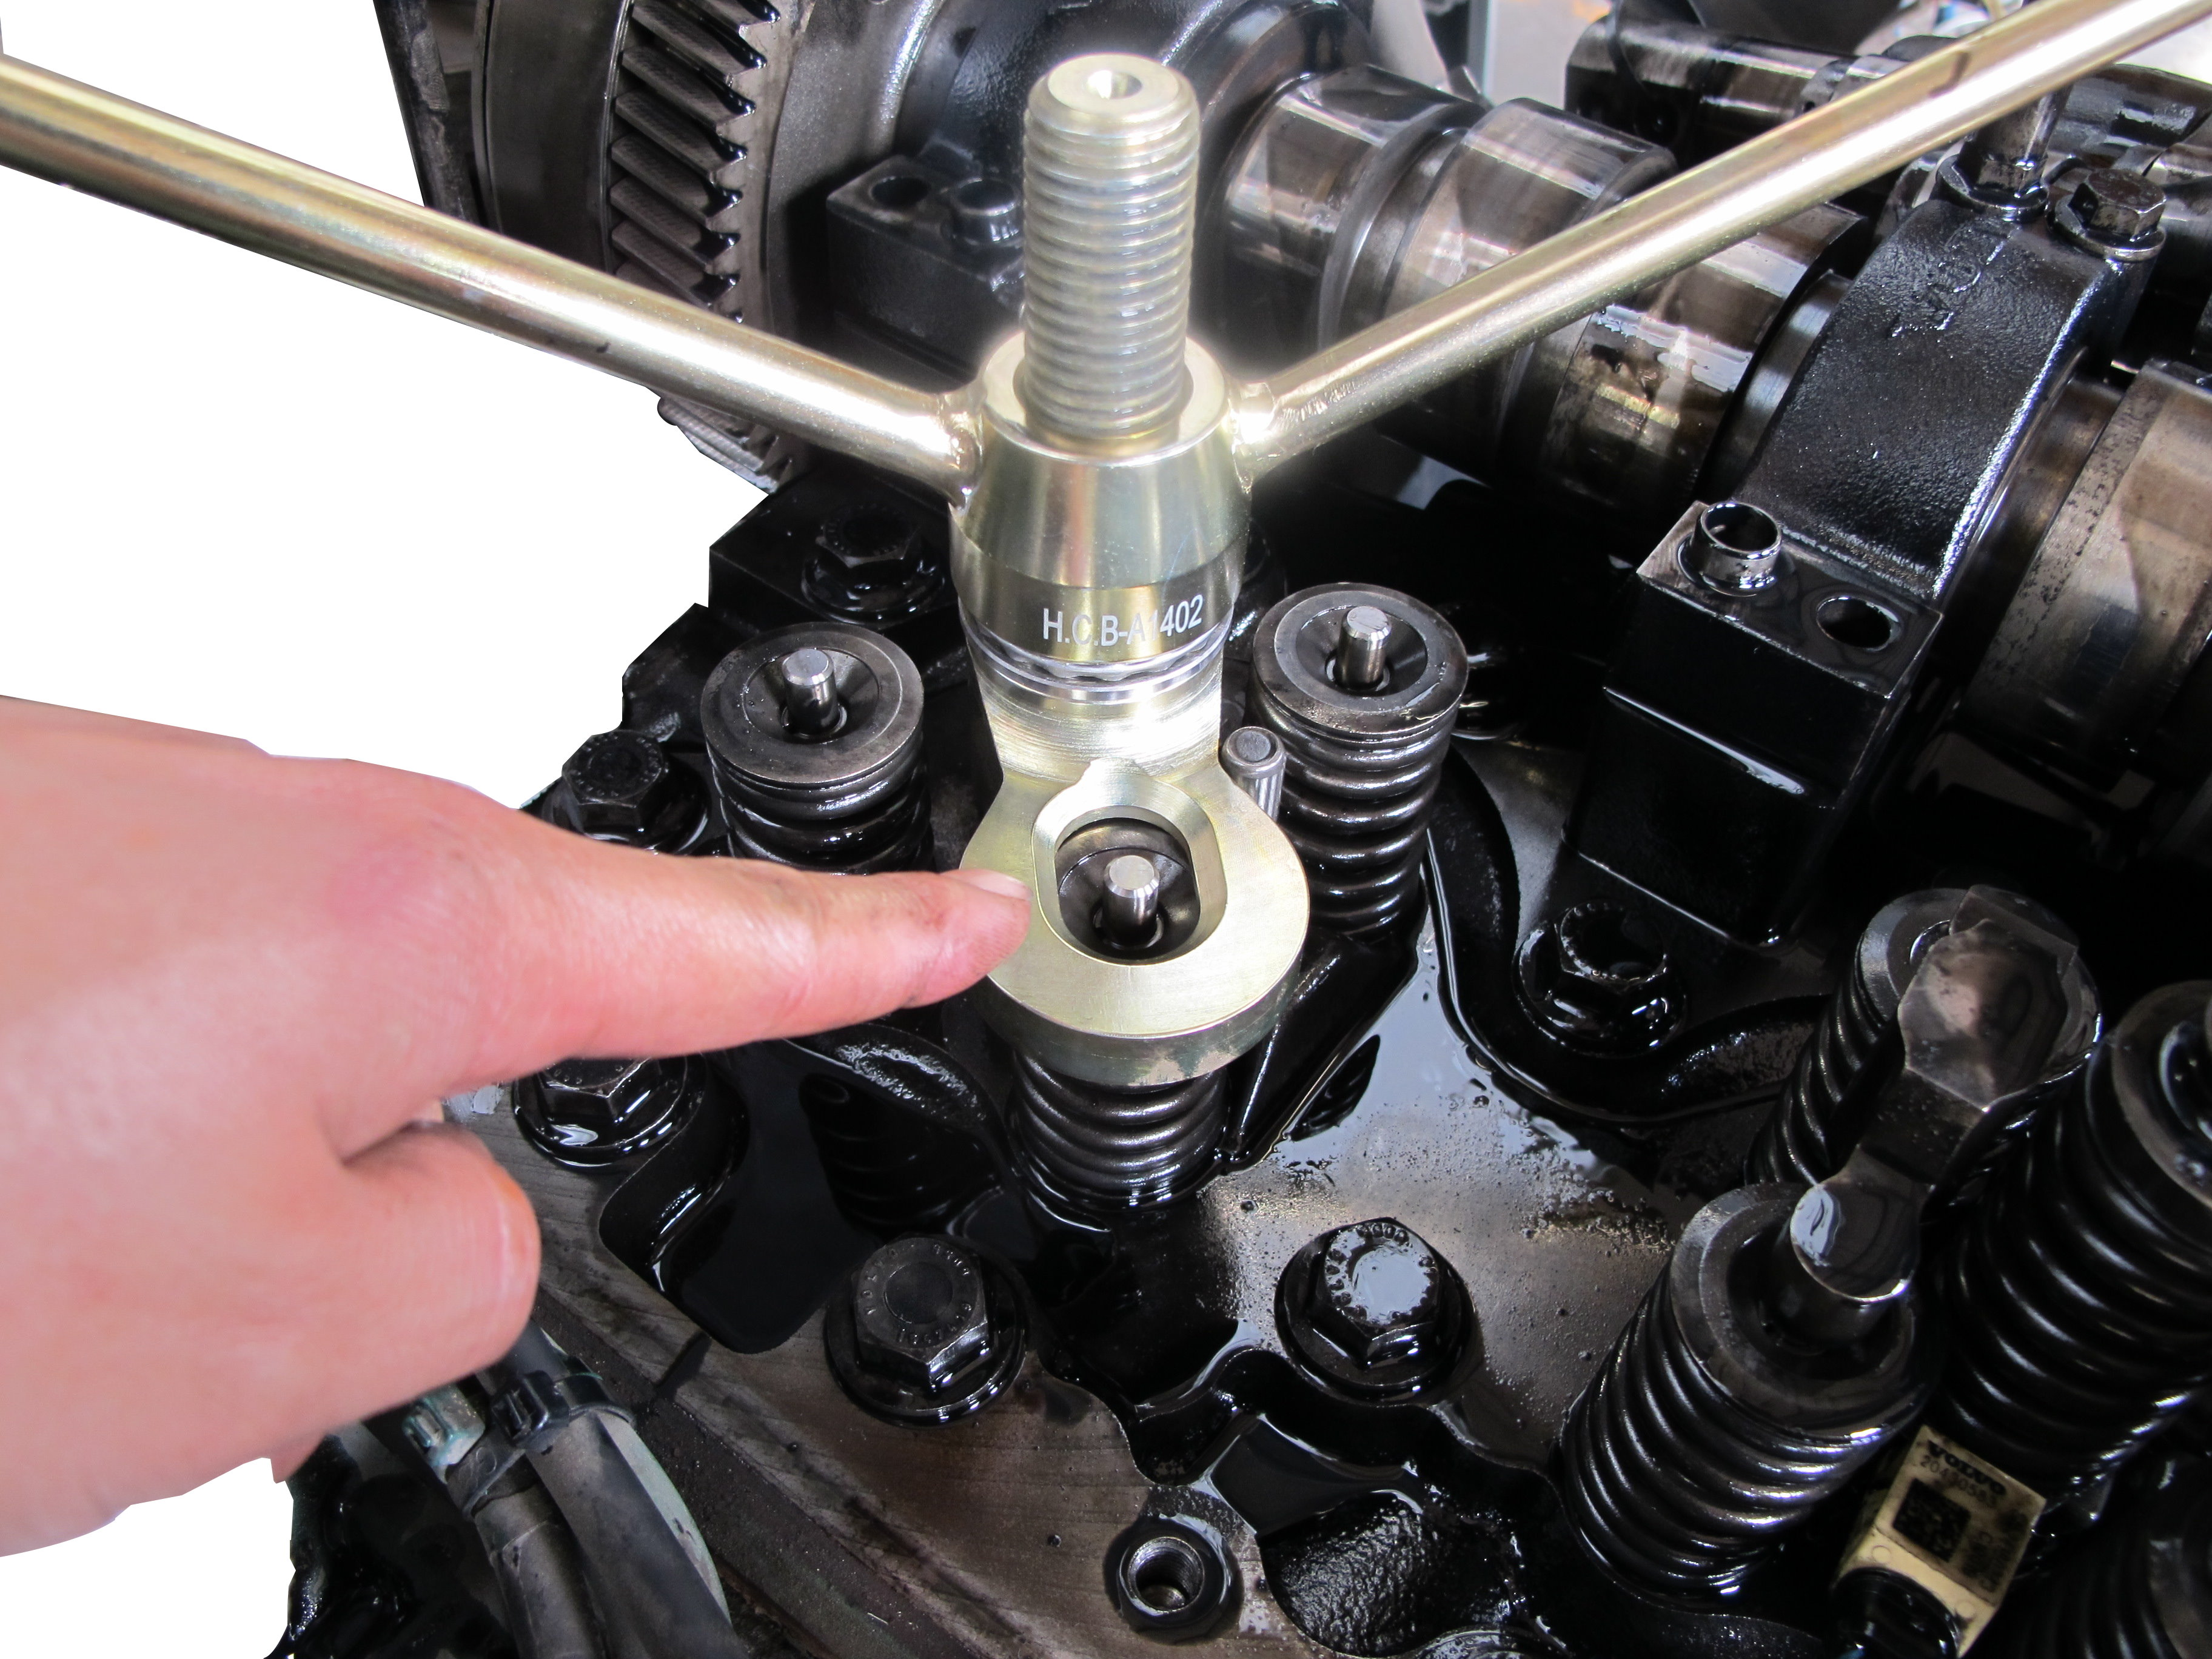

Step 1: Place the cylinder head on a flat and clean surface. Make sure that the cylinder head is not scratched when the valves are removed.
Step 2: Install press tool H.C.B-A1402 in the unit injector hole. Screw the tool in the unit injector retainer screw hole.
Step 3: Place the tool’s moving part above the valve spring to be removed. Turn down the tool’s “wing nut” until the valve disc has been pressed down and the valve collets can be removed.
NOTE: Place valves and springs in a marked rack to facilitate reinstallation at the same place in the cylinder head.
Step 4: Remove remaining valves the same way as above.
Step 5: Remove the oil seals from the valve guides.
H17
Step 6: The size for the screw: M10 x P1.5, L: 25mm
- To remove and install the valve spring of VOLVO FM 12 truck.
- Genuine no.: 9990210
- Application: VOLVO FM12 TRUCK
- The size for the screw: M10 x P1.5, L: 25mm
H.C.B-A1402
VOLVO (FM) VALVE SPRING COMPRESSOR TOOL KIT

Step 1: Place the cylinder head on a flat and clean surface. Make sure that the cylinder head is not scratched when the valves are removed.
Step 2: Install press tool H.C.B-A1402 in the unit injector hole. Screw the tool in the unit injector retainer screw hole.
Step 3: Place the tool’s moving part above the valve spring to be removed. Turn down the tool’s “wing nut” until the valve disc has been pressed down and the valve collets can be removed.
NOTE: Place valves and springs in a marked rack to facilitate reinstallation at the same place in the cylinder head.
Step 4: Remove remaining valves the same way as above.
Step 5: Remove the oil seals from the valve guides.
H17
Step 6: The size for the screw: M10 x P1.5, L: 25mm
- To remove and install the valve spring of VOLVO FM 12 truck.
- Genuine no.: 9990210
- Application: VOLVO FM12 TRUCK
- The size for the screw: M10 x P1.5, L: 25mm

