
H.C.B-A1387
BENZ AXLE NUT SOCKET
(H36, 12 POINTS, 95mm)
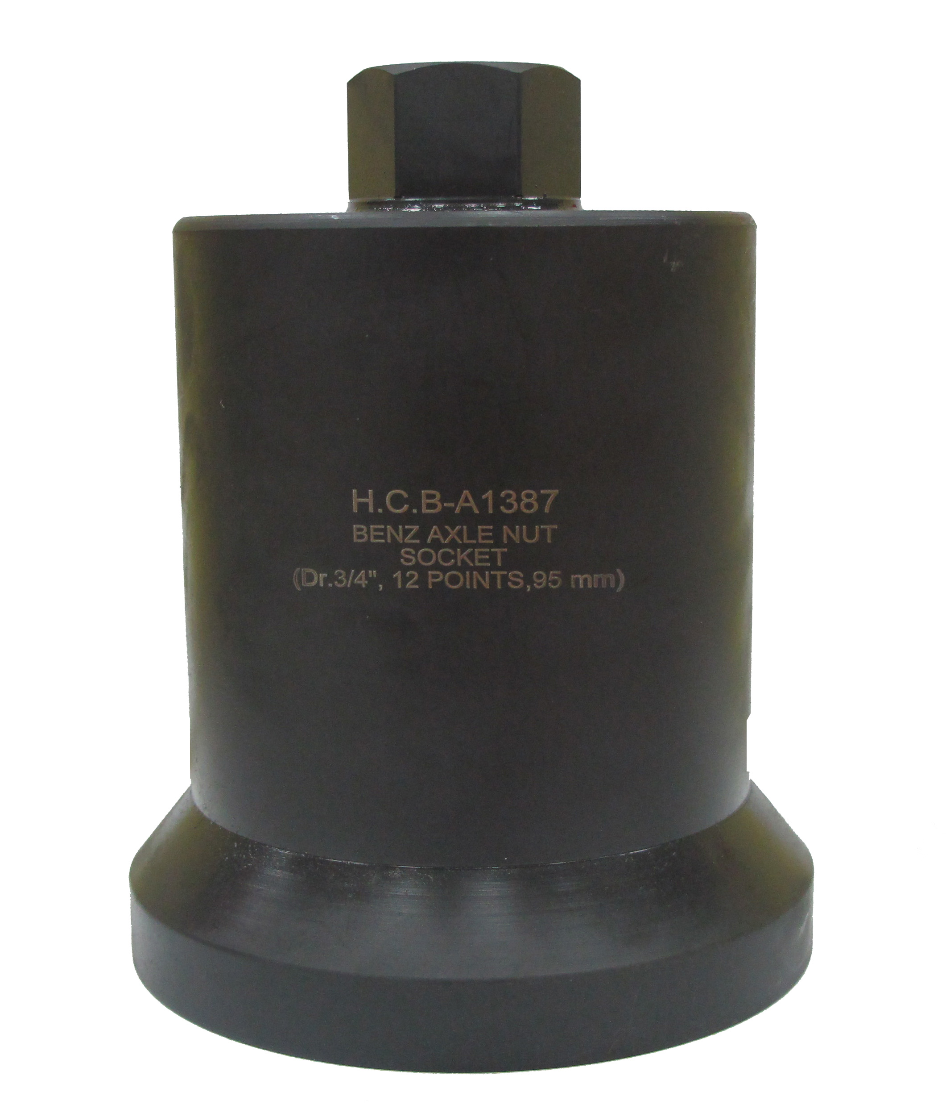

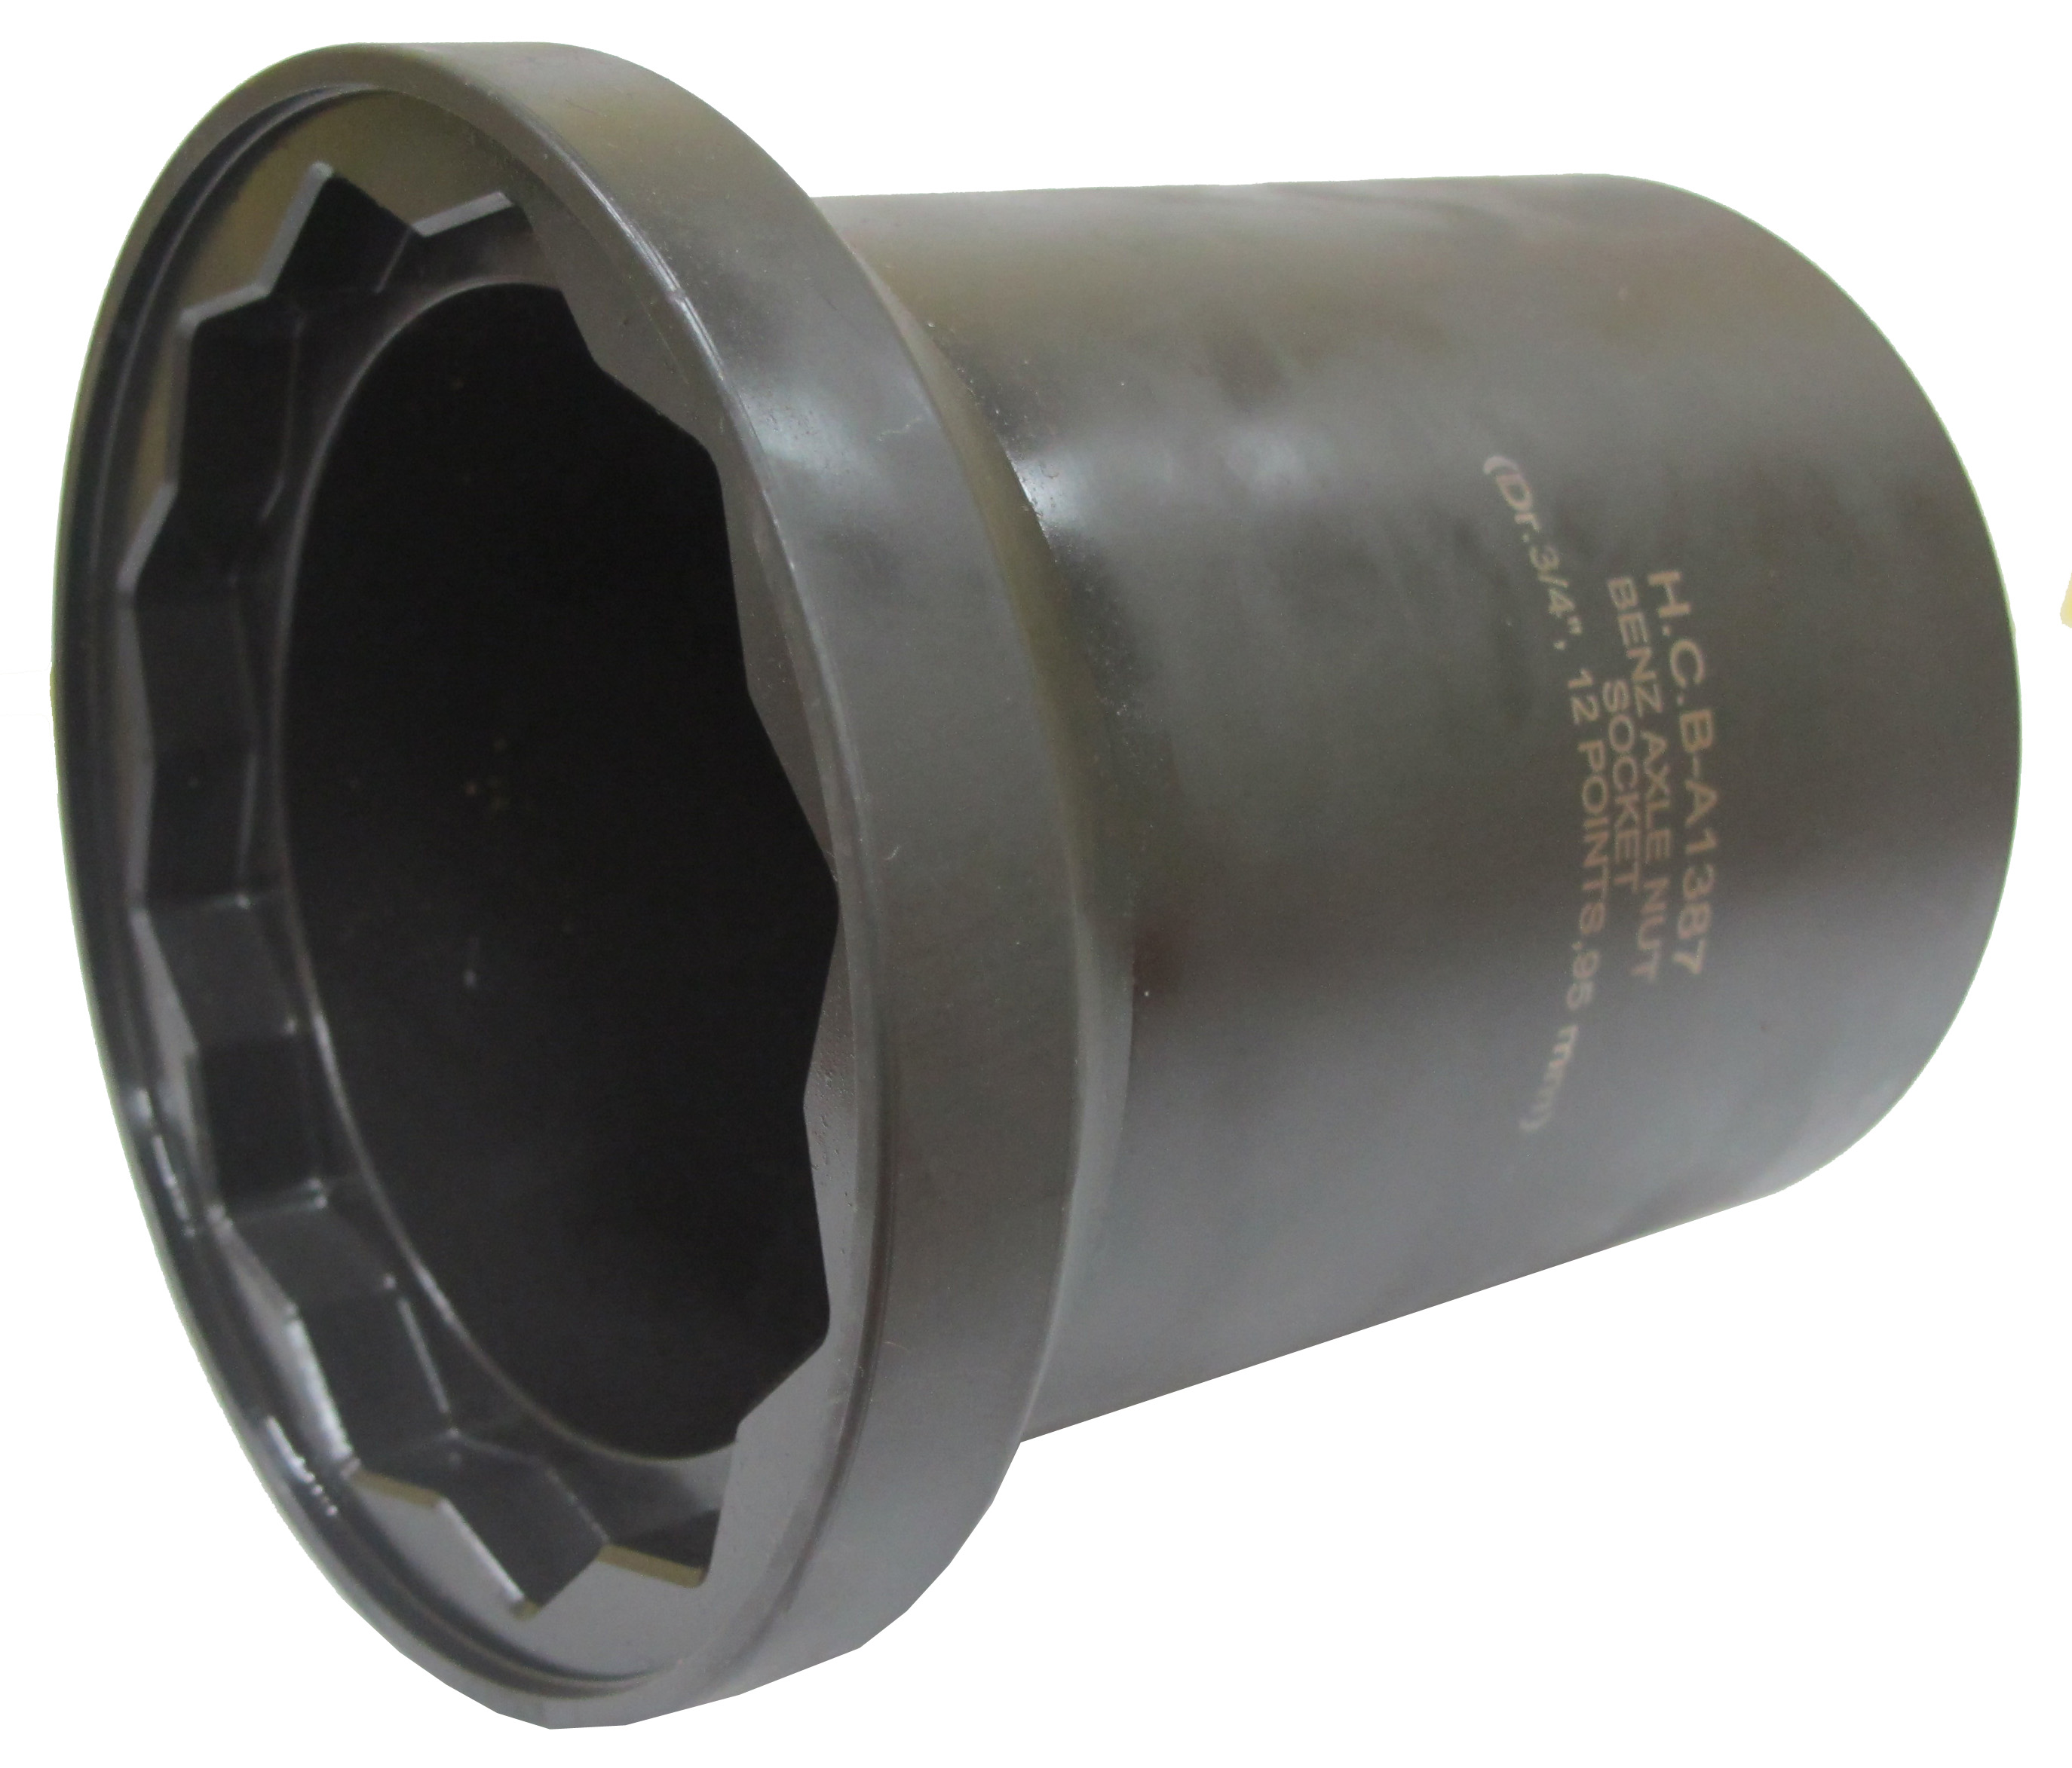

- The size of drive nut is 6 points, 36mm.
- Suited to male nut in the axle.
- It can be used with impact wrench or torque wrench.
- Size: H36, 12 points, 95mm
- Applicable: Benz trailer

H.C.B-A1387
BENZ AXLE NUT SOCKET
(H36, 12 POINTS, 95mm)

- The size of drive nut is 6 points, 36mm.
- Suited to male nut in the axle.
- It can be used with impact wrench or torque wrench.
- Size: H36, 12 points, 95mm
- Applicable: Benz trailer

