
H.C.B-A1384
BENZ TRUCK TRANSMISSION OIL LEVEL GAUGE
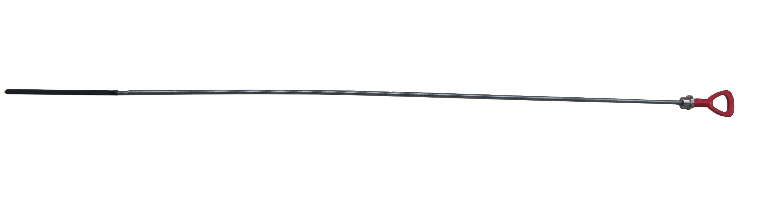

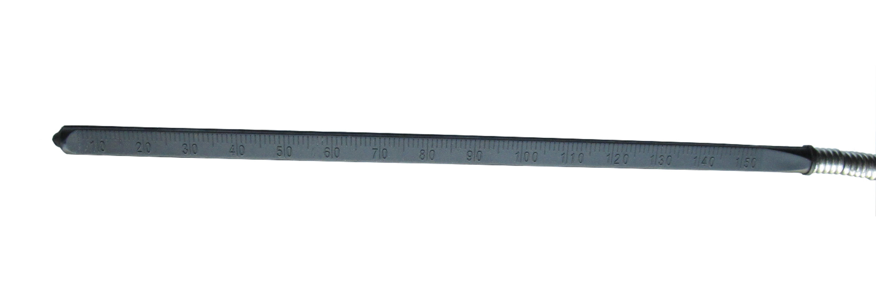

- For measuring the oil level of transmission.
- Application: Benz truck

