
H.C.B-A1380

VOLVO TRUCK FAN BEARING BASE SOCKET (Dr. 1/2")
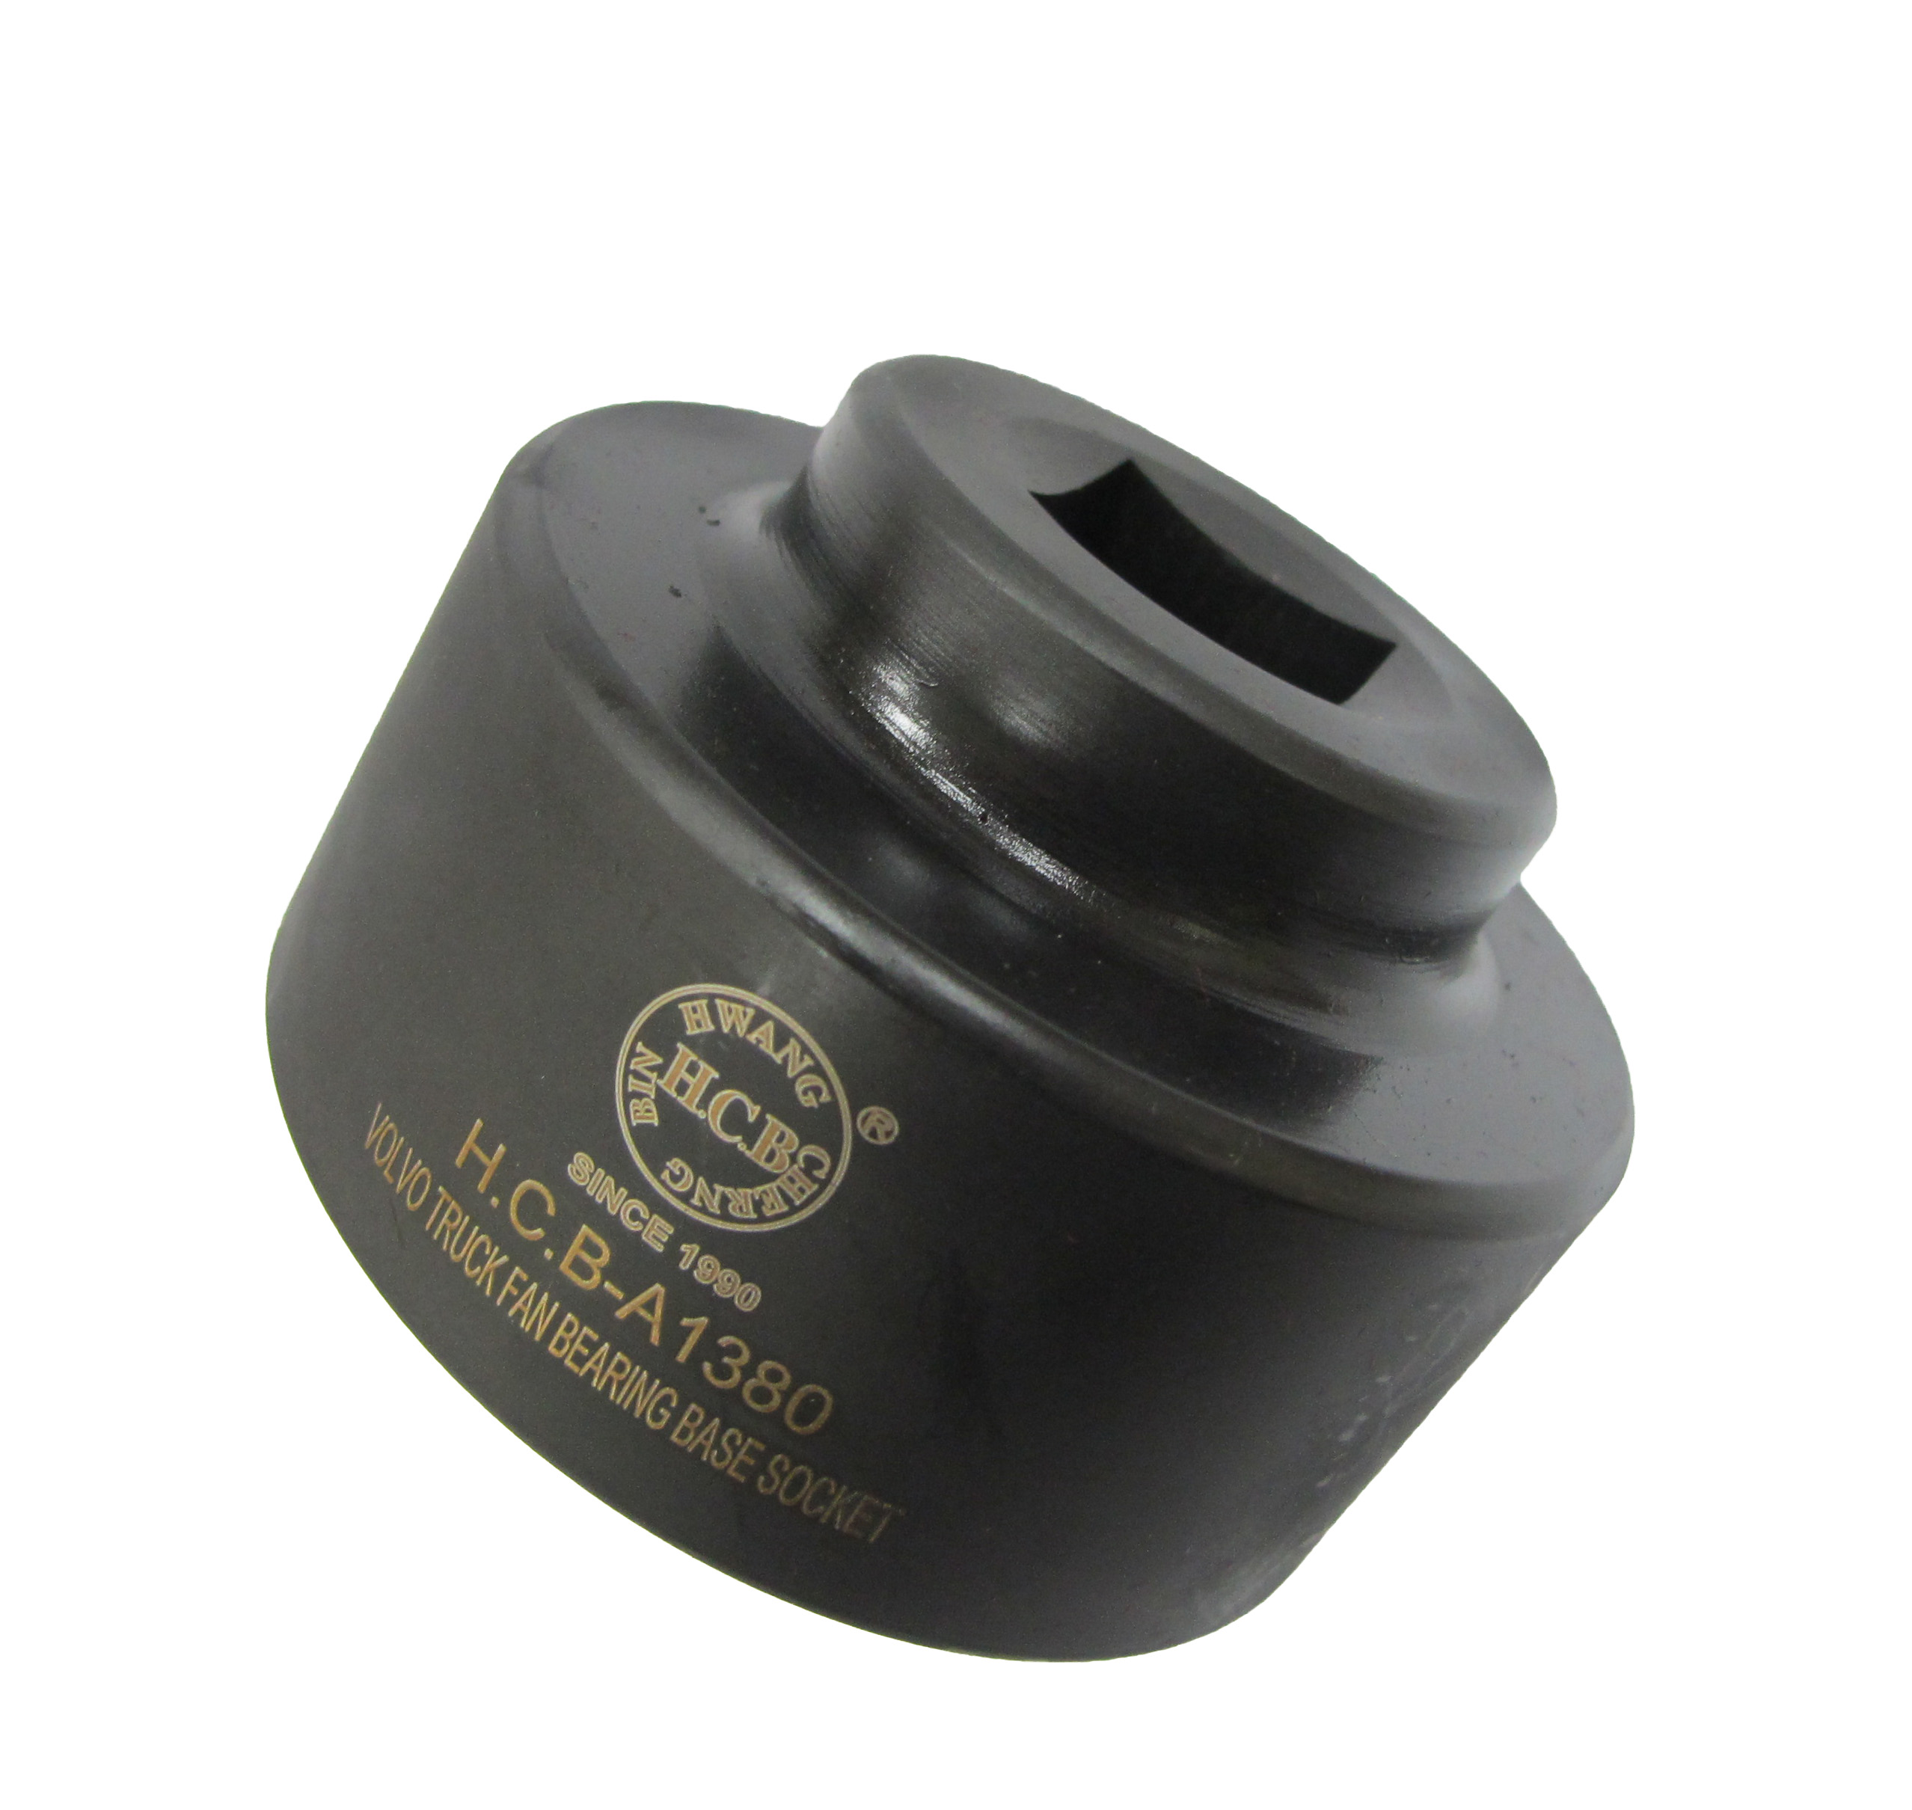
Dr. 1/2”

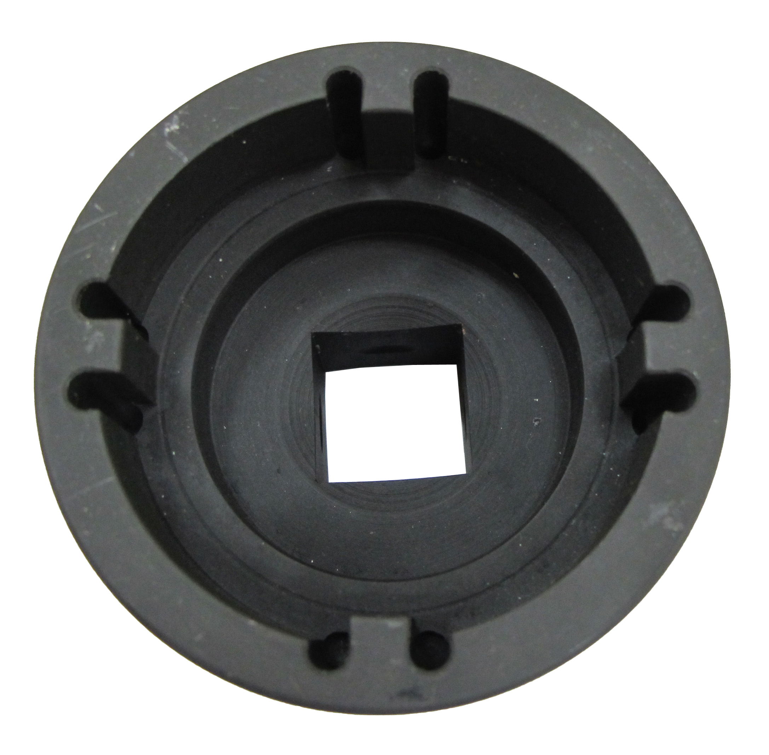
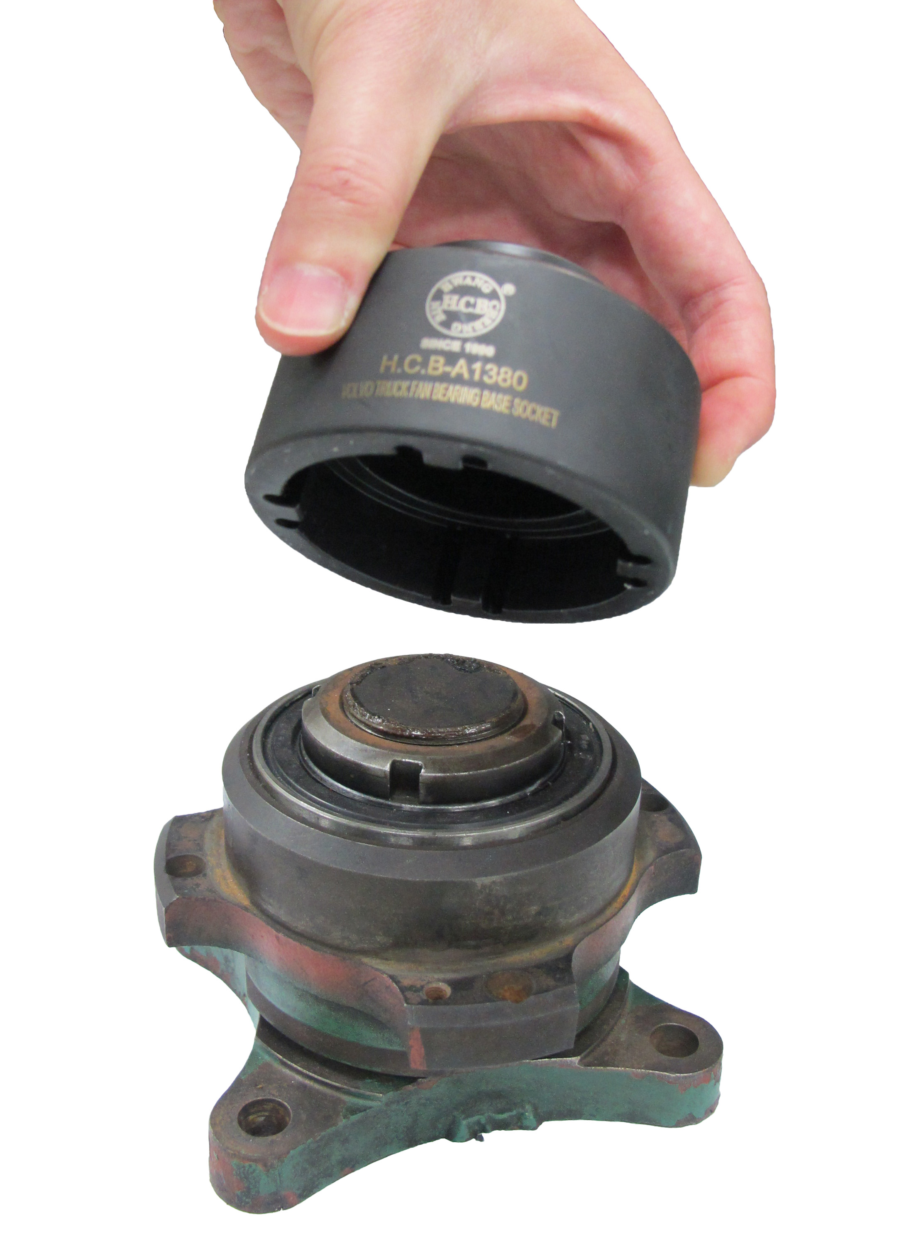

- This tool is designed for removing nut to replace bearing.
- Use great on FM12.

H.C.B-A1380

VOLVO TRUCK FAN BEARING BASE SOCKET (Dr. 1/2")
Dr. 1/2”

- This tool is designed for removing nut to replace bearing.
- Use great on FM12.

